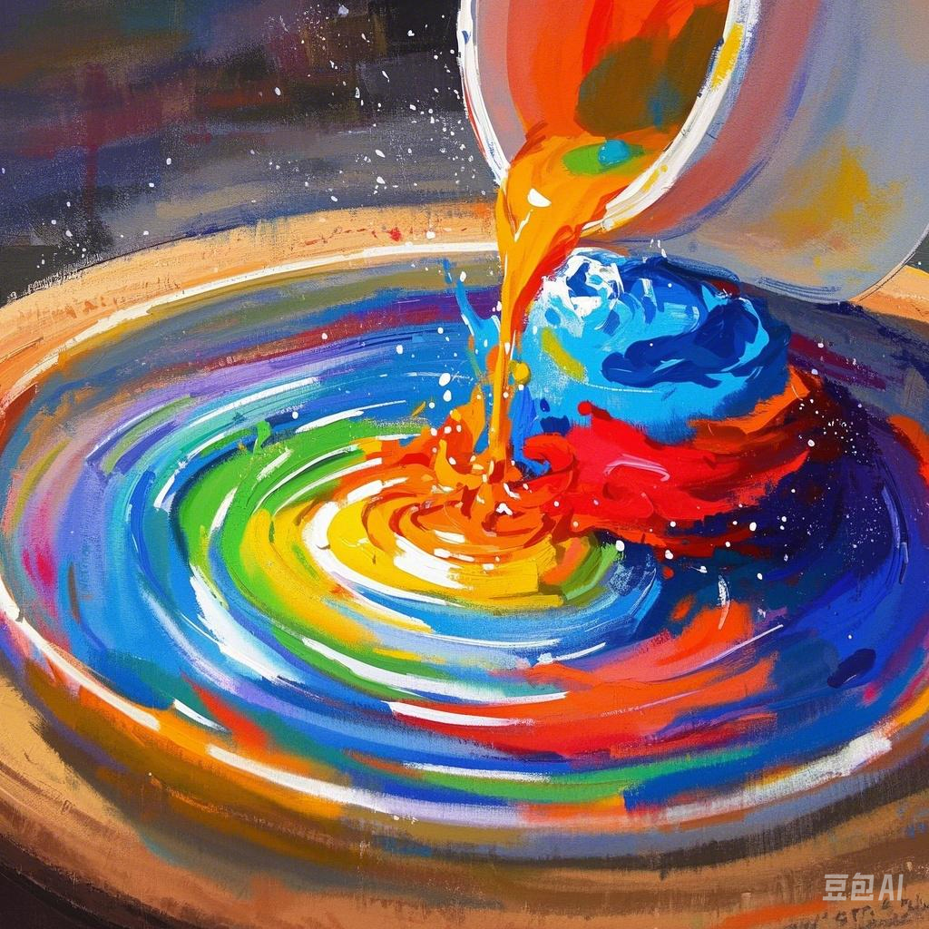

泉州国艳新材料科技有限公司

Quanzhou Guoyan New Materials Technology Co., Ltd.

专业聚氨酯色浆生产企业Professional polyurethane color paste production enterprise

专业生产聚氨酯色浆、PU色浆、高浓度香精、增白剂、抗黄剂、EVA色母粒、颜料等产品。

Specializing in the production of polyurethane color paste, PU color paste, high concentration essence, whitening agent, anti yellowing agent, EVA color masterbatch , pigment and other products.

公司简介：泉州国艳新材料科技有限公司，是一家专业从事颜料、聚氨酯色浆、PU色浆、色母粒、助剂等生产、销售、服务于一体的生产企业。产品广泛应用于各种海绵、聚氨酯制品、鞋材、PU制品、汽车泡棉、塑胶制品、油漆、油墨等行业。公司拥有多名经验丰富颜料技术人员和专家顾问团队指导，先进的研发设备，并成立专业客服队伍，专业为客户提供来样调色服务。产品通过SGS环保认证、ISO9001:2008质量体系认证，符合欧盟环保要求。 “环保、稳定、优质”是国艳新材料永远不懈的追求，高品质的产品，最竭诚的服务与广大新老客户，真诚合作，共同发展！

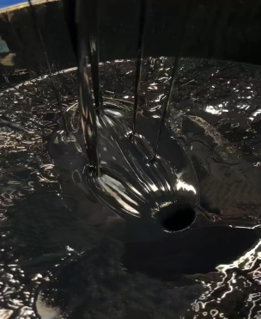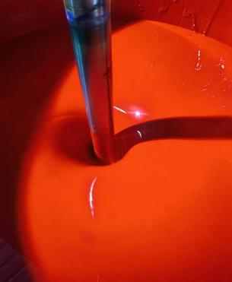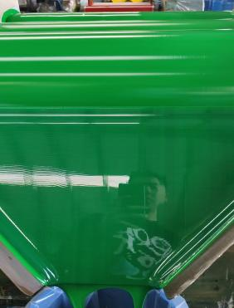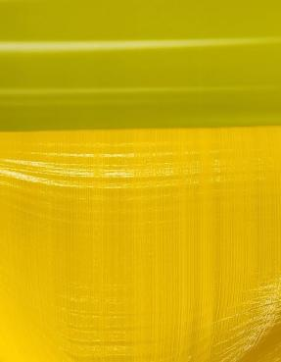

Quanzhou Guoyan New Materials Technology Co., Ltd. is a professional production enterprise specializing in the production, sales and service of pigments, polyurethane color pastes, PU color pastes, color masterbatches, and additives. Our products are widely used in various sponge, polyurethane products, shoe materials, PU products, automotive foam, plastic products, paints, inks and other industries. The company has a number of experienced pigment technicians and expert advisory teams for guidance, advanced R&D equipment, and has established a professional customer service team to provide professional color matching services based on customer samples. Our products have passed SGS environmental protection certification and ISO9001:2008 quality system certification, and meet the environmental protection requirements of the European Union.

"Environmental protection, stability and high quality" are the eternal pursuits of Guoyan New Materials. We provide high-quality products and the most sincere services to new and old customers, and sincerely cooperate and develop together!

聚氨酯色浆

产品种类:聚氨酯类

产品名称:聚氨酯用色浆

主要产品:特黑，深蓝，天蓝，黄，红，绿，紫，特白等

应用范围:聚氨酯类产品，如聚氨酯类海绵、聚氨酯类鞋材、汽车泡棉、PU材料、建筑材料等

性能:

●与聚氨酯系统料完美的配伍性(专为聚氨酯系统料设计的体系)

●各种聚氨酯发泡和非发泡产品着色

●使您的生产过程更清洁、易添加

●色浆高度流动性(可避免出现机械故障)

●增强色强的强度(使用最高强度的色浆)

●持久的色调和颜色强度

●采用耐高温环保颜料

研磨细度: <=15um

**色相**:基础聚氨酯色浆和其他颜色可以调配出任何颜色的色浆。由于色浆在不同的聚氨酯体系(聚醚、聚氨酯)中，所表现出的颜色有所不同，所以要想得出精准的颜色需要在客户自己的聚氨酯体系中才能调出。

**添加量:**基于多元醇3%的添加量是一个产品颜色最稳定，又没有流纹的参考添加量。

**粘度/流动性:**聚氨酯色浆在25℃条件下的粘度是2000-3500mpa.s。这个粘度范围是非常适合自动或人工添加，我们也可以根据客户的需求对粘度进行调整。

**密度(20℃):**1.05-1.85g/cm保质期:12个月

**包装规格**:20KG、35KG、50KG、200KG/桶

**储存:**由于聚氨酯色浆对潮气比较敏感，所以色浆一定要储存在密闭的桶内.储存温度应该在20℃到30℃的范围内.

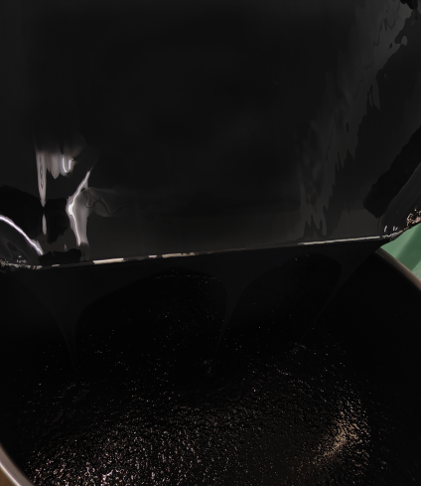 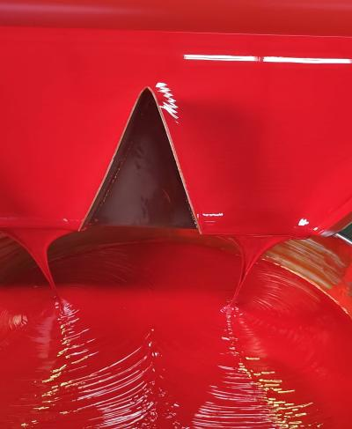 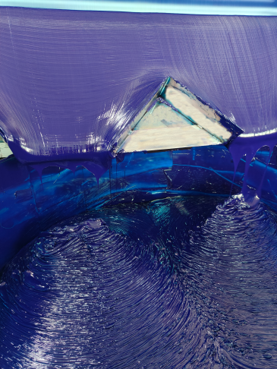

**Polyurethane color paste**

**Product type**:Polyurethane

**Product Name**: Polyurethane Color Paste

**Main products**: Extra black,deep blue, sky blue, yellow, red, green, purple, extra white, etc **Application scope**: Polyurethane products, such as polyurethane sponges, polyurethane shoe materials, automotive foam, PU material , building materials, etc.

**Performance**:

●Perfect compatibility with polyurethane system materials (a system designed specifically for polyurethane system materials)

●Coloring of various polyurethane foam and non foam products.

●Make your production process cleaner and easier to add

●The color paste has high fluidity (which can avoid mechanical failures)

●Enhance the intensity of color intensity (using the highest intensity color paste)

●Persistent tone and color intensity

●Using high-temperature resistant rings

**Grinding fineness**:<=15um

**Color hue**: Basic polyurethane color paste and other colors can be mixed to create any color paste. Due to the presence of colorants in different polyurethane systemsIn polyether and polyurethane, the colors displayed may vary, so to obtain accurate colors, it is necessary to use the customer's own polyurethaneOnly in the ester system can it be removed.

**Addition amount**: Based on the 3% addition amount of polyols, it is the reference addition amount for a product with the most stable color and no flow lines.

**Viscosity/flowability**:The viscosity of polyurethane color paste at 25 ℃ is 2000-3500pa.s.This viscosity range is very suitableAutomatically or manually added, we can also adjust the viscosity according to customer needs.

**Density (20 ℃)**:1.05-1.85 g/cm

**Shelf life**:12 monthsPackaging

**specifications**: 20KG,35KG,50KG,200KG/barrel

**Storage**:Due to the sensitivity of polyurethane color paste to moisture, it must be stored in a sealed bucket. The storage temperature should be withinWithin the range of 20℃ to 30℃

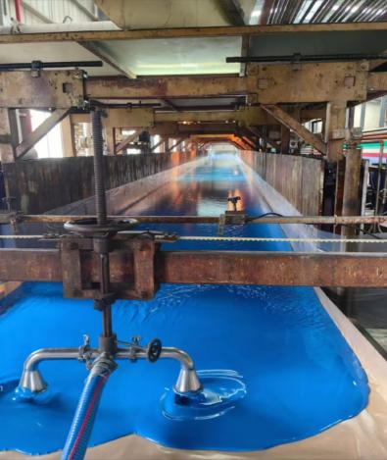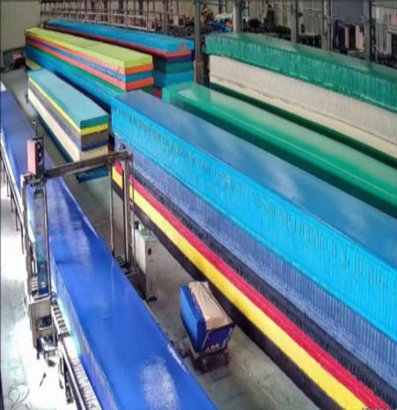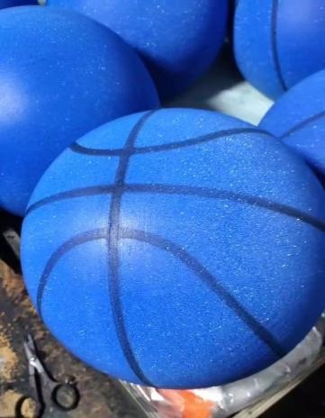

**荧光色色浆**

产品种类:聚氨酯类

产品名称:聚氨酯荧光色色浆

主要产品:荧光红、荧光桔、荧光黄、荧光绿、荧光紫、荧光桃红、荧光宝蓝、荧光玫红等应用范围:聚氨酯类产品，如聚氨酯类海绵、鞋材、汽车泡棉、PU材料、建筑材料等。

性能:

●与聚氨酯系统料完美的配伍性(专为聚氨酯系统料设计的体系)

●各种聚氨酯发泡和非发泡产品着色

●使您的生产过程更清洁、易添加

●色浆高度流动性(可避免出现机械故障)

●增强色强的强度(使用最高强度的色浆)

●持久的色调和颜色强度

●永不褪色(采用非常耐光的颜料)

●色泽艳丽

研磨细度:<=15um

色相:基础聚氨酯色浆和其他颜色可以调配出任何颜色的色浆。由于色浆在不同的聚氨酯体系(聚酯、聚醚)中，所表现出的颜色有所不同，所以要想得出精准的颜色需要在客户自己的聚氨酯体系中才能调出。

添加量:基于多元醇3%的添加量是一个产品颜色最稳定，又没有流纹的参考添加量。

粘度/流动性:荧光色浆具有良好的流动性，在25℃条件下的粘度是2000-3500mpa.s。这个粘度范围是非常适合自动或人工添加，我们也可以根据客户的需求对粘度进行调整。

**密度(20℃)**:1.05-1.45g/cm

保质期:12个月

包装规格:20KG、60KG、200KG/桶

储存:

由于聚氨酯荧光色浆对潮气比较敏感，所以色浆一定要储存在密闭的铁桶内,储存温度应该在20℃到30C的范围内,如果在运输或储存过程中出现极端温度时下面的步骤可推荐使用:在寒冷的环境下，色浆应放置在室温(max.25℃)环境下几天时间直到温度全部恢复到20℃以上。为了让温度恢复的快，也可以把色浆放置在45-55℃的烘箱或烘房里6到8个小时。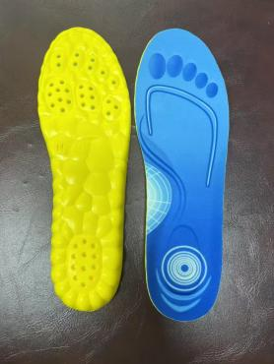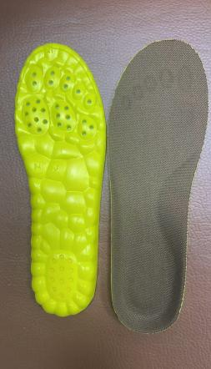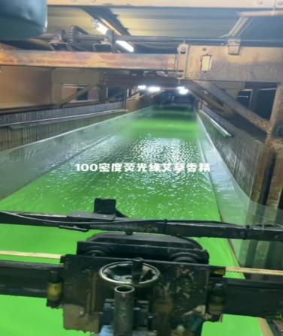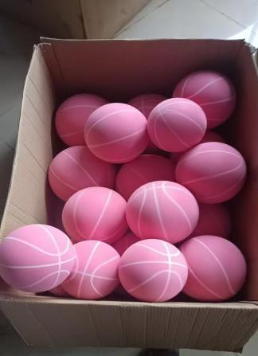

**Fluorescent color paste**

**Product type**: Polyurethane

**Product Name**: Polyurethane Fluorescent Color Paste

**Main products**: fluorescent red, fluorescent orange, fluorescent yellow, fluorescent green, fluorescent purple, fluorescent peach red, fluorescent royal blue, fluorescent rose red, etc **Application scope**: Polyurethane products, such as polyurethane sponges, shoe materials, automotive foam, PU material ,building materials, etc.

**Performance**:

●Perfect compatibility with polyurethane system materials (a system designed specifits polyurethane system materials)

●Coloring of various polyurethane foam and non foam products

●Make your production process cleaner and easier to add

●The color paste has high fluidity (which can avoid mechanical failures)

●Enhance the intensity of color intensity (using the highest intensity color paste)

●Persistent tone and color intensity

●Never fade (using highly light resistant pigments)

●Brilliant color

Grinding fineness:<=15um

**Color hue**: Basic polyurethane color paste and other colors can be mixed to create any color paste. Due to the presence of colorants in different polyurethane systemsln polyether and polyurethane, ihie aolors displayed may vary, so to obtain accurate colors, it is necessary to use the customer's own

thaneOnly in the ester system can it be removed.

**Addition amount**: Based on the 3% addition amount of polyols, it is the reference addition amount for a product with the most stable color and no flow lines.

**Viscosity/flowability:** Fluorescent color paste has good flowability, with a viscosity of 2000-3500pa.s at 25℃.This viscosity rangelt is very suitable for automatic or manual addition, and we can also adjust the viscosity according to customer needs.

**Density (20℃):** 1.05-1.45 g/cm

**Shelf life**:12 months

**Packaging specifications**:20KG,60KG,200KG/barrel

**Storage**:Due to the sensitivity of polyurethane fluorescent color paste to moisture, the color paste must be stored in a closed iron bucket. The storage temperature should be withinWithin the range of 20℃t30 ℃. If extreme temperatures occur during transportation or storage, the following steps can ber ecommended:In cold environments, the color paste should be left at room temperature (max.25℃)f a few days until the temperature fully recovers to above 20℃.In order to quickly re8 aver the temperature, the color paste can also be placed in an oven or oven at 45-55 ℃ for 6 to 8 hours.

香精

产品介绍

香精的主要作用是弥补产品本身的香味缺陷，赋予部分产品鲜活的原味，强化产品的香味，掩盖产品的难闻气味。添加量小，成本低，产品附加值高。与其他添加香精的方法相比，工业香精可耐250度以上的高温，留香持久，可获得品质一致的产品。工业香精更大的优点是涂抹方便，香味的挥发度也比较理想。产品广泛应用于日用化工业、制药业、纺织业、鞋材、皮革业橡胶塑料业等各个行业。

PRODUCT INTRODUCTION

The main function of essence is to make up for the flavor defect of the product itself, give some products fresh original flavor, strengthen the flavor of the product, and cover up the unpleasant smell of the product. Small addition amount, low cost, and high product added value. Compared with other methods of adding essence, industrial essence can withstand the high temperature of more than 250 degrees, keep fragrance for a long time, and can obtain products with the same quality. The greater advantage of industrial essence is that it is easy to apply, and the volatility of fragrance is also relatively highIdeal. The product is widely used in various industries such as daily chemical industry, pharmaceutical industry, textile industry, shoe materials, leather industry, rubber and plastic industry, etc.

按气味分类 Classify by odor

花香类:茉莉、桂花、玫瑰、薰衣草、香草、草莓等。

Floral fragrance: Jasmine, Osmanthus, Rose, Lavender, Vanilla, Strawberry, etc.

果香类:苹果、柠檬、草莓、甜橙、橙子等。

Fruity: Apple, lemon, strawberry, sweet orange, orange, etc.

中药类:艾草、中草药、人参

Traditional Chinese Medicine: Artemisia argyi, Chinese herbal medicine, ginseng, Polygonum multiflorum

其他类别:巧克力、古龙水、薄荷、牛奶、糖果味等。

Other categories: chocolate, cologne, mint, milk, Candy flavor , etc.

如有特殊要求，可根据客户需求制作所需香精

If there are special requirements, the necessary essence can be made according to customer needs

包装:5公斤桶装，20公斤/箱 Packaging: 5kg barrel,20kg/box

选择合适的存放环境:香精应该存放在干燥、阴凉、通风的环境中，避免阳光直射和潮湿。同时，存放环境应该远离火源和易燃物品，确保安全。

Choose a suitable storage environment: essence should be stored in a dry, cool and ventilated environment, avoiding direct sunlight and humidity. Meanwhile, the storage environment should be kept away from ignition sources and flammable materials to ensure safety.

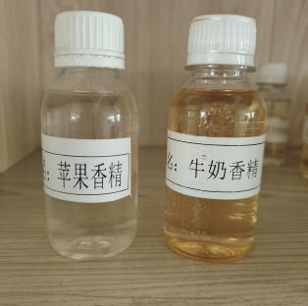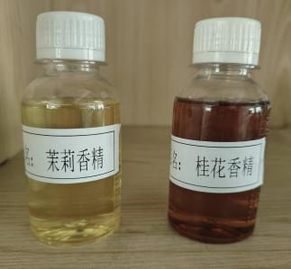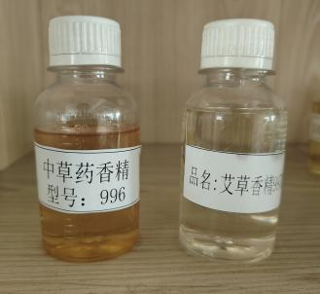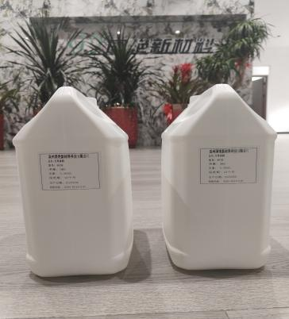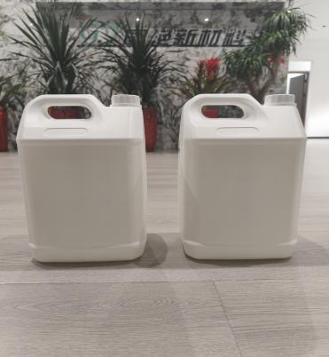

UV耐黄变剂

**产品类型**Product Type

特殊的液体型紫外线吸收剂。 Special liquid type UV absorbent.

**产品领域** Product Area

UV 耐黄变剂提供了优异的光保护聚氨酯体系。它很容易均匀的溶于聚酯和聚醚多元醇。表明它用于聚氨酯体系中与异氰酸酯和其他添加剂的相容性非常好。

UV resistant yellowing agent provides excellent photo protective polyurethane system. It is easily and uniformly soluble in polyester and polyether polyols.Indicating its excellent compatibility with isocyanates and other additives in polyurethane systems.

**产品描述** DESCRIPTION

外观:淡紫色液体 Appearance: Light purple liquid

熔点范围:25-30C Melting point range:25-30℃

密度(20°C):约1.15 g/cm Density (20°C): Approximately1.15g/cm3

粘度(20°C):约3500 MPa.S Viscosity (20°C): Approximately 3500 MPa.S

水溶性:不溶性 Water solubility: insoluble

**包装**:20公斤/铁桶35公斤/塑料桶

Packaging:20kg/iron drum35 kg/plastic bucket

**贮藏**:常温下贮藏，干燥条件。25-30℃)温度最佳。

Storage: Store at room temperature under dry conditions. The optimal temperature is between 25-30°C).

**保质期**:12个月，耐黄变剂密封保存在原桶中。

Shelf life: 12 months, sealed with anti yellowing agent and stored in the original barrel.

**特殊条件**:需使用前搅拌好。立即关闭原桶，以防止吸湿和污垢污染。

Special condition: Stirwell before use. Immediately close the original bucket to prevent moisture absorption and dirt contamination.

