新產
Research an(
品研發部
Development Department
—
电4i
望牛墩路
望牛墩镇
高上步
景鸿酒店
君爵酒店
江二中
高土步路口
德邦物流
出入
上甲
华南MALL
金田纸，
裕隆机械制造有限公司
科瑞莱空调
嘉新海绵
汽车总
流涌尾村
大汾
曲海大韦
明轩大酒店
裕隆机械制造有限公司
交通示意
' A . 市人民医院 BP加油站
「深高速道涪、 一
万江出入口
通货赢场:次？交

乐凳市縮曖flliR制造有限公司
DongGuan U-Long Machinery Co.,Ltd.
12020・2021 圈
U-LONG Foam Machine
Base on sincerity and quality
创裕隆
地址：广东省东莞市万江区汾溪路大汾工业区
Address: DaFen Village, WanJiang District, Dongguan City, GuangDong, China
TEL: 0086-769-23171181 FAX: 0086-769-23171182 联系人：黎生
Http: //www.u-long.com.cn 手机微网址：Http:〃m .u-long.com.cn
E-mail: u-long@u-long.com.cn
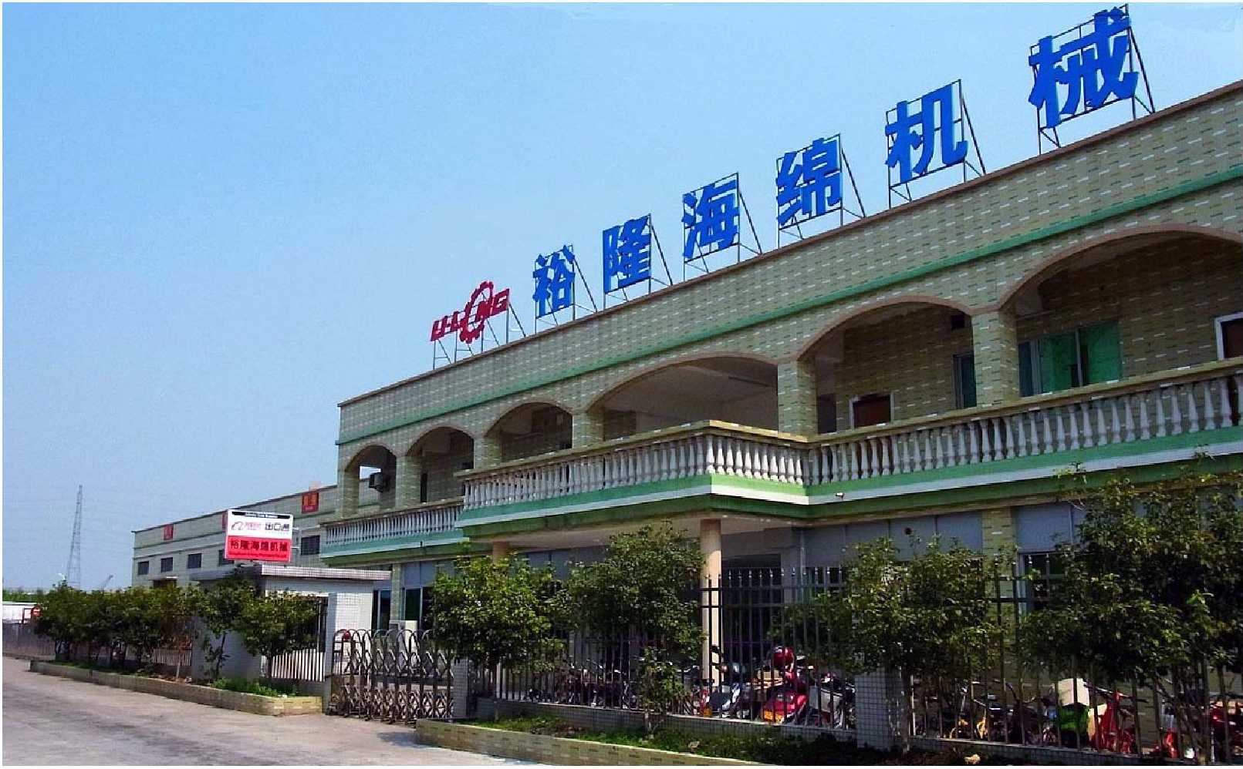
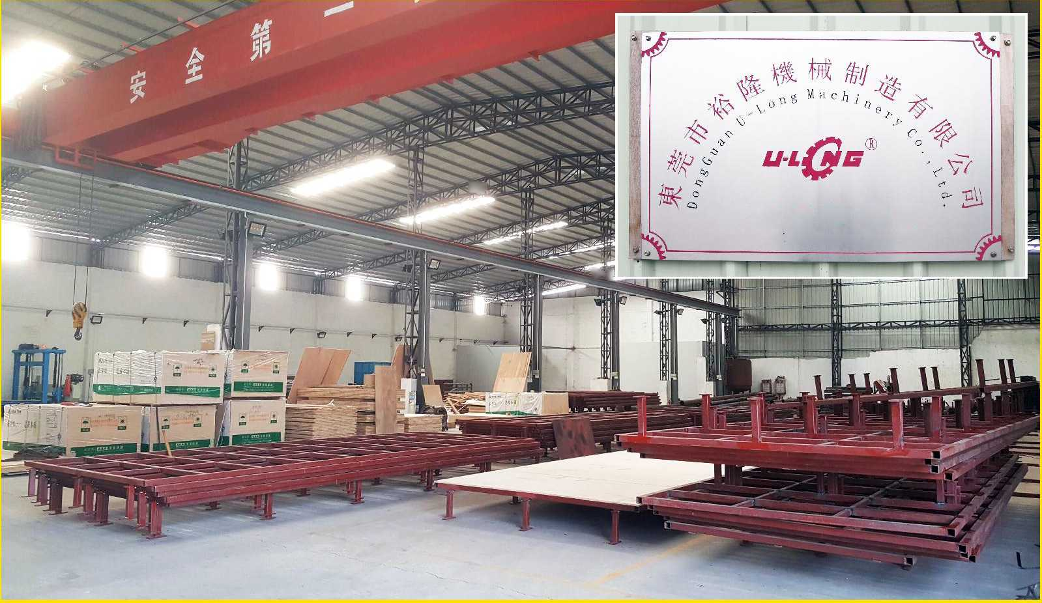
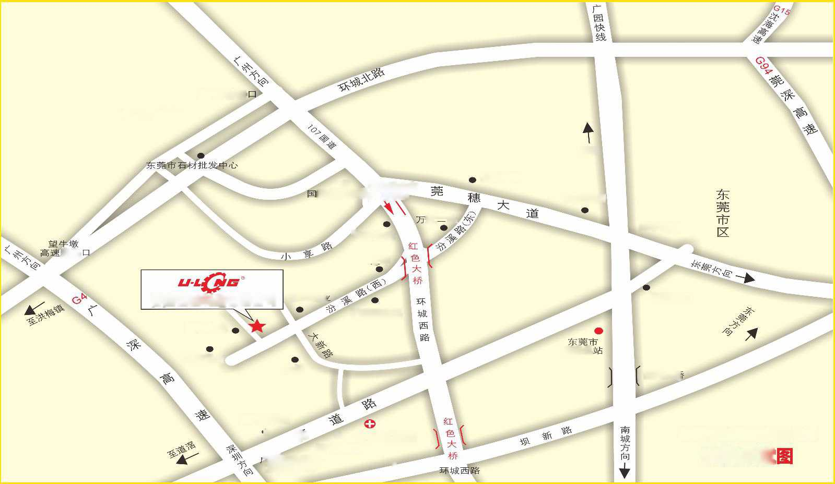
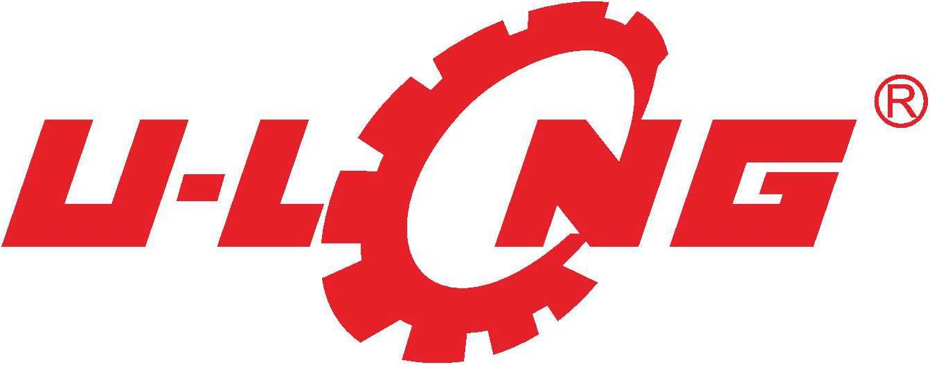



公司简n

东莞市裕隆机械制造有限公司是一家

专业生产海绵机械设备的新型企业。本公

司汇聚了多年在海绵机械设备制作领域的

先进经验，锐意进取，不断开拓创新,精心设

计生产新一代海绵机械设备。产品精益求

精，服务诚恳待人，裕隆人渴望成为各广

大用户真诚的合作伙伴!

Corporation Introduction
Dong Guan U-Long machinery limited company is a hi-tech enterprise specializing in foam machine• Our company has been marshaling advanced trade experience for years, what's more, our company is always exploiting and innovating in order to design and produce the new generation machine. The capabilities of our products are outsta service is genuine, and all the staff of U-Long want to be pure-hearted business partners with all the users.
* • 善
Certificate of Compliance
捋
Mik
n ”5心顷，3
IES5尸 I
Certificate of Compliance
-、.一… ..
4 •<. .1^'irw c » X-VA* ,入• •
V”，广、,’: KA'tf* »•/. »7» r*. fcGcc *. V A .■，［二3”
RT" TwlinrJrvjy Co. Lt:.
U.duXrA. tl>i »t4r>lMit« xi»l wuw •
:ihll~5u ：l LV3 :l :ctrx :疗卜，： .»<Ct • h». «« J,. 邱 ES"
rexowl rrr。。"*«•■<»*<• ："、" u 〃。丨 乂浦：， ««.*Z4IP.f< .C J»? I* U C"lf ,:A K fl M .« J». LU ’
.« m$T：G1012CK：F 7
V/MVIV；
U心
WAV WVHf.fc
I • »»l 1%, 1^-111 R； >J. II..0-1
lit IQ -””Qd 访
• YHMW I YP !«•
J4t,24 731
>r；
a
质M管理ffiSiA证证书
东莞市裕隆机械制造有限公司
；g】4：g MWKWVF
位■，円休足整合：
GR'TISO01-2008 idt ISQ9001:2008 »»
IT常■臺史安：
五会朋摑設务：全冬机械说布、的設L、 生产和阪务
k/|X3<. 4 ..
北朿海？5E甘认该有限公司
” • t.・m<m:«cxui
QI AIJTY MA^.MiEMKXT
S1STH51 < ERTIFU ATK
W« organtzallon:
DongGuan U-Long Machinery Co., Ltd.
侦加，07BK妳 3
i& ^conrofmcy wltJi QuMty gn勺SwMJtd: GB/T19001-2008 idt ISOM01:20W
TI.M u»tiGc.ui is 颂。to the fog»m
Designing and Manuracturlng of Hanlvraro Machinery (Foam Machinery, Rubbor Machinery!
、A・e»，丄f LW-m f ®..、2U：f。Cfc*rd
Ch 二sjFzre
女用力f♦々利ifB
專用制墨专判旺15
Nff V
发明专利证书
Certificate wf LttV-auMoh
U-Long Machine
Help you get more wealth and success
裕隆机械，助你富裕兴隆!
P
UO专qESJQ—5网轮女W旧姗B旧y ■
£od
(DnbEUI 昌。寫)根 qq<«. (.sq目Z)剧丑®・ (覆归 vqmos)#輕• (•2d.2q畐)宥归s«經.
(OEXOW)frla豳. (§030寫)蛇旧质蠅.
(HzeJm)®EJ・
(螺dtu)跃四歓. (。港 60s)邮中<• aMqwlnN)r^HJM. (.2曰 ZMH)剧唳««!. (•2取8乏)剧厶nl闯.
(芨86您郵•
(旨若。)寫号• (曰 pns)i:摭• (昌8。君)市喪»• QMS阕玉裙• QAgx) 35唳驰• -凶爰系赣•
(A*mF)HH-屮 (8旨。寫)版寫蜓• (PUBod) 洲趣 2>£so8nf)4K創S®•(曰溥 q』gz<)ffl歐W匱
- (.swnqls 要變桝•
- (8810)噩聽•
- GUFqfl)洲睇瑯•
(澹昌qlv) 粗四HJ技匡• (USS 喺 qzQ)S1服龍B権就• (sssna)输幾職盹疆•
【凶查泰备，
C02AGSE)蜘旧馈觀•
230) IWW• 創«旬糊•
(Dns§2賃匐昌暇•
2d) « • G-Smoalv)識嬰度• -凶要系致4<咫系<•
(.2P5)慳&• (suuq-cs)平判叫搽 (b曾【)紀箱底• (耳*1)禄四不 .SSDUOPUD 昌回眠理&(InmnEA)®賴 IPUS)延汩度豊会：(.2POCFI30)挪髀< (目 E喺 d)ffl毎剛£]• (目 mo)瞰£
(§&)妖喪平 (目 PE)ml蕊 (扫源ITS)
(US)密成 …BIVP。专n)斷護屋
2。冃qge囊田誅• (SJXS)昌届• (PUEWqH)HM• (so.2ddwqd)<##• (.2SASBW) 3EIS聚成, (目目A)c用• 〔凶 n^e
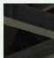

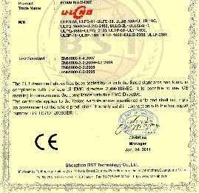
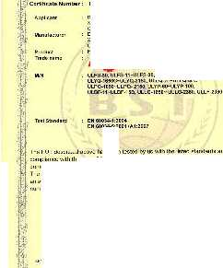
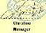

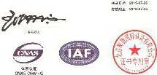
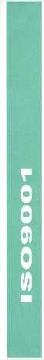
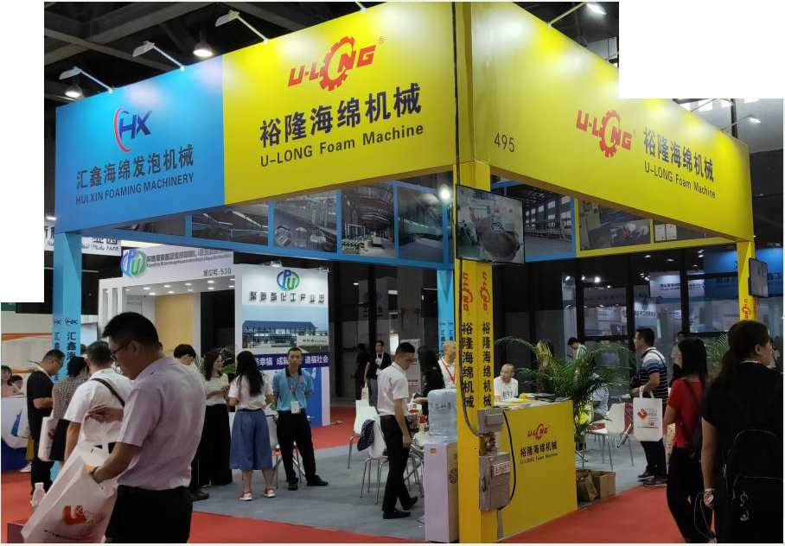
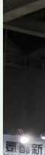
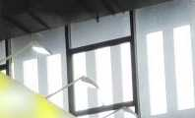
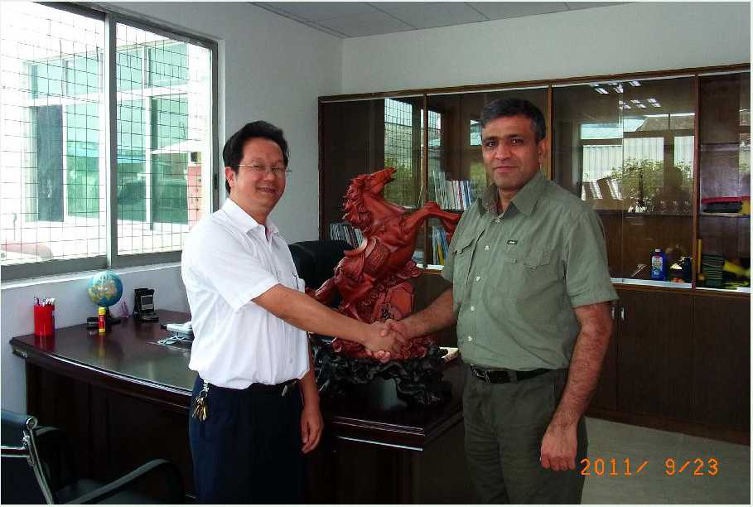
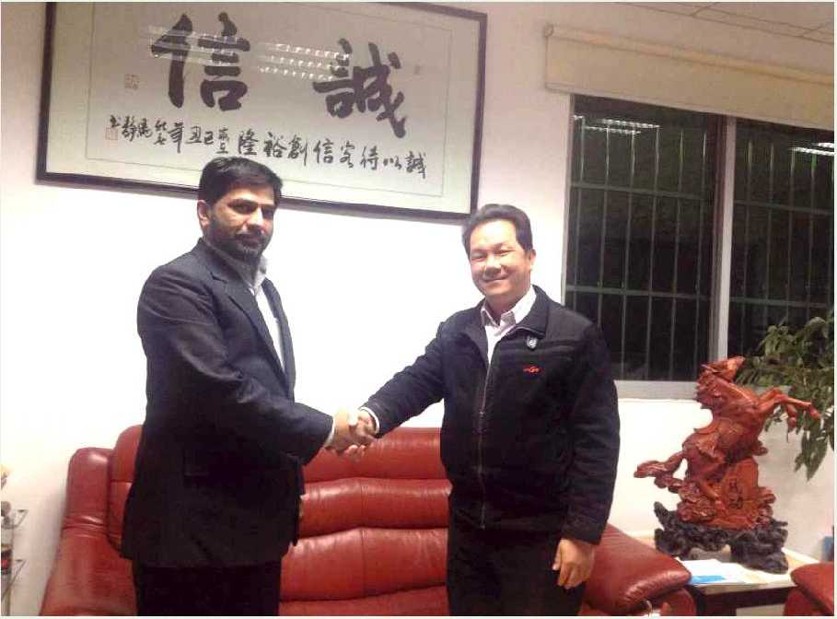



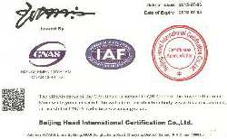




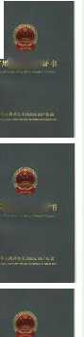

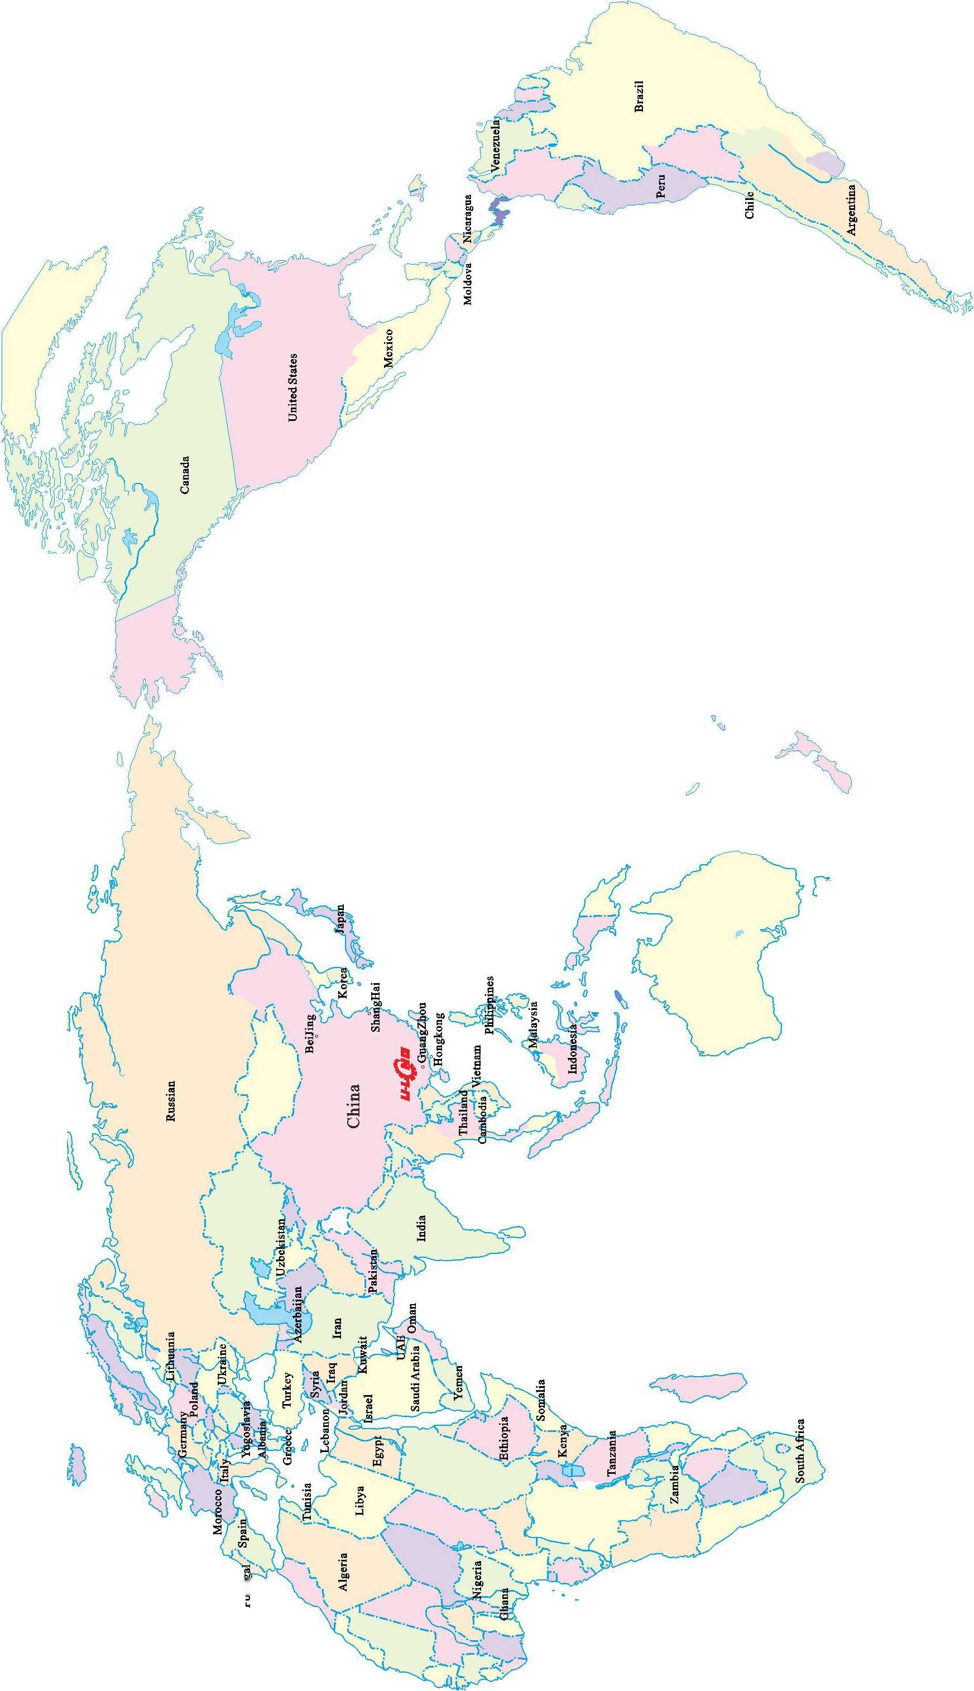


东凳市isBiiiniH制造有IE公司
产品目录

CONTENTS
海绵测量仪器

Foam Instruments
海绵压陷系数测定仪
Foam Compression Coefficient Tester
海绵回弹系数测定仪
Foam Rebounding Coefficient Tester
海绵厚度测量仪(0〜30mm)
Foam thickness tester
硬度计
Foam Hardness tester
海绵厚度测量仪(0^10mm)
Foam thickness tester
海绵拉伸强度测定仪
Tensile strength of foam tester
ULLF-2500 海绵水平自动连续发泡生产线 Horizontal Automatic Continuous Foaming Machine ULQD-2380 海绵切顶机 Top Foam Cutting Machine
ULQB-2380 发泡线组合切边机 Side Foam Cutting Machine U LCD-2380A 海绵裁断机 Block Foam Cutting Machine
ULCD-2380B 海绵横断式裁断机 Transversely Block Foam Cutting Machine

ULTS-2380海绵连续生产线侧纸提升装置Block Squaring Equipment ULCF-11 自动箱式发泡机 Batch Foaming Machine
ULBF-11/15A 手动卧式发泡机 Seated Foaming Machine(Manual Operation) ULBF-11/15B 手动立式发泡机 Vertical Foaming Machine(Manual Operation) MODELF・1#/F・2#/Y・1#海绵方形及圆形模具Foam Block Moulding # ULLG-1650/2150/2350 海绵轨道平切机 Long Sheet Foam Cutting Machine
ULLG-O-1650/2150/2350 强力海绵路轨平切机 High Density Foam Long Sheet Cutting Machine
ULYP-6000/7280/10500 海绵圆盘平切机 Carousel Splitting Foam Cutting Machine ULPQ-1650/2150 海绵平切机 Horizontal Foam Cutting Machine ULPQ-lll-1650/2150 再生海绵平切机 Horizontal Re-bonding Foam Cutting Machine ULPQ-WDXF-1650/2150 海绵网带吸风平切机 Horizontal Foam Mesh-belt Cutting Machine(with vacuum) ULPQ-ll-1250/1650/2150 海绵高精度吸风平切机 Horizontal High Precision Horizontal Foam Cutting Machine(with vacuum)
ULPQ-XD-1250/1650 聚氨脂硬质泡沬平切机 Horizontal Hard PU Cutting Machine
UiyX-O-2250 强力海绵压型机 Strong Profile Foam Machine ULYX-1650/2150 海绵压型切割机 Profile Cutting Machine ULYX-O-2250B 超强力海绵压形机 Heavy Duty Foam Profile Cutting Machine
ULKP-1650/2150 海绵开片机 Foam Slice Machine ULSPQ-800 海绵三维立体切割机 Foam Three Dimensional Cutting Machine(Manual Operation) ULQB-1900 再生海绵粘合切边机 Re-bonding Foam Edge Cutting Machine ULQB-2300 海绵导向切边机 Foam Guidance Edge Cutting Machine ULLQ-2L 海绵直切机(<h型)Vertical Foam Cutting Machine(Small) ULLQ-3L 海绵三轮直切机(中型)Vertical Foam Cutting Machine(3 Sheel) ULLQ-4LW 湿帘纸切割机 Wet Screens Cutting Machine ULLQ-4LE 海绵直切机(高精度型)Vertical Foam Cutting Machine(Precision) ULLQ-4L 海绵直切机(市型和加大型)Vertical Foam Cutting Machine(Middle and Big) ULLQ-4LA 海绵半自薪直切机 Semi-automatic Vertical Foam Cutting Machine ULLQ-4LB 海绵全自动直切机 Automatic Vertical Foam Cutting Machine ULLQ-4LC 海绵全自动直切机(单面/双面切割)Automatic Vertical Foam Cutting Machine(Single Side/Double Side Cutting)・・ ULLQ-ZH-2150 全自动海绵组合切割机 Fully Automatic Foam Cutting Machine ULJQ-2L-A 海绵角度切割机(圆孤型)Angle Foam Cutting Machine(Circle) ULJQ-2L-B 海绵角度切割机(直线型j Angle Foam Cutting Machine(Beeline)

ULJQ-2L-C 海绵角度切割机(直线型)Angle Foam Cutting Machine(Beeline)

ULJQ-3L 海绵三轮角度切割Angle Foam Cutting Machine(3 wheels)
ULJQ-4L 海绵四轮自动角度切割机 Automatic Angle Foam Cutting Machine
ULZK-45A 海绵卧式钻孔机 Foam Seated Boring Machine ULZK-45B 海绵立式钻孔机 Foam Vertical Boring Machine ULYQ-2150 海绵圆切机 Foam Peeling Machine ULYQ-1900B 再生海绵圆切机 Re-bonding Foam Peeling Machine ULYQ-1650C 强力旋切机 Strong Peeling Machine ULYQ-1650D 超强力旋切机 Heavy Duty Peeling Machine ULQK-1500 岩棉保温管分中切割机 RockWool Insulated Pipe Cutting Machine ULQK-1500B 岩棉保温管组合切割机 RockWool Insulated Pipe Cutting Machine ULCNC-1650A 线刀数控异形切割机 CNC Contour Cutting Foam Machine ULCNC-2150B 数控异形海绵切割机(单/双刀)Vibration Blade CNC Contour Cutting Foam Machine(Single/Double Blade)… ULFJJ-2150 海绵放绵复卷机 Foam Rewinding Machine ULCWYM-2350 海绵除味排气压绵机 Foam Odor and Exhaust Pressing Machine ULFX-6200/6900 手动仿形切割机 Contour Cutting Machine(Manual Operation) ULDB-30A/60A 床垫封口打包机 MatressSeal Packing Machine ULDB-60B 海绵压缩真空打包机 Foam Block Seal Packing Machine ULDB-30T/60T 废绵打包机 Scrap Foam Packing Machine ULJB-10A 再生海绵生产线 Foam Re-bonding Machine ULJB-10B 再生海绵生产线(带蒸汽)Foam Re-bonding Machine(with steam) ULJB-12C 再生海绵生产线(双模具)Foam Re-bonding Machine(Double Mouldings) ULQB-2L 再生海绵旋转切机 Re-bonding Foam Rotary Side Cutting Machine ULJB-10C 圆泡再生海绵生产线 Round Foam Re-bonding Machine ULCL-10 粉碎海绵储存称量罐 Crushed Foam Storage and Scale Tank ULMB-1 废绵包升降机 Scrap Foam Bundle Elevator ULRY-2 海绵热压定型机 Foam Hot-pressure Machine ULZY-2 再生海绵座垫蒸汽压型机 Re-bonding Foam Cushion Pressure Machine(with steam) ULFS-11/22 海绵粉碎机 Foam Cushion Machine ULFS-30A/30B 海绵粉碎机 Foam Cushion Machine ULSJ-1250/1650/2150 上胶机 Gelatinizing Machine ULMP-2150 床垫薄膜封口机 Mattress Film Packing Machine ULCV-2100 床垫装袋机 Mattress Cover Filling Machine ULJH-1650/2150/2350 海绵接合机 Foam Jointing Machine

ULJM-1650/2150/2350 卷料计码机 Beat-code Machine ULYM-A/B/C 排气压绵机 Exhaust Pressing Foam Machine
ULYM-2500B 六辗排气压绵机 Six Roller Exhaust Pressing Foam Machine ULYM-2500C 十辗排气压绵机(输送带式)Ten Roller Exhaust Pressing Foam Machine(with conveyor belt) ULJJ-50 海绵搬运夹具(50M) Foam Crane Unit ULPU-7000/9800 PU发泡模具转盘 PU Foaming Turntable ULMRT-1慢回弹海绵回弹时间测试仪Memory Foam Rebound Time Tester

ULRT-80000 海绵反复压缩疲劳测试仪 Foam Reciprocating Tester 海绵测量仪器 Foam Instruments
- -2
2
-3
3
4
4
5
5
- ・7 ・8
9
10
10
11
12
- 12
- •13
- 14
15
15 ■16 ■16
- •17 -17
18
18
19
19
- ■20
- ■21 ■21 ■22 ■22
23
- ■24
24
25
25
26
26
27
27
28
- .29
- .30
30
.31
- .32
32
33
- .33
34
34
35
36
37
37
37
38
38
39
- •40
41
41
42
42
43
注：以上数据和参数仅供参考，实际技术数据以出厂产品为准。
Remark: The above data is only for reference, all the parameter is subjected to the sold production.
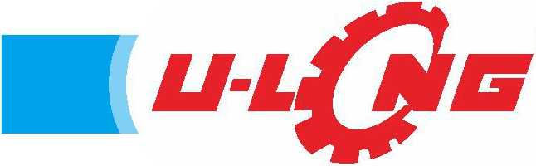
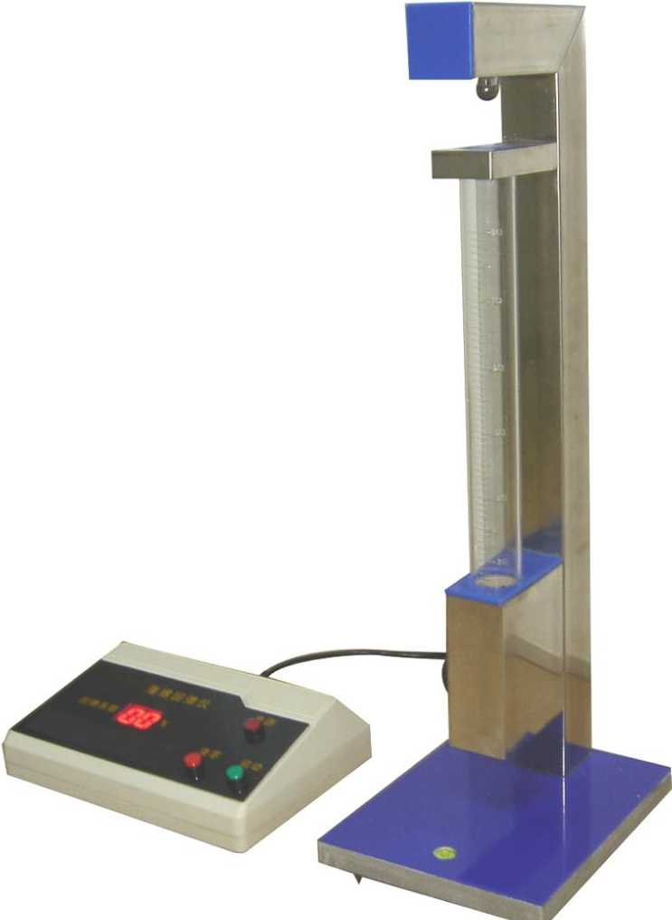
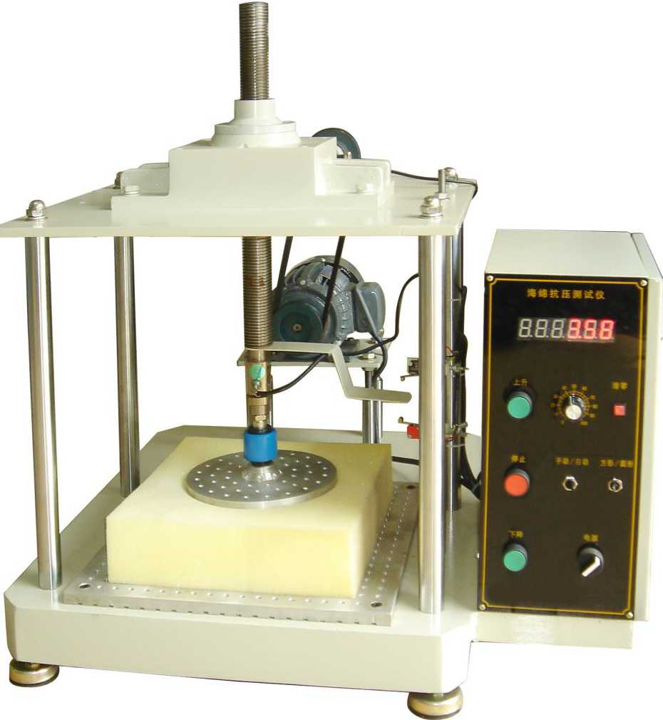
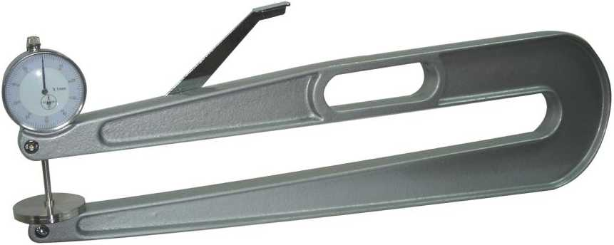
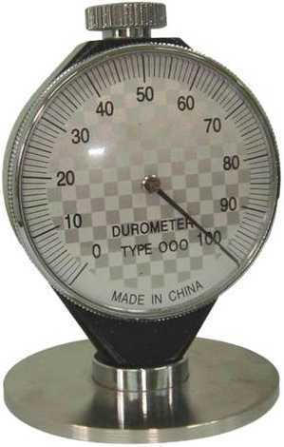
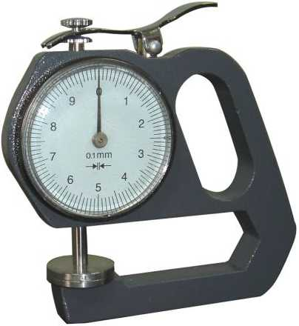
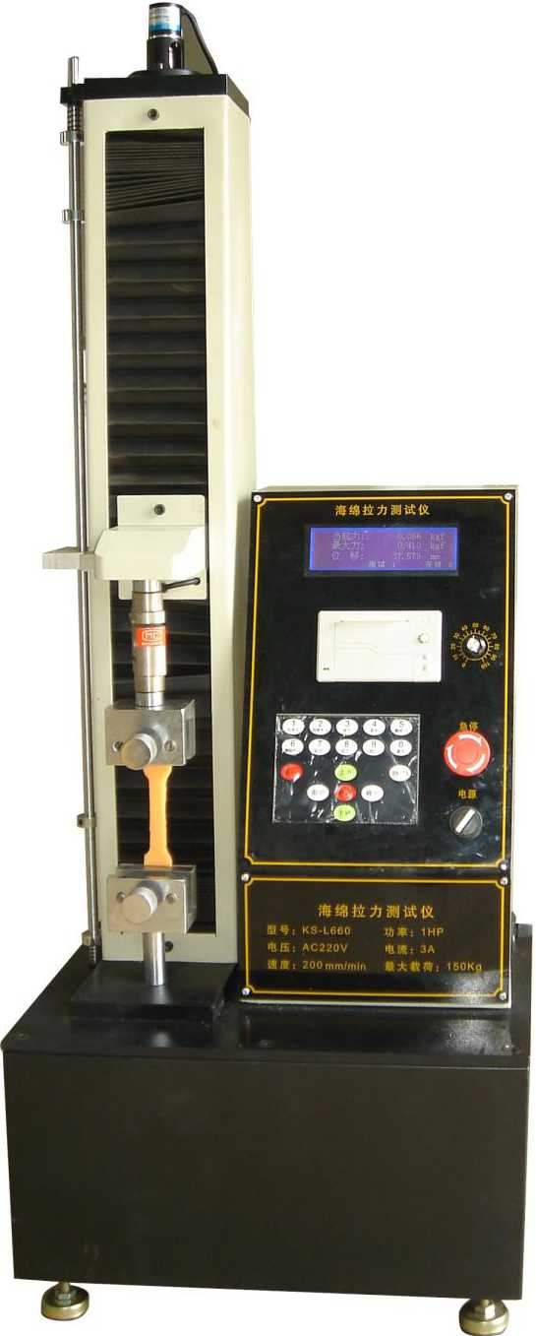

东凳市isBiiiniH制造有IE公司
DongGuan U-Long Machinery Co.,Ltd.

ULLF-2500

海绵水平自动连续发泡生产线
EJI

ULMRT-1

Horizontal Automatic Continuous Foaming Machine
本设备主要用于大规模的海绵连续生产，本机发泡密度为5-150Kg/m3,本机釆用先进的触摸屏及PLC操作系统,

慢回弹海绵回弹时间测试仪

Memory Foam Rebound Time Tester
自动化程度高，生产成本低，泡绵品质优良稳定，是大型海绵厂最为理想的生产设备。
This device is mostly used to continuously produce large-scale foam (5-150kg/m3), which adopts the advanced touch screen technology and PLC operating system. The high automation, outstanding foam producing while low cost makes it the most ideal equipment for large-scale foam production.
控制柜 Control box
控制阀 Control valves
双喷头 Double Spray Head
本机主要用于慢回弹海绵(惰性海绵)经压缩 75%后再回弹到90%所需要的时间，是各慢回弹海 绵生产厂家必备的检测设备。
It is used to measure the time required for inert foam's recovering to 90% of its original thickness in one minute after 75% compression. It is the necessary tester for memory foam manufacturers.
主要技术参数 Main Technical Specification
测试样品尺寸 Tested Sample Size L150xW150xH150mm
压缩时间
Pressing time
1 min

ULRT-80000

海绵反复压缩疲劳测试仪

ULRT-80000 Foam Reciprocating Tester
溢流槽发泡Foaming
hi
大料储料罐Big material tank
小料储料罐Small material tank
本机主要用于检测各类海绵经恒定的压力 (750N)作用下反复压缩(80000次)后产生的厚度变形减 少值及硬度降低值，本机具有自动调整补偿压力的功 能，保证测试过程中压缩压力的恒定不变。
本机是各类家具海绵生产厂家必备的检测仪器。
烘箱长度 | Over length | 20m | 输送带长度 | Link conveuer belt length | 20m
发泡高度 | Foaming height | <1.4m | 输送带线速度 | Conveyer belt speed | 2-8m/min
发泡宽度 | Foaming width | 1m~2.5m | 侧板调节宽度 | Side board adjustment width | 1m~2.5m
发泡密度 | Foaming density | 5-150kg/m³ | 混合头功率 | Mix-head power | 45 kw
总功率 | "Total power | 150kw | 总吐量 | Total output | 350kg/min
机器外形尺寸(长 x 宽 X 高)Machineexternalsize(LxWxH): |  |  |  | 40mX5mX3m

主要技术参数：Main Technical Specification
注：以上数据和参数仅供参考，实际技术数据以出厂产品为准。
Remark: The above data is only for reference, all the parameter is subjected to the sold production.
This machine is mainly used to detect the thickness deformation reduction and hardness reduction of various foams after repeated compression (80000 times) under constant pressure (750N). The machine has the function of automatically adjusting compensation of pressure and ensure the constant compression pressure during testing.
It is the necessary tester for all kinds of furniture foam manufacturers.
主要技术参数 Main Technical Specification
压力 | Pressure | 750N
测试样品厚度 | Tested Sample Thickness | 50mm
压缩速度 | Pressing speed | 70 times/min

注：以上数据和参数仅供参考，实际技术数据以出厂产品为准。
Remark: The above data is only for reference, all the parameter is subjected to the sold production.


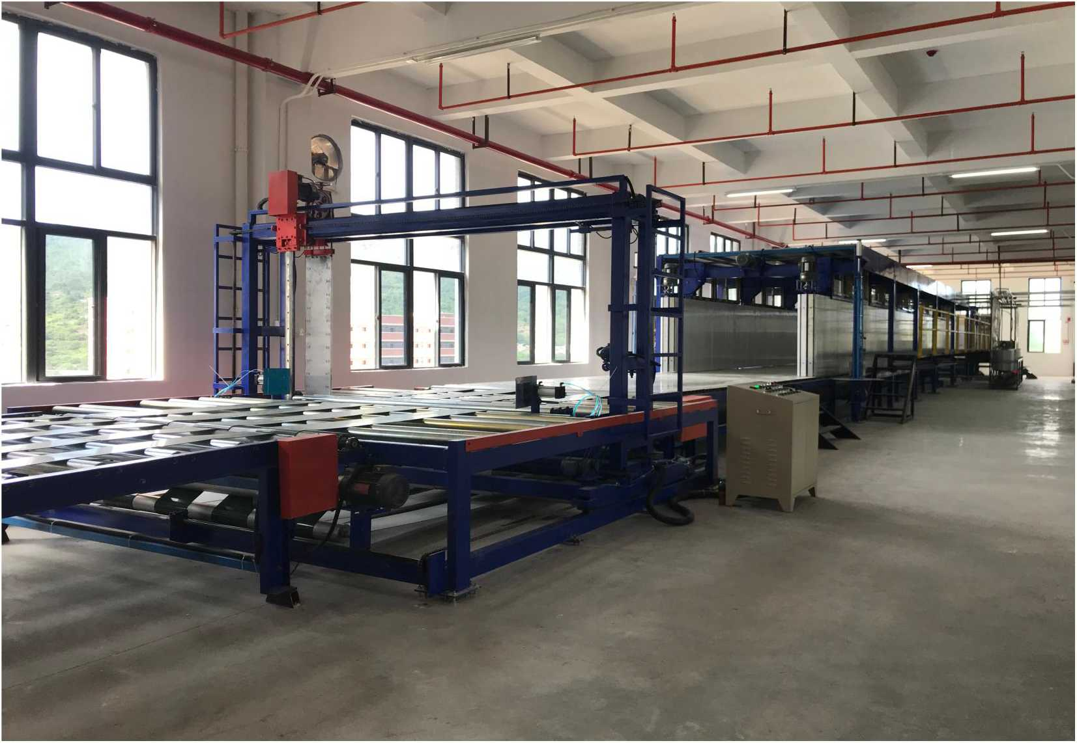
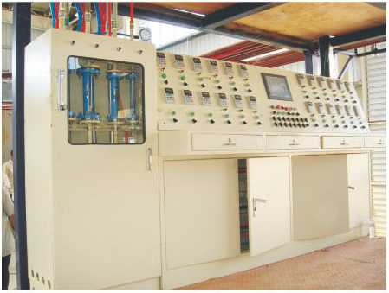
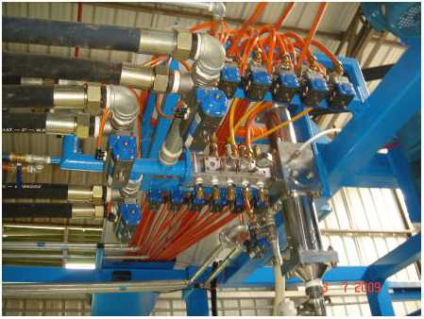
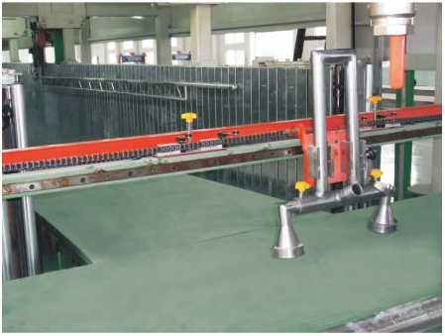
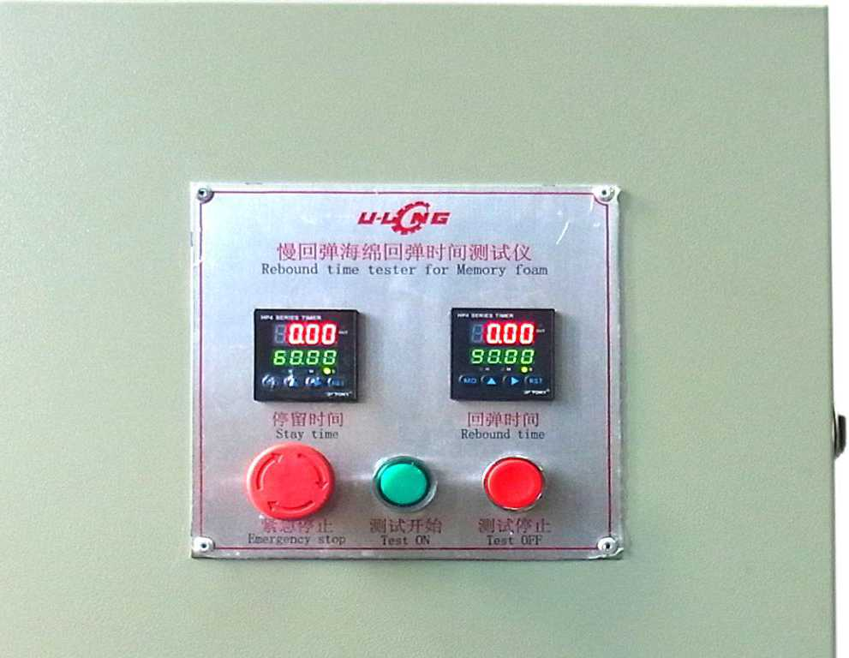
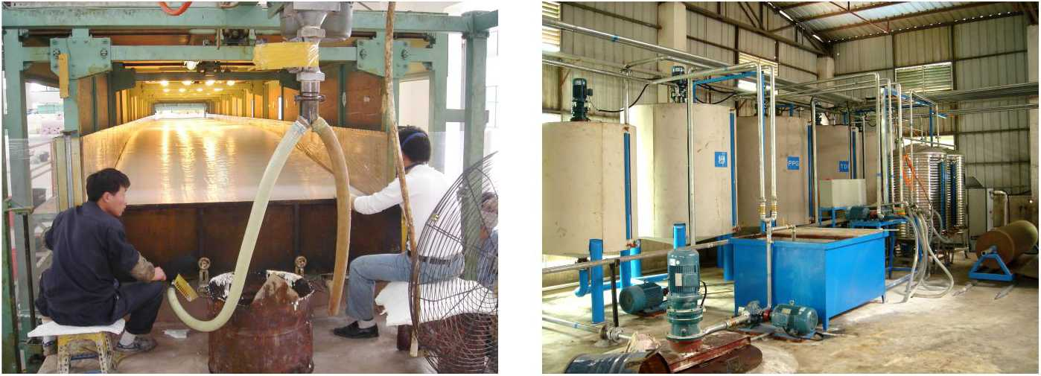
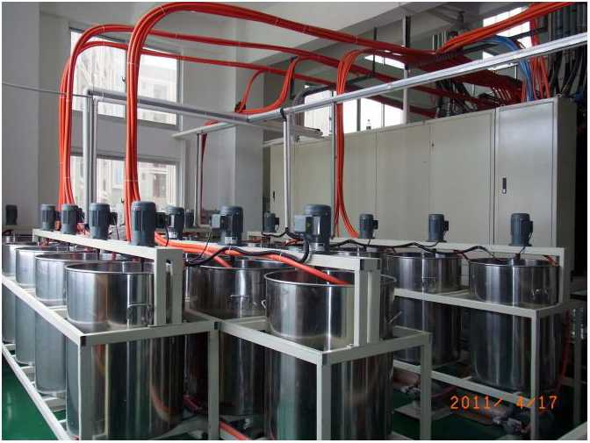
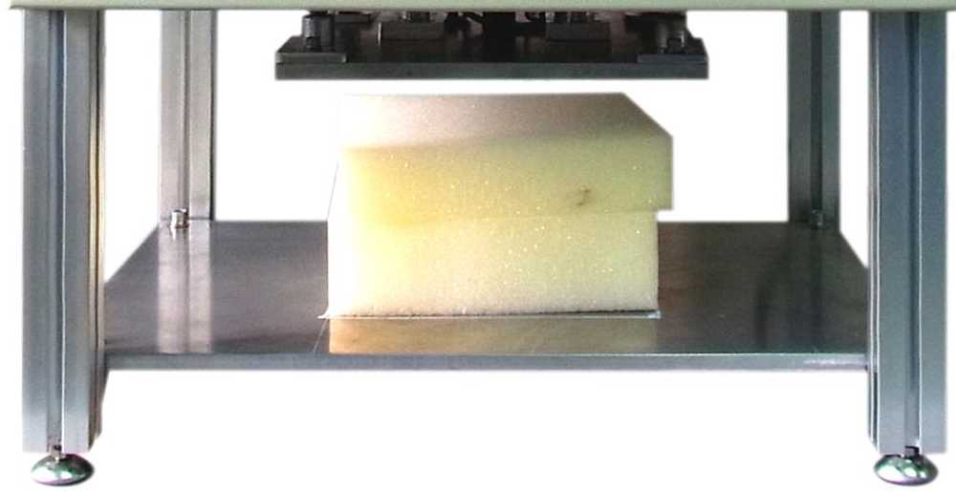
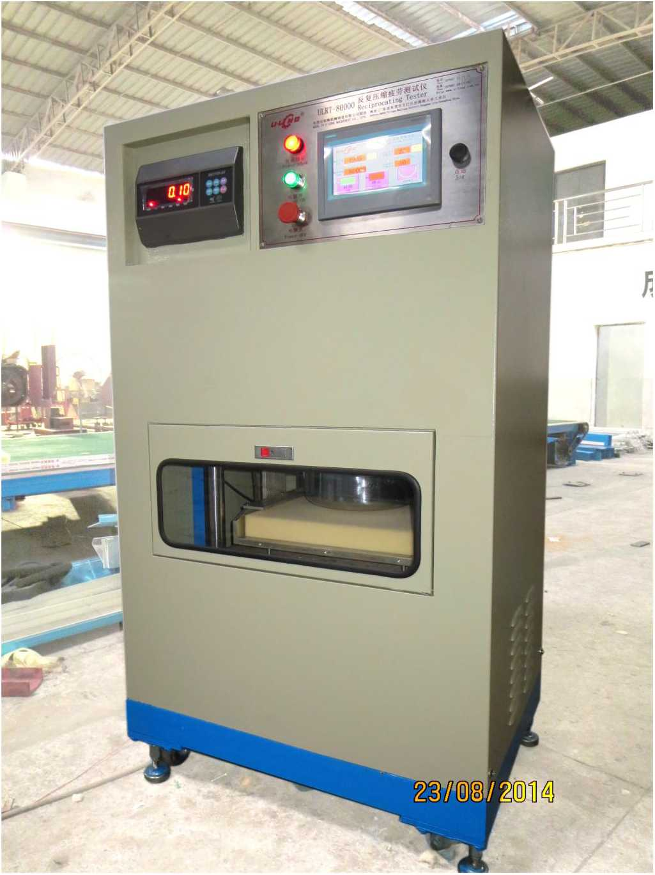

东凳市isBiiiniH制造有IE公司
DongGuan U-Long Machinery Co.,Ltd.

U LJ J"50 海绵搬运夹具(50M) Foam Crane Unit

ULQD-2380
本机主要用于机械连续发泡长海绵的搬运工作，是机械自动发泡的必备配套产品。

海绵切顶机
This machine is mainly used for the handling long foam of mechanical continuous foaming. It is a necessary supporting product for mechanical automatic foaming.

Top Foam Cutting Machine
主要技术参
本机用于在发泡过程中从海绵顶部切开顶皮或从中间水平 对半切开海绵，提高海绵在发泡熟化过程中的散热程度以防止 海绵变黄，是内衣海绵及阻燃海绵生产厂家的必备设备。
This machine is used to cut the foam from the top or middle while foaming to improve the heat dissipation and prevent the foam⁵s yellowing. It is the necessary equipment for the underwear foam and retardant foam manufacturers.
型号 | Model | ULJJ-50 | 总功率 | Total power | 6Kw
可夹泡绵长度 | Foam crane length | 50 M | 机械重量 | Machine weight | 6500Kg
可夹泡绵宽度 | Foam crane width | 1000~2300mm | 机器外形尺寸 | Machine external size | L4600xW2600xH1700mm

主要技术参数：Main Technical Specification
型号 | Model | ULQD-2380
切绵宽度 | Cutting foam width | 2400mm
切绵高度 | Cutting foam height | 1300mm
刀架升降速度 | Blade frame up & down speed | 21m/min
刀带周长 | Blade length | L 8940mm
输送带输送速度 | Conveyor belt speed | 0~8m/min
总功率 | Total power | 5.1 Kw
机器重量 | Machine weight | 1500Kg
机器外形尺寸 | Machine external size | L1500mm x W4550mm x H3000mm

Main Technical Specification

ULQB・2380 发泡线组合切边机 Side Foam Cutting Machine
本机主要用于在发泡过程中对海绵两侧边进行切割，令海绵侧面更光滑平整，散热效果更佳。

ULPU-7000/9800 pu发泡模具转盘 PU Foaming Turntable
This machine is mostly used to cut the two sides of the foam while foaming, to make two sides smoother and have better heat dissipation.
本转盘主要用于PU连续灌注发泡的生产 This machine is mostly used for PU continuously affuse.
-T- f ▲
J
注：以上数据和参数仅供参考，实际技术数据以出厂产品为准。
主要技术参数：
Main Technical Specification
修边宽度 Cutting width | 1000~2380mm
单边切割厚度  Single side cutting thickness | 3~85mm
修边高度  Cutting Height | H1300mm
总功率  Total Power | 2.68Kw
机器重量  Machine weight | 1800Kg
外形尺寸(Machine external size)
L3500xW750xH2660mm

Remark: The above data is only for reference, all the parameter is subjected to the sold production.
注：以上数据和参数仅供参考，实际技术数据以出厂产品为准。
Remark: The above data is only for reference, all the parameter is subjected to the sold production.
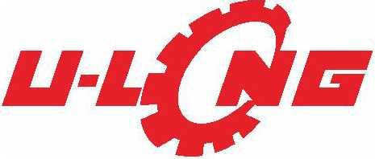

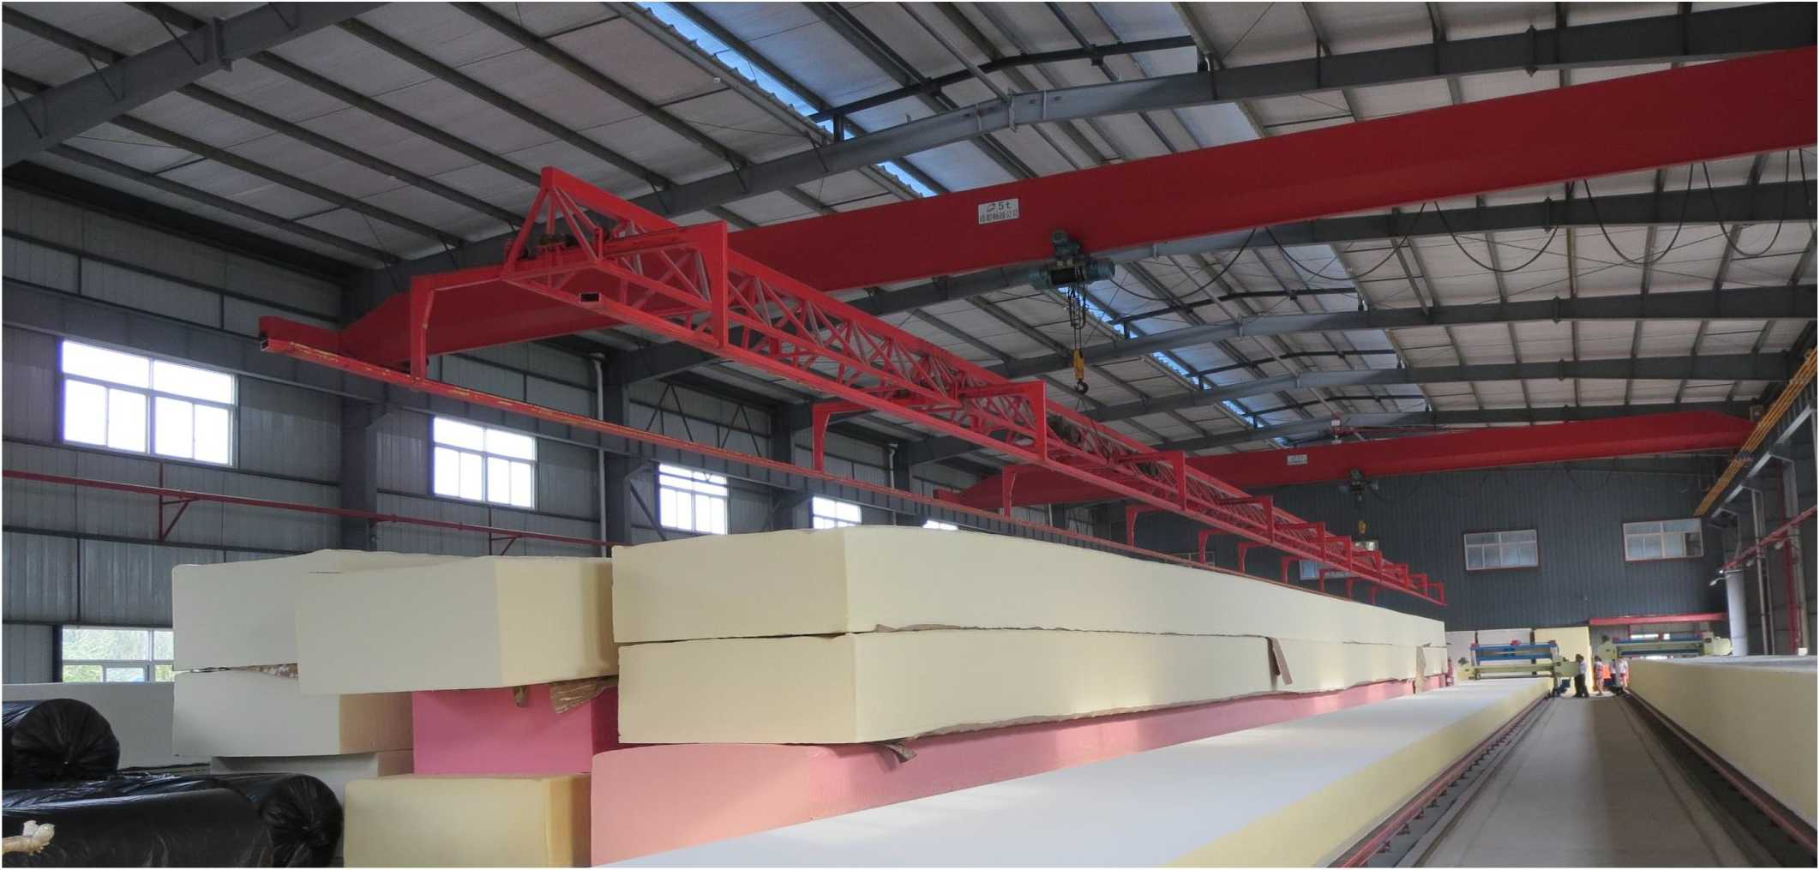

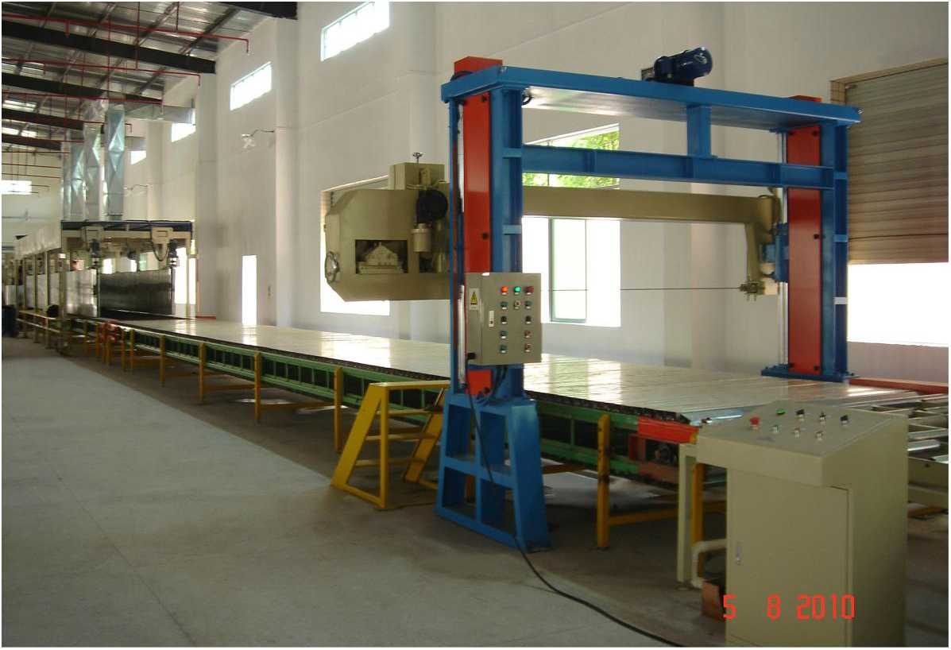
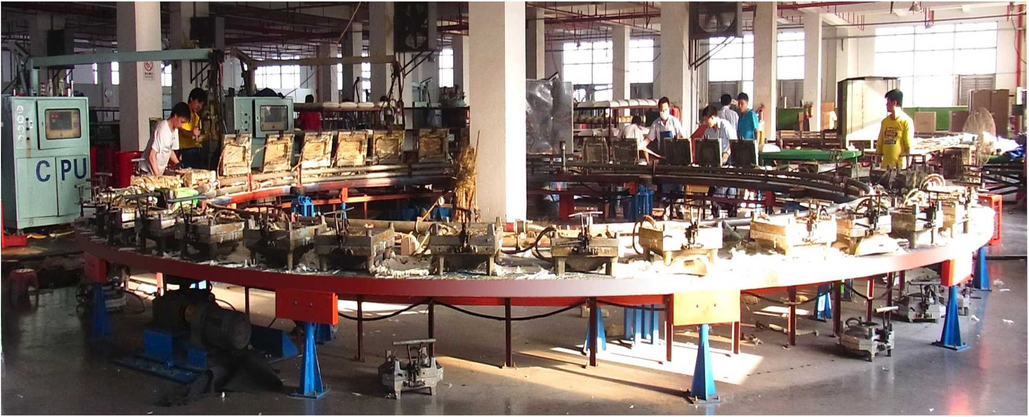
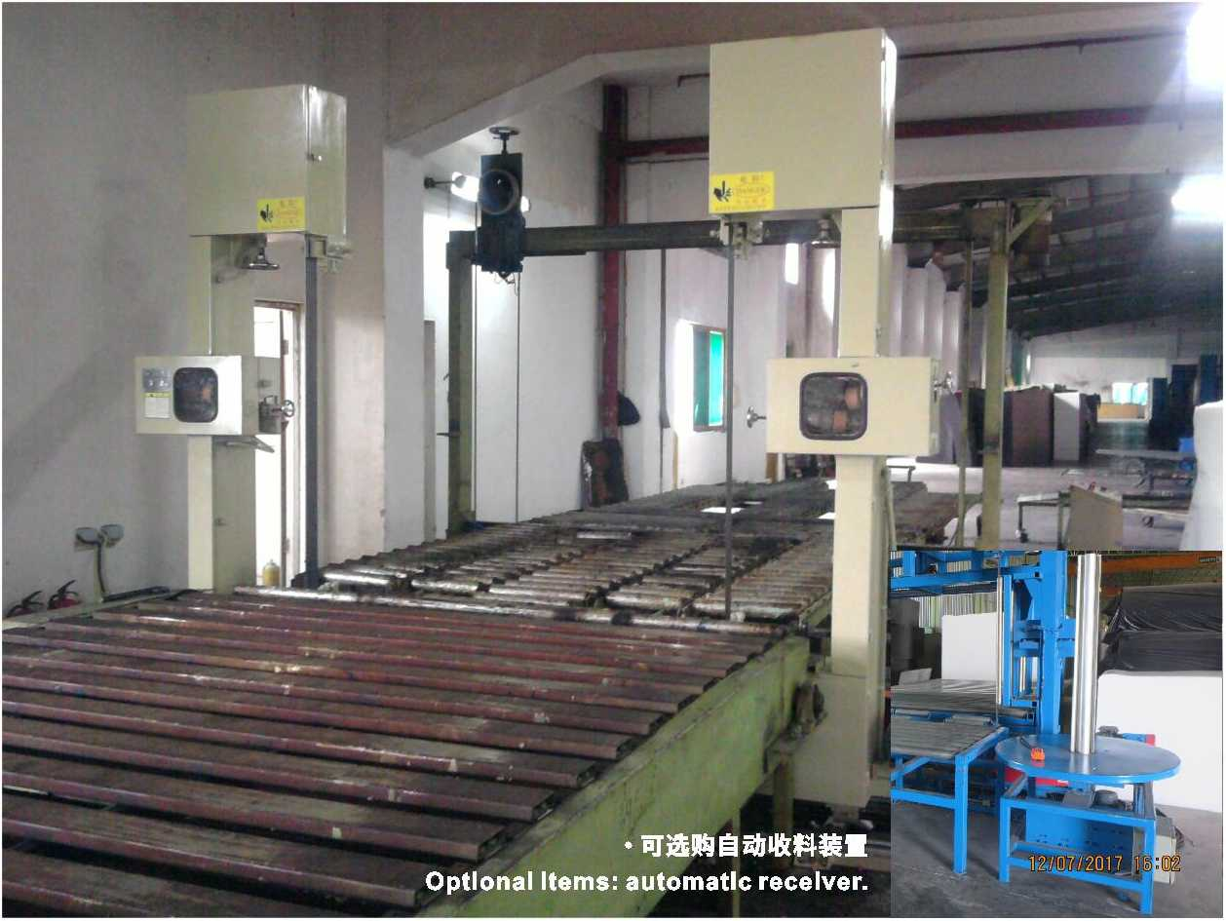

东凳市isBiiiniH制造有IE公司
DongGuan U-Long Machinery Co.,Ltd.

ULCD-2380A

海绵裁断机

Block Foam Cutting Machine
本机器安装在海绵发泡输送线上，主要用于海绵连续发泡 过程中把海绵切割到某种长度，以便运输、储存及加工。这种机 器数字控制，刀带细而且锋利，由上往下切割，切割水平运动 的海绵，该机操作简单，切割精确。
Theblock Cut Machine is installed above the foaming conveyor line, it is used to cut the continuous foam blocks into a certain length for shipping, storage and future processing. It is controlled by digital system, fitted with very thin and sharp blade, which runs vertically in a high speed. The operating is simple while the cutting is accurate.

ULYM-2500B 六做籾

Six Roller Exhaust Pressing Foam Machine
本机采用三组大型滚筒压绵排气，使之其中的闭孔气
体冲破隔膜排出，增加开孔率，令海绵回复原有弹性，是
各种慢回弹海绵制品提高品质的首选设备!
This machine uses three groups of cylinders to compress foam to exhaust, so that the closed-hole gas can break through the barrier and discharge, to increase the opening rate and make the foam return to its original elasticity. It is the preferred equipment for improving the quality of all kinds of slow-resilient foam products.
型号 | Model | ULCD-2380A
切绵宽度 | Cutting foam width | 2400mm
切绵高度 | Cutting foam height | 1300mm
刀架升降速度 | Blade Frame up & down speed | 21m/min
刀带周长 | Blade length | L10940mm
输送带输送速度 | Conveyor belt speed | 0~8m/min
总功率 | Total power | 8.69 Kw
机器重量 | Machine weight | 2000Kg
机器外形尺寸 | Machine external size | L6000mm xW4550mm x H4000mm

ULCD-2380B

海绵横断式裁断机

Transversely Block Foam Cutting Machine
本机器安装在海绵发泡输送线上，主要用于海绵连续 发泡过程中把海绵切割到某种长度，以便运输、储存及加工。
这种机器数字控制，刀带细而且锋利,
由左往右运动，切
割水平运动的海绵，该机操作简单，切割精确。
The machine is installed above the foaming conveyor line.itisusedtocutthecontinuousfoamblocksintoa certain length forshipping, storage and future processing. It is controlled by digital system, fitted with very thin and sharp blade, which runs vertically in a high speed. The operating is simple while the cutting is accurate.
型号 | Model | ULCD-2380B
切绵宽度 | Cutting foam width | 2400mm
切绵高度 | Cutting foam height | 1300mm
刀架移动速度 | Blade Frame moving speed | 21m/min
输送带输送速度 | Conveyor belt speed | 0~8m/min
总功率 | Total power | 8.69 Kw
机器重量 | Machine weight | 2000Kg
机器外形尺寸 | Machine external size | L6000mm xW4550mm x H4000mm

注：以上数据和参数仅供参考，实际技术数据以出厂产品为准。
Remark: The above data is only for reference, all the parameter is subjected to the sold production.
型号 Model | ULYM-2500B

有效压绵尺寸 | Pressing foam size | W2500mm
压绵厚度 | Pressing thickness | 0~650mm
最大速度 | Pressing speed | 45m/min
总功率 | Total power | 17Kw
压辐直径 | Diameter of roller | 巾 270mm
机器重量 | Machine weight | 4500KG
机器外形尺寸 | Machine external size | L4400x W3000x H2000mm

ULYM-2500C十棍排气压绵机（输送带式）噬篇滯惴彳耐叫瞞“m*眼
本机采用三组大型滚筒压绵排气，安装在海绵发泡输 送线上，主要把整泡海绵去除闭孔现象，令海绵增加弹 性，更加柔软，提高海绵质量。
The machine adopts three groups of cylinders to compress foam to exhaust, and is installed above the sponge foaming conveyor line. It mainly removes the closure phenomenon of whole foam, to make the foam more elastic, softer and improves the quality of foam.
型号 | Model | ULYM-2500C
有效压绵尺寸 | Pressing foam size | W2500mm
压绵厚度 | Pressing thickness | 25~1400mm
最大速度 | Pressing speed | 45m/min
总功率 | Total power | 41.9Kw
压辐直径 | Diameter of roller | 巾 300mm
机器重量 | Machine weight | 7500KG
机器外形尺寸 | Machine external size | L10130xW2100x H3000mm

注：以上数据和参数仅供参考，实际技术数据以出厂产品为准。
Remark: The above data is only for reference, all the parameter is subjected to the sold production.

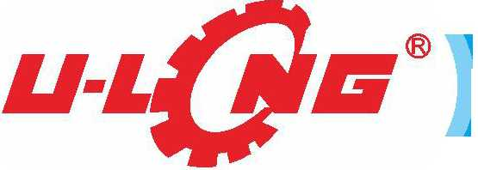
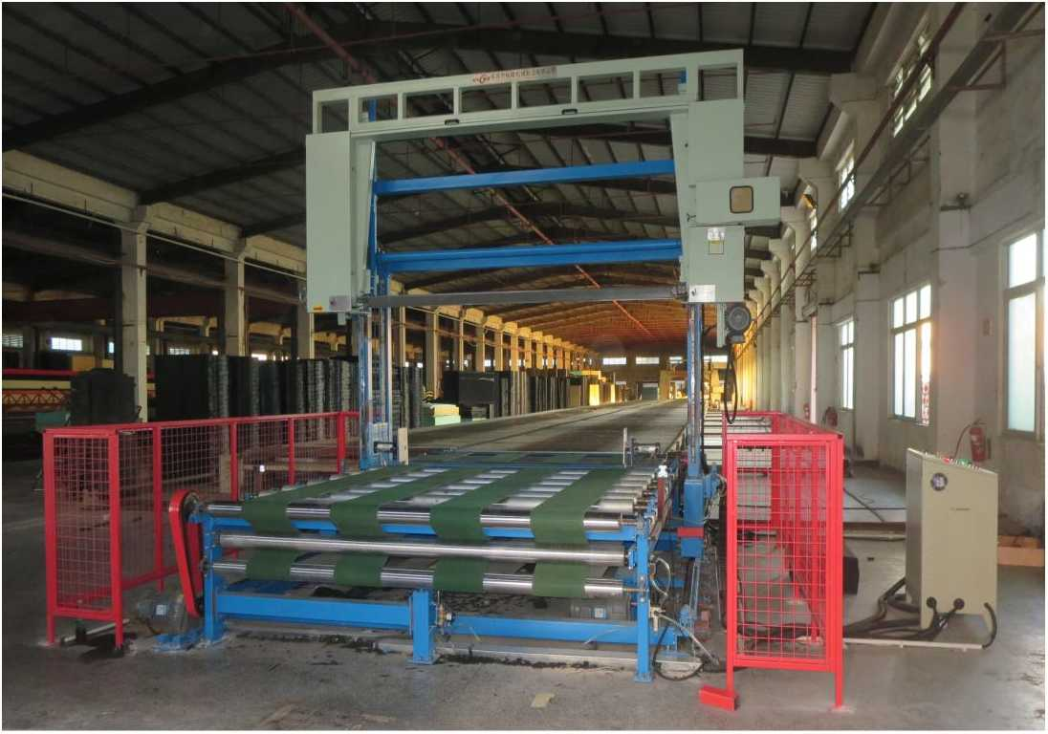
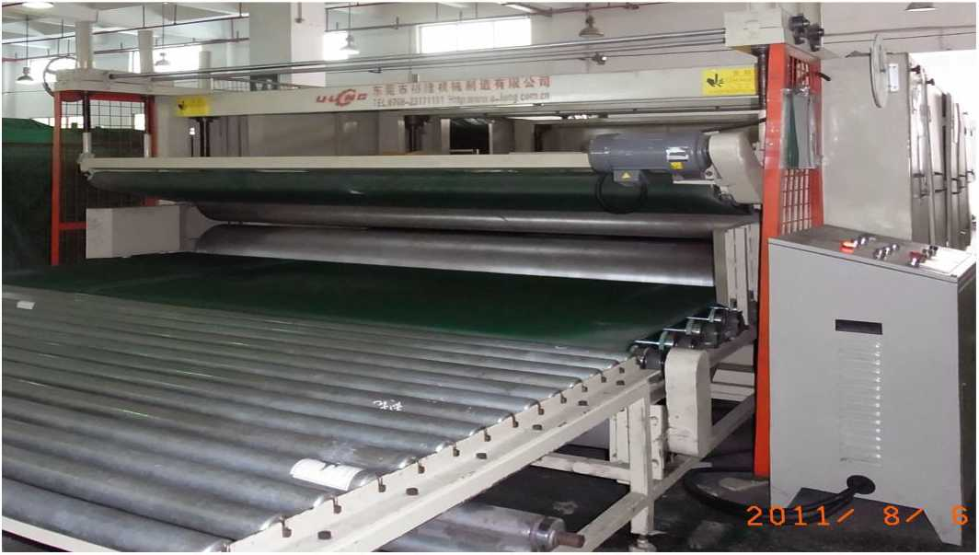
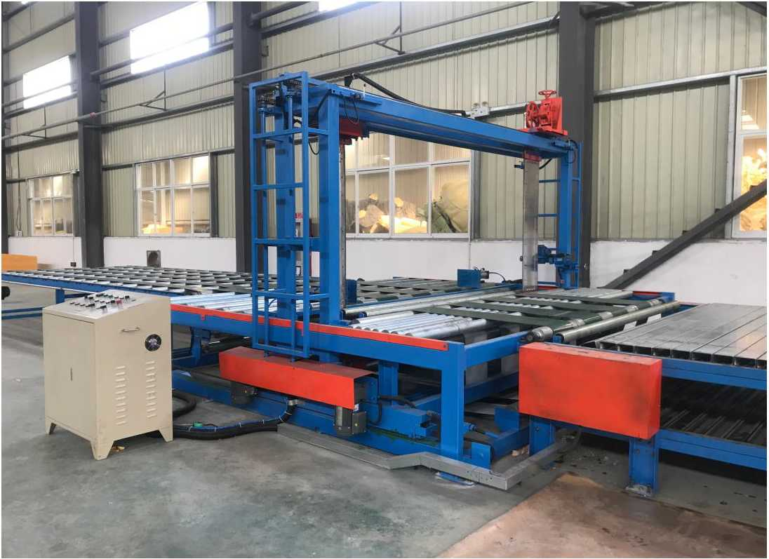
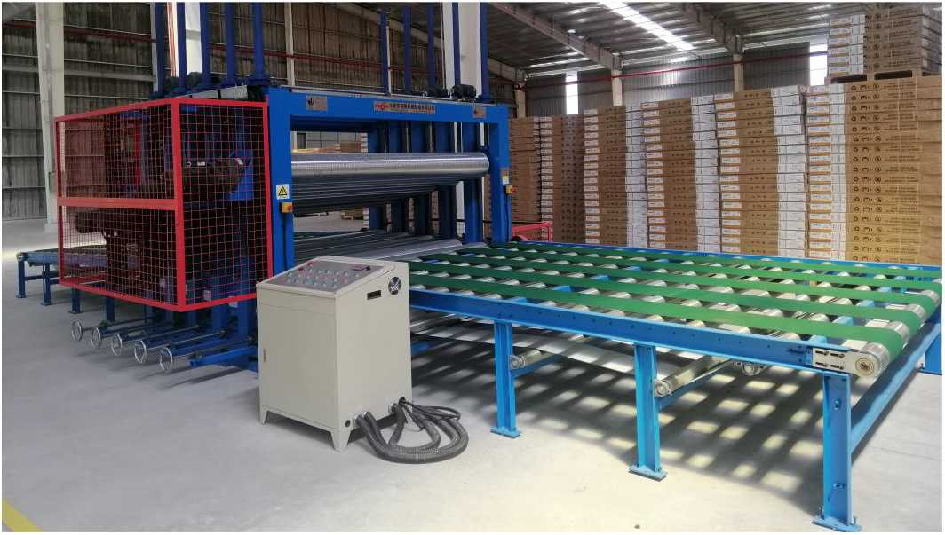

东凳市isBiiiniH制造有IE公司
DongGuan U-Long Machinery Co.,Ltd.

ULYM-A/B/C 排气压绵机 Exhaust Pressing Foam Machine
主要把闭孔海绵经过压缩排气后去除闭孔现象，使海绵的质量更好。
ULTS-2380

海绵连续生产线侧纸提升装置
This machine is mainly used to remove closure after compressed exhausting for the better-quality foam.

ULYM-1650/2150A型 排气压绵机（两辐）
ULYM-1650/2150AS排气压绵机(两辐)
Exhaust Pressing Foam Machine (Two Roller)
型号Model | ULYM-1650A | ULYM-2150A
可压绵尺寸 Pressing foam size | W1650mm | W2150mm
压绵厚度  Pressing thickness | 0~200mm | 0-200mm
压绵速度 Pressing speed | 0~60m/min | 0~60m/min
总功率  Total power | 1.5Kw | 1.5Kw
机器重量 Machine weight | 1200Kg | 1500Kg
机器外形尺寸 Machine external size | L3050xW1300xH1350mm | L3550xW1300xH1350mm

主要技术参数：Main Technical Specification
Block Squaring Equipment
ULCF-11
本装置主要功能是在海绵发泡生产过程中通 过提升烘道两侧边膜，以达到提高海绵的两边高度, 取得平整的海绵顶部，大幅提高海绵发泡的成品率。
This device is used to upgrade the bilateral edge membrane of drying channels while foaming to improve the side height and make the top of the foam smooth to boost success rate of foaming.

自动箱式发泡机

ULYM-1650/2150B型排气压绵机（四辗/六辗）
ULYM-1650/2150B型 排气压绵机(

Batch Foaming Machine
辐/六視）
Exhaust Pressing Foam Machine (Four/Six Roller)
型号Model | ULYM-1650B | ULYM-2150B
可压绵尺寸 Pressing foam size | W1650mm | W2150mm
压绵厚度  Pressing thickness | 0~250mm | 0~250mm
压绵速度  Pressing speed | 0~60m/min | 0~60m/min
总功率  Total power | 4Kw | 4Kw
机器重量 Machine weight | 2500Kg | 3000Kg
机器外形尺寸 Machine external size | L5100xW3000xH1900mm | L3500xW3500xH1900mm

主要技术参数：Main Technical Specification
本机采用自动移动式搅拌系统,配备下 料自动计量系统，配料准确，操作简单，生产 效率及海绵质量大为提高。
This machine adopts Automatic Mobile Stirring System, equipped with Automatic Metering System, which ensures simpler operation, more accurate blending, higher production efficiency and better quality.
主要技术参数：Main Technical Specification
发泡模具尺寸  组份  发泡高度  发泡密度  最大吐量 搅拌头功率 | Foaming moulding size Component  Foaming height  Foaming density  Total output Mixing-head power | L3000xW2000mm  3  1200m  8-100Kg/m³  250Kg  11-15Kw
总功率 | Total power | 30Kw
主机外形尺寸 | Main machine external size | L3500xW1500xH3500mm

ULYM-C型 排气压绵机（整泡）
ULYM-C型排气压绵机(整泡)
Exhaust Pressing Foam Machine (Whole Block)
型号 | Model | ULYM-C
压绵尺寸 | Pressing foam size | W2000 x L3000mm
最大行程 | Treading distance max | 1400mm
最大压力 | Pressing max | 80T
最大速度 | Pressing speed | 60mm/sec
总功率 | Total power | 20Kw
机器重量 | Machine weight | 5500Kg
机器外形尺寸 | Machine external size | L10000xW2700xH4500mm

主要技术参数：Main Technical Specification
注：以上数据和参数仅供参考，实际技术数据以出厂产品为准。
ULCF-11/15 自动箱
东莞市裕隆机械制造有限公司i
地，止:广东省东莞市万江区汾溪路
ADD:DaFen Village.Viuijituig District.Itons
Batch Foaming Machine
NERY
A me,
PPG
Remark: The above data is only for reference, all the parameter is subjected to the sold production.
注：以上数据和参数仅供参考，实际技术数据以出厂产品为准。
Remark: The above data is only for reference, all the parameter is subjected to the sold production.
■如。■
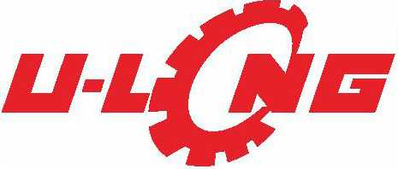

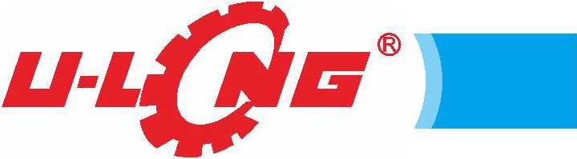
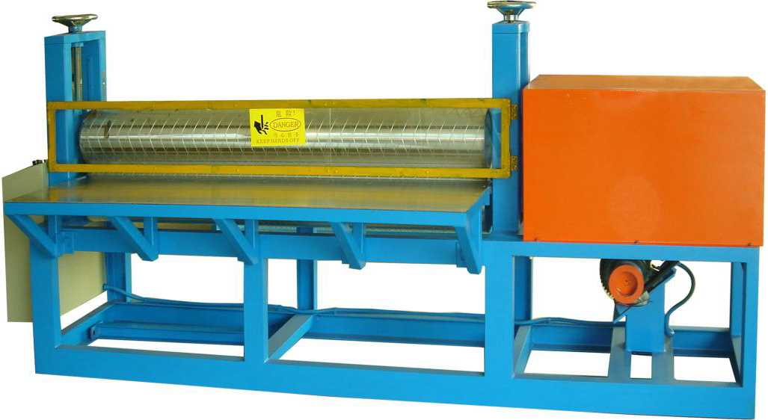
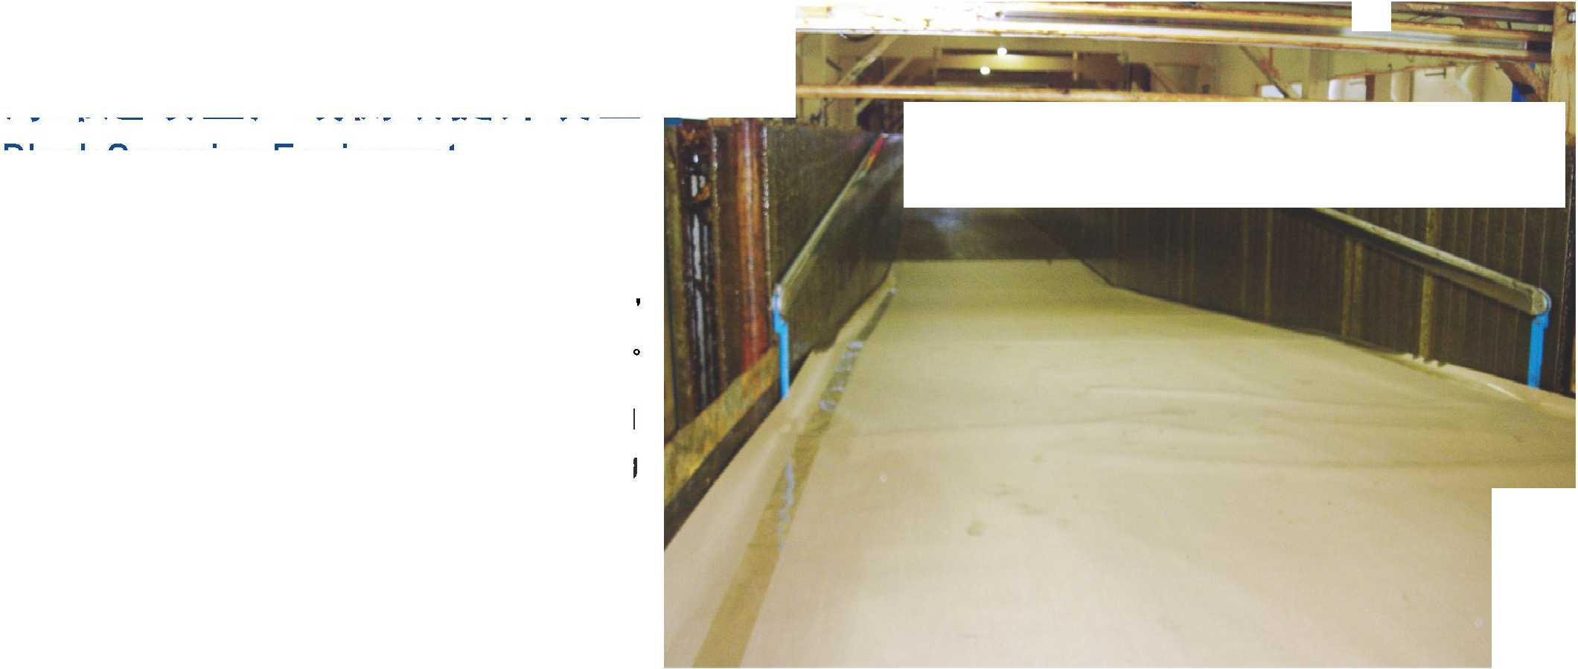
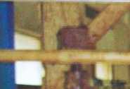
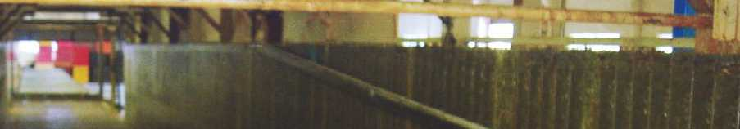
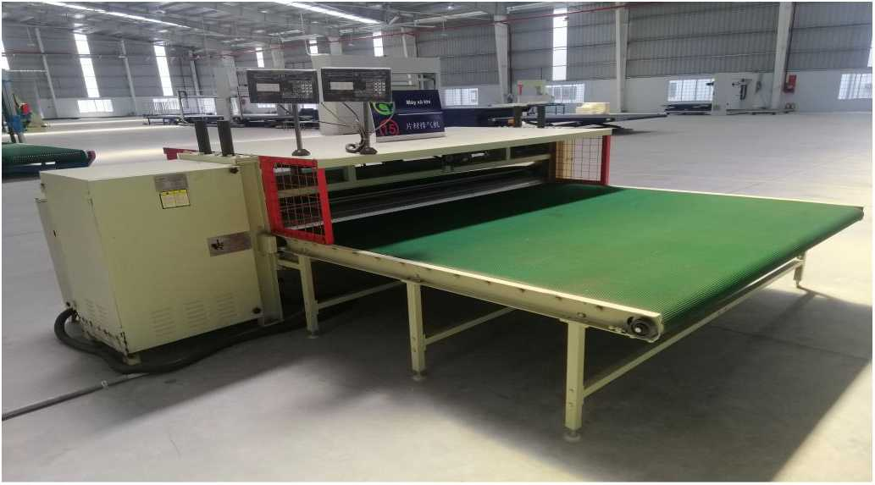
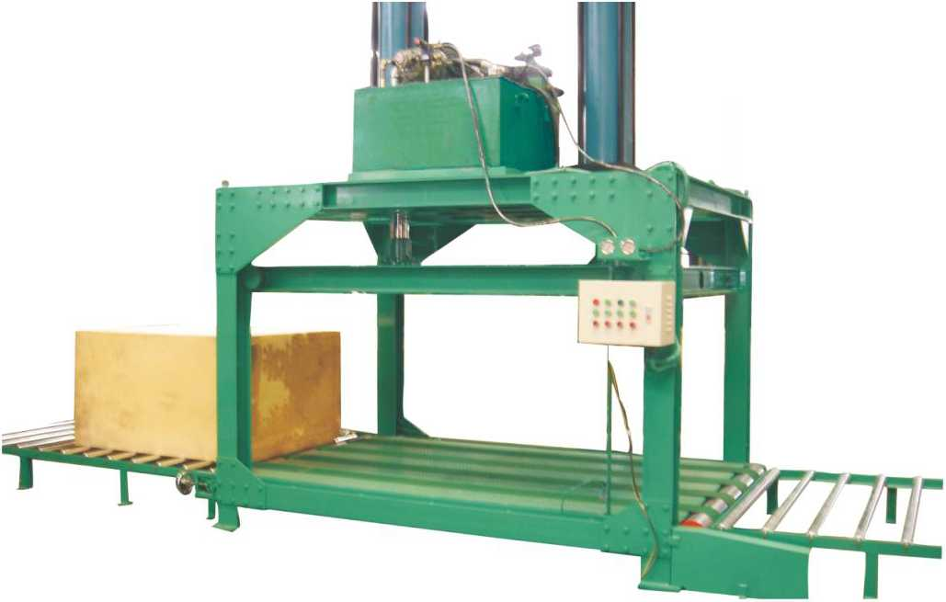
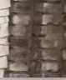
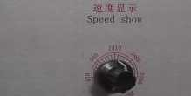
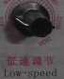
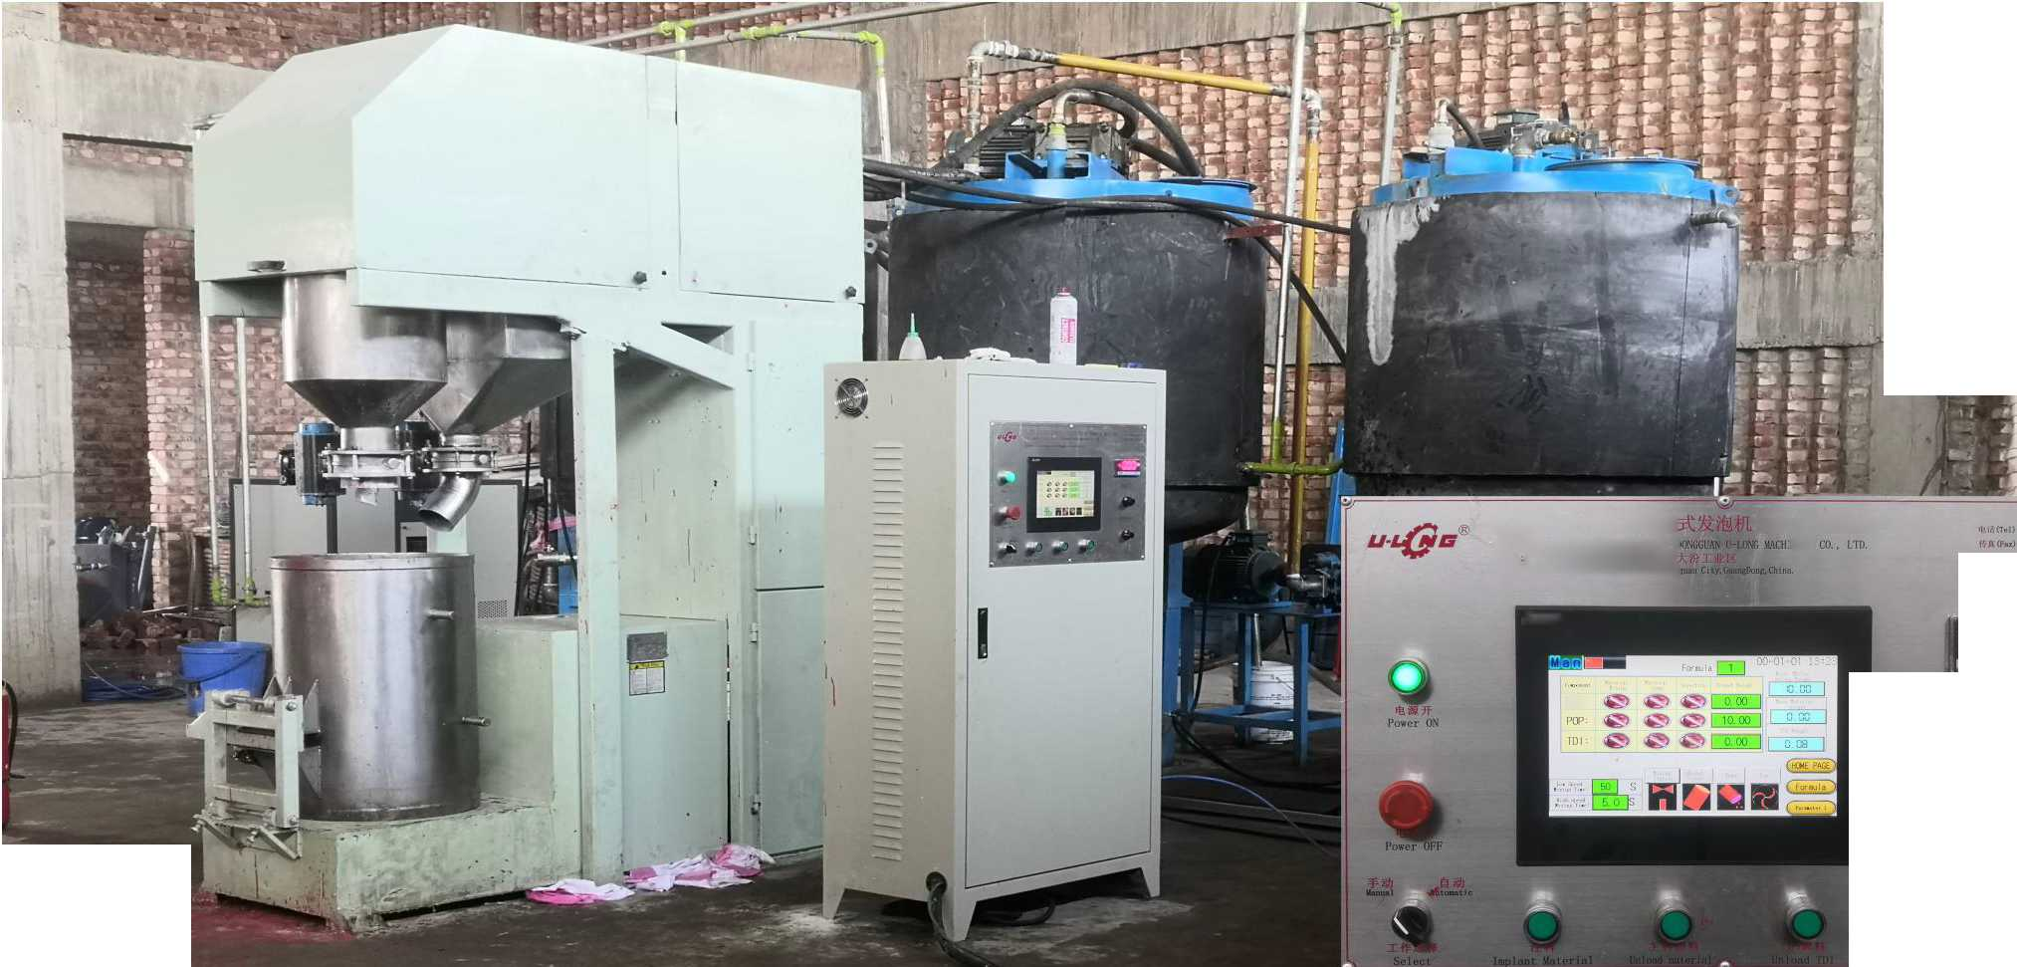

东凳市isBiiiniH制造有限公司
DongGuan U-Long Machinery Co.,Ltd.

ULBF-11/15A
ULJH-1650/2150/2350

手动卧式发泡机

海绵接合机

Seated Foaming Machine (Manual Operation)

Foam Jointing Machine
主要用途：Main Usage
本机采用电子变频调速器控制，搅拌加速快，带有电子减速刹车，搅拌均匀，操作简便，是小批量生产海绵的首选设备。
This machine adopts electronic frequency converter speed regulator control and stir fast and well with electronic brake.
It is the first choice for small-scale foam producing.
主要技术参数：Main Technical Specification
本机主要用于卷绵的接头接合工作, 再配合卷料打码机，以适合客户不同长 度要求的卷绵生产工作。
型号Model | ULBF-11A | ULBF-15A
总功率  Total power | 11Kw | 15Kw
最大发泡量  Foaming output (maximum) | 150Kg | 180Kg
搅拌最高转速  Mixing speed (maximum) | 0-2800r/min | 0-2800r/min
机器重量  Machine weight | 700Kg | 800Kg
发泡桶配置  （（I）450mm,。500mm, 4）550mm） | Foaming-bucket 2PCS
机器外形尺寸（长X宽X高）  Machine external size | L1250xW650xH1100mm

This machine is mainly used for the joining of coiled foam, and then with the coiled material typewriter, to meet the requirements of different lengths of coiled foam production of customers.
型号 Model | ULJH-1650 | ULJH-2150 | ULJH-2350

主要技术参数：Main Technical Specification
最大接合宽度 | Joint width (max) | W1650mm | W2150mm | W2350mm
最大接合厚度 | Joint Thickness(max) | 0~20mm | 0-20mm | 0~20mm
总功率 | Total power | 2Kw | 2Kw | 2Kw
机器重量 | Machine weight | 650Kg | 750Kg | 800 Kg
机器外形尺寸 | Machine external size | L2570 x W1000 x H1500mm | L3070 xW1000xH1500mm | L3070 xW1000xH1500mm

ULBF-11/15B

手动立式发泡机

Vertical Foaming Machine (Manual Operation)
型号 Model | ULBF-11B | ULBF-15B
总功率 Total power | 11Kw | 15Kw
最大发泡量  Foaming output (maximum) | 150Kg | 180Kg
搅拌最高转速  Mixing speed (maximum) | 0-2800r/min | 0-2800r/min
机器重量  Machine weight | 950Kg | 1050Kg
发泡桶配置  （巾 450mm,巾 500mm,（|）550mm） | Foaming-bucket 2PCS | Foaming-bucket 2PGS
机器外形尺寸（长X宽X高）  Machine external size | L1380xW940xH3050mm

主要技术参数：Main Technical Specification
ULJM-1650/2150/2350

卷料计码机

Beat-code Machine
本机主要用途是将各种面料包括海绵、布料等, 经计码后重新卷好为成品。可选配自动对边功能装 置,卷绵更整齐，效率更高。
i：i
This machine is mainly used for rolling up again as finished products of all kinds of fabrics, including foams, cloth, etc. Automatic side-to-side function device is for your option, coil more steam, with tidier coiling and higher efficiency.
型号Model | ULJM-1650 | ULJM-2150 | ULJM-2350
最大卷料宽度  Reel material width(max) | W1650mm | W2150mm | W2350mm
卷料速度  Reel material speed | 50m/min
总功率  Total power | 0.75KW
机器重量  Machine weight | 950Kg | 1000Kg | 1100Kg
机器外形尺寸  Machine external size | L2500xW830xH1500mm | L3000xW830xH1430mm | L3200xW830xH1430mm

主要技术参数：Main Technical Specification
注：以上数据和参数仅供参考，实际技术数据以出厂产品为准。
Remark: The above data is only for reference, all the parameter is subjected to the sold production.
注：以上数据和参数仅供参考，实际技术数据以出厂产品为准。
Remark: The above data is only for reference, all the parameter is subjected to the sold production.


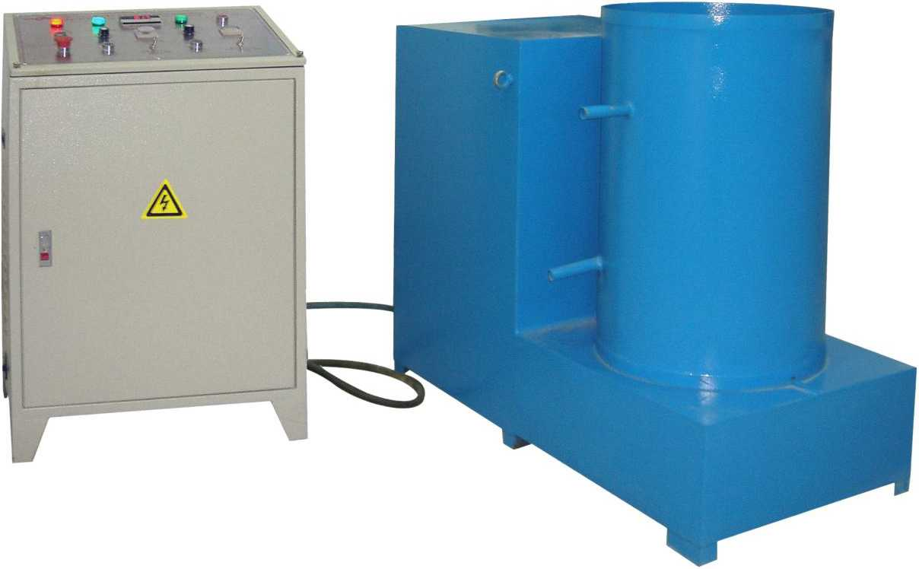
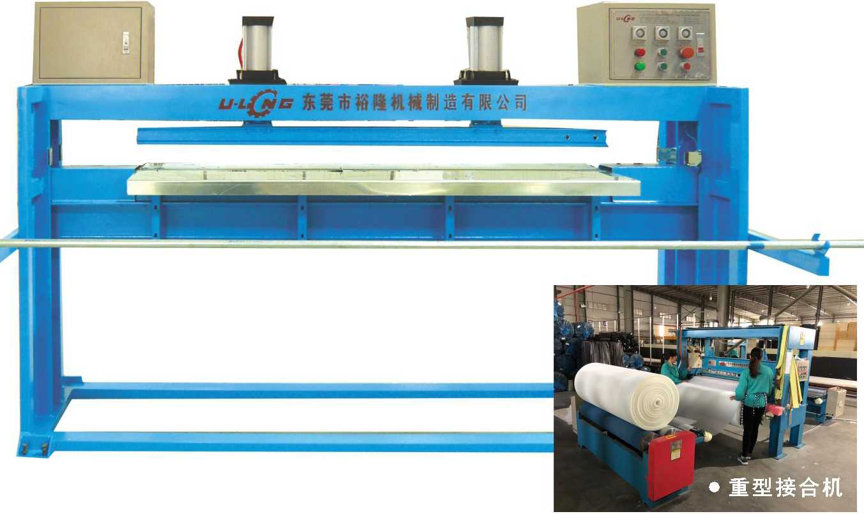
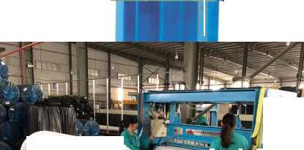
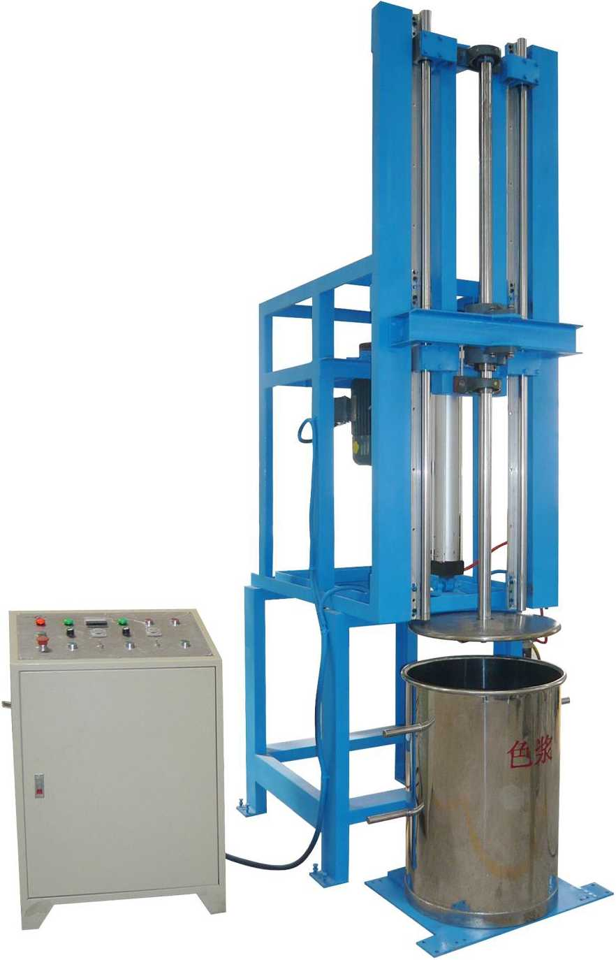
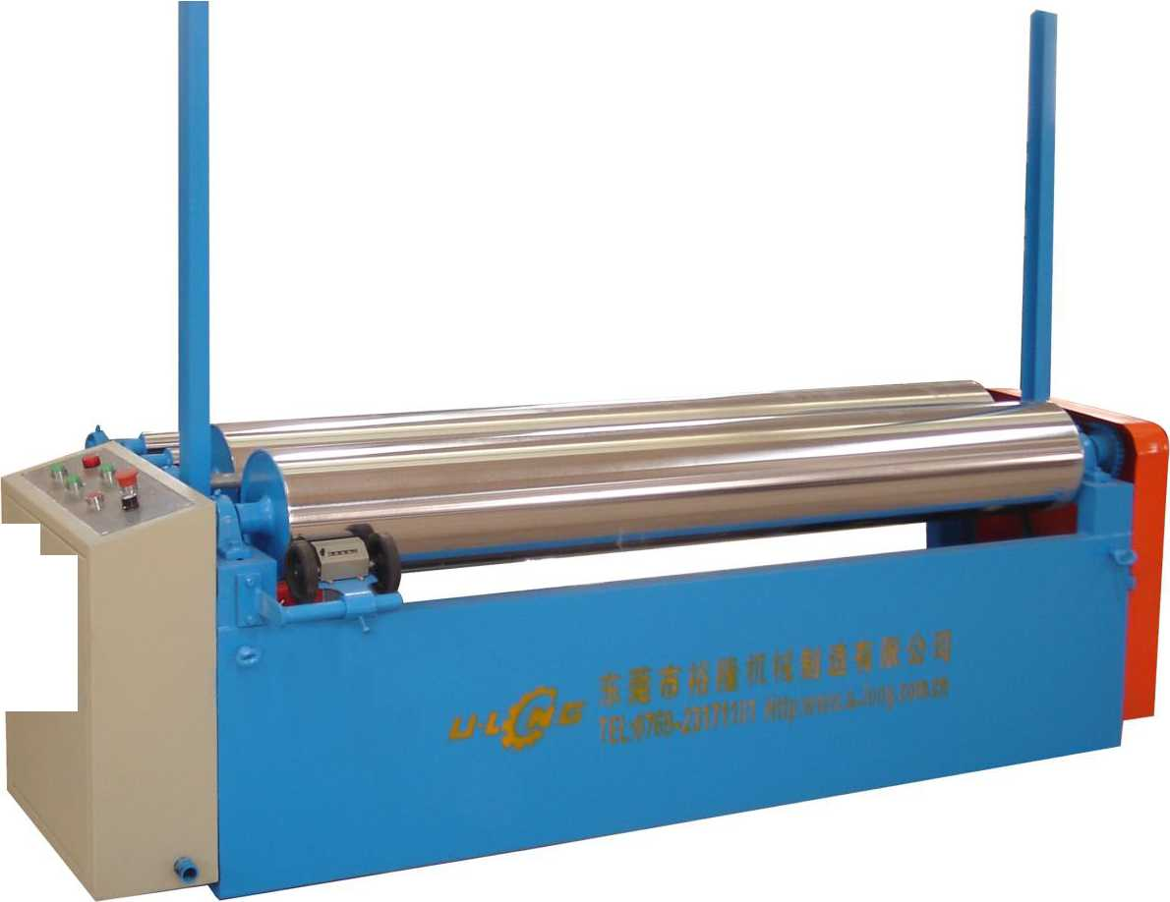
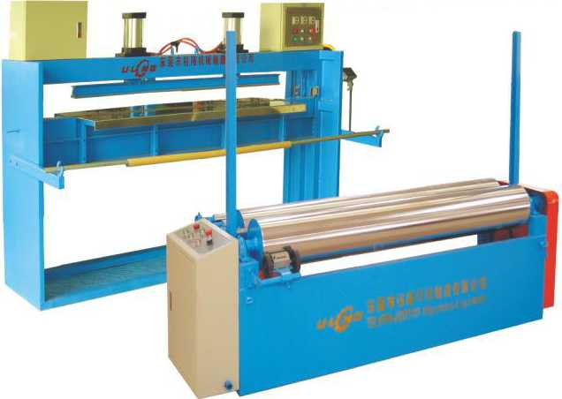

东凳市isBiiiniH制造有限公司
DongGuan U-Long Machinery Co.,Ltd.

ULSJ-1250/1650/2150 上胶机Gelatinizing Machine
海绵方型及圆型模具
&JI
本上胶机主要用途是将强力胶水通过高精密度的滚筒，均匀地涂在各种面料上，并进行贴合，适用于各类海绵、布料、皮革、无纺布、 塑胶板等各种面料。

Foam Block Moulding #
This machine is mostly used in besmearing strong adhesive equally on all kinds effacing through exact density platen, and progress jointing.
It is be same with all kinds of foam rubber、cloth> leather、 nonspuncloth> plastic board etc.
MODEL F-1#
型号Model | ULSJ-1250 | ULSJ-1650 | ULSJ-2150
最大加工宽度 Processing width (max) | 1250mm | 1650mm | 2150mm
最大加工厚度 Processing thickness(max) | 1-200mm | 1-200mm | 1-200mm
总功率  Total power | 1.15Kw | 1.15Kw | 1.15Kw
机器重量 Machine weight | 800Kg | 950Kg | 1200Kg
机器外形尺寸  Machine external size | L2100xW750xH1300mm | L2500xW750xH1300mm | L2500xW750xH1300mm

主要技术参数：Main Technical Specification

ULMP-2150 Machine
气动自动方模
型号Model | Model F-1#
发泡长度 Foaming length | L2000*3050mm 可调(Adjustable)
发泡宽度  Foaming width | W1000~205Gmm 可调(Adjustable)
发泡高度  Foaming height | H1200mm

Automatic pneumatic foaming moulding#
Model F-1#气动自动方模
(Automatic pneumatic foaming moulding#)
本机主要用热合原理，将床垫用塑料薄膜进行封口包装。同时配有可升降旋转工作台、当完成一边的封口后，可轻松、准确地
将床垫旋转90。、180。、270。来实现其它边的封合。操作简便，生产效率高。
MODEL F-2#
木制手动方模
Manual foaming moulding#
主要技术参数：Main Technical Specification
包装宽度  Packing width | 2150mm
电热功率  Heating power | 2kw
工作气压  Working pressure | 0.8Mpa
外型尺寸  Outer size | 2300mm(L)x2500mm(w)x1440mm(h)

This machine is adopt the heat sealing principle to seal the PVC for mattress, pillow as such material. IVs with turning working table, you can turn 90\ 180% 270° to seal the different side of the mattress.
型号Model | Model F-2#
发泡长度  Foaming length | L2000-3050mm 固定尺寸(Fixed size)
发泡宽度  Foaming width | W1000~2050mm 固定尺寸(Fixed size)
发泡高度  Foaming height | H1200mm

(Manual foaming moulding#)

ULCV-2100 SS_{Fil},_{ing} Machine
MODEL Y-1#
1:1
主要技术参数：Main Technical Specification
最大宽度Max.width | 2100mm 可调(Adjustable)
床垫高度 Mattress height | 100-270mm 可调(Adjustable)
装袋速度Filling speed | 22m/min
电机功率Power | 1.2KW

本机主要用于套装床垫面袋。操作方便，生产效率高。
This machine is used for filling the cover of foam mattress. It is easy control.
注：以上数据和参数仅供参考，实际技术数据以出厂产品为准。
手动圆模
Manual circular foaming moulding#
主要技术参数：
Main Technical Specification
发泡尺寸Foaming size
巾 1600xH1800MM
Remark: The above data is only for reference, all the parameter is subjected to the sold production.
注：以上数据和参数仅供参考，实际技术数据以出厂产品为准。
Remark: The above data is only for reference, all the parameter is subjected to the sold production.


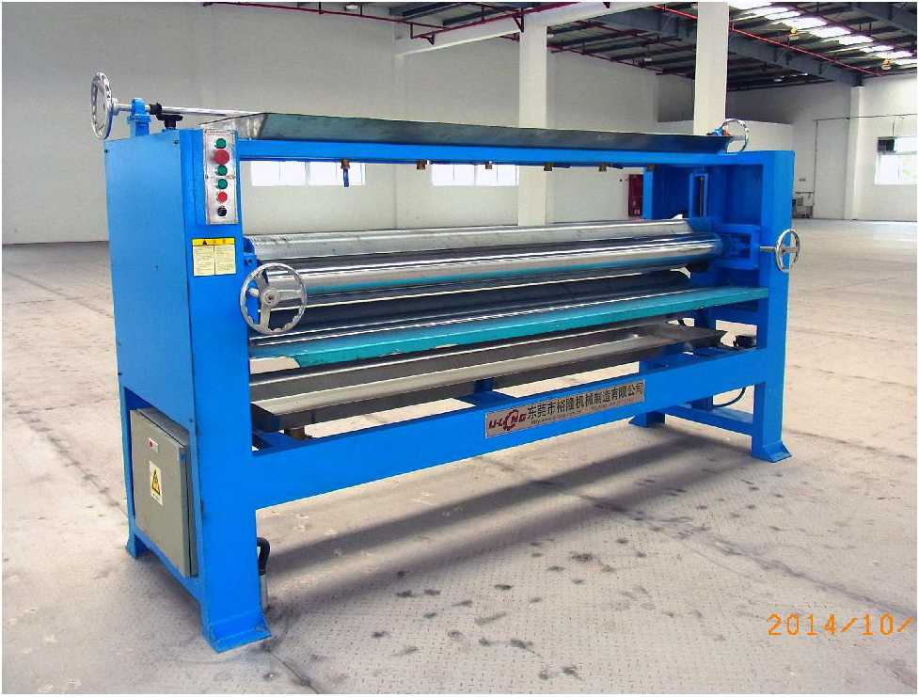
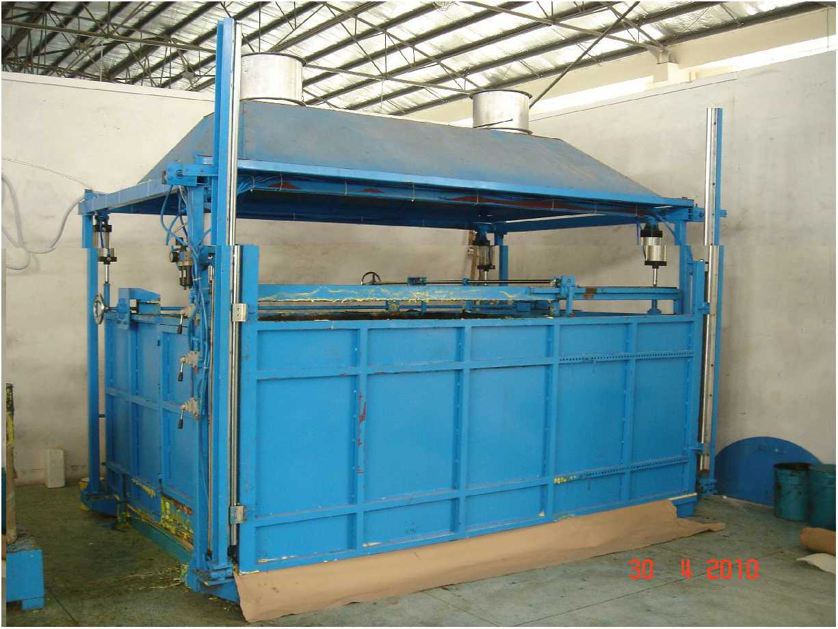
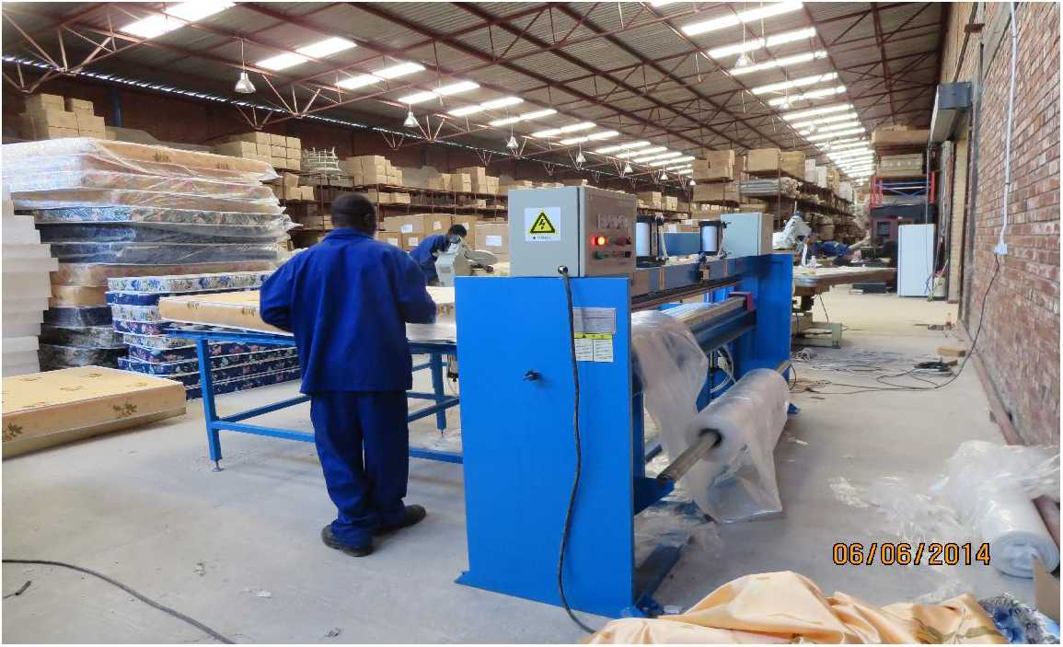
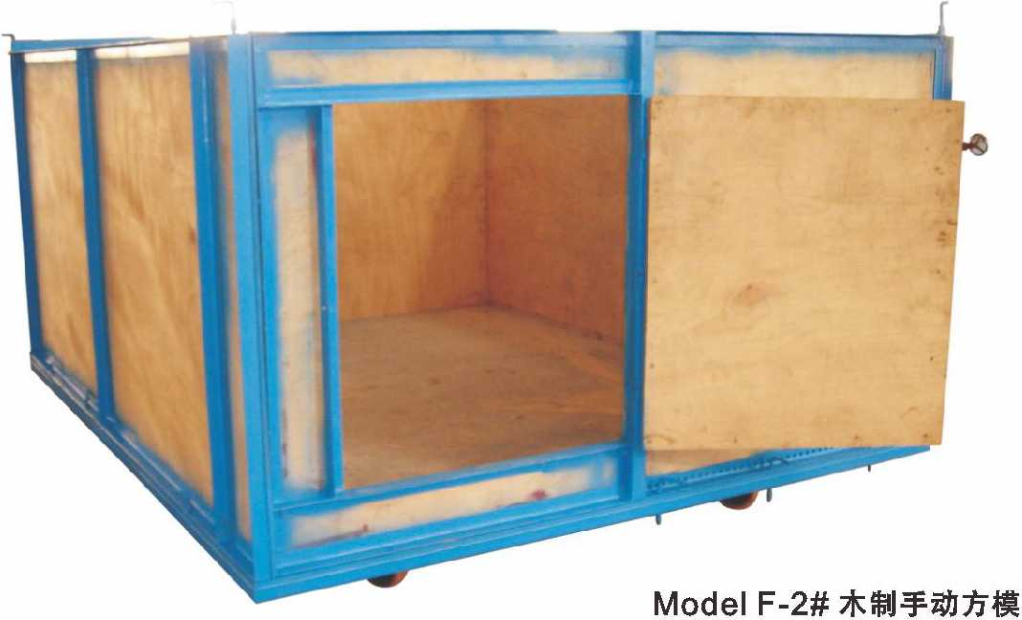
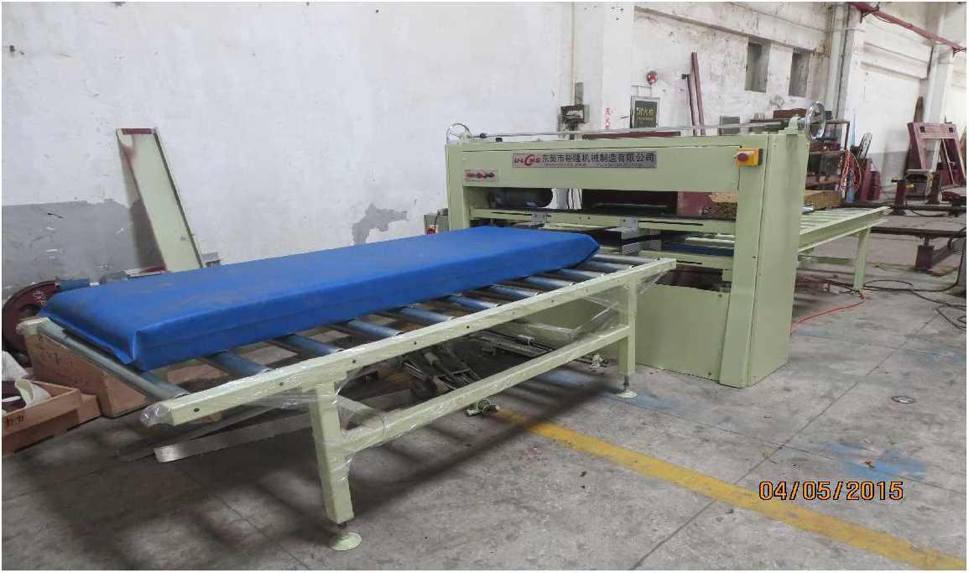
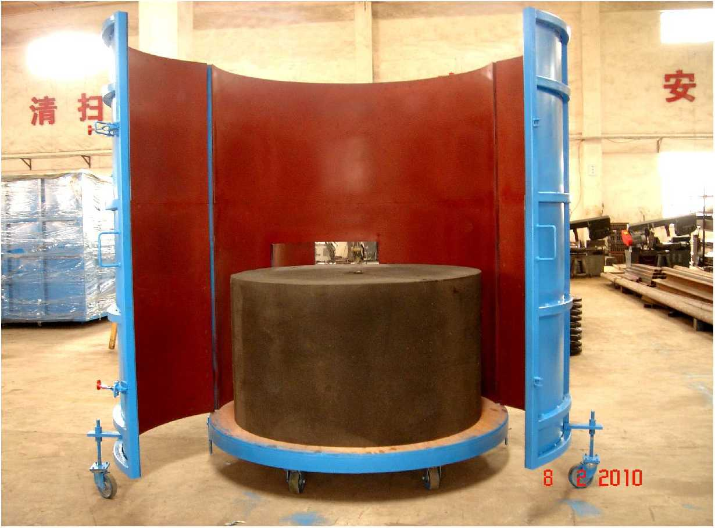

东凳市isBiiiniH制造有限公司
DongGuan U-Long Machinery Co.,Ltd.

ULLG-1650/2150/2350

ULFS-30A

海绵轨道平切机 Long Sheet Foam Cutting Machine

海绵粉碎机
KT

Foam Crushing Machine
15KG8米高强度钢轨一次加工成型
15KG Smeterrail process in one-time
本机主要用于海绵边角料 等粉碎后再回收利用，与再生搅 拌机配套做成再生海绵，本机 功率强大，出风力强，生产效 率极高。
重型自动收料装置
This machine used for chipping edge & comer foam blocks and also reclaiming is utilized, with re-bonding machine to come into bonded foam. The chipping system is using special bullet type of crushing teeth which ensure perfect even foam crushed flocks.
双驱动装置
Double Driving Devices
轻型自动收料装置
Simple Automatic Receiver
Strong Automatic Receiver
主要用途：Main Usage
本机主要用于连续方泡海绵（50米）的无限长切片工作，本机占地面积小，操作方便，生产效率高，是连续发泡生
产厂家的必须配套设备（本机可选配自动收料装置，效率更高。）本机可以选配钢支架固定式平台，能够有效的增加
海绵与平台的摩擦力，大力改良切割的质量,提高海绵的利用率。
This machine is mostly used to 50m foam blocks slicing, with small footprint, simple operation and high production efficiency. It | 型号Model | ULLG-1650 | ULLG-2150 | ULLG-2350
 | 可切海绵宽度  Cutting foam width | W1650mm | W2150mm | W2350mm
 | 可切海绵高度  Cutting foam height | H1250mm | H1250mm | H1250mm
is the necessary equipment for continuous foaming manufacturers. (automatic feeding device is optional, | 切片厚度  Cutting thickness | 2~60mm | 2~60mm | 2~60mm
 | 行走速度 Treading speed | 0~90m/min | 0~90m/min | 0~90m/min
higher efficiency). Fixed steel platform is optional, which can | 刀带长度  Blade length | L7400mm | L8400mm | L8800mm
effectively increase the friction | 总功率 Total power | 8.92KW | 10.42KW | 10.42KW
between foam and the platform, improving the cutting effect and | 主机重量  Mainframe weight | 1500Kg | 1800Kg | 2000Kg
utilization rate. | 机器外形尺寸  Machine external size | L3550xW2640xH2350mm | L4050xW2640xH2350mm | L4350 x W2640 x H2350mm

注：以上数据和参数仅供参考，实际技术数据以出厂产品为准。
Remark: The above data is only for reference, all the parameter is subjected to the sold production.
hiu <
叩,「 —，j
一"〃痴郦Wiy：二,、 ¹

ULFS-30B

海绵粉碎机(带输送带)

Foam Crushing Machine
型号 | Model | ULFS-30A | ■ ULFS-30B
破碎速度 | Breaking speed | 100~550Kg/h | 100~550Kg/h
破碎最小粒度 | Breaking particulate min | 3mm-25mm | 3mm~25mm
总功率 | Total power | 35.5Kw | 37 Kw
机器重量 | Machine weight | 2200Kg | 2500Kg
筛网 | Screen(8mm, 18mm, 30mm) | 3PCS | 3PCS
风机 | Fan machine | 5.5Kw | 5.5Kw
机器外形尺寸 | Machine external size | L3500xW2150xH1900mm | L4000 x W2150 x H1900mm
注：该设备专用 于破碎海绵)严禁带铁钉和布条。Remark: This machine only crush foam, can not crush nail and shred.

注：以上数据和参数仅供参考，实际技术数据以出厂产品为准。
Remark: The above data is only for reference, all the parameter is subjected to the sold production.

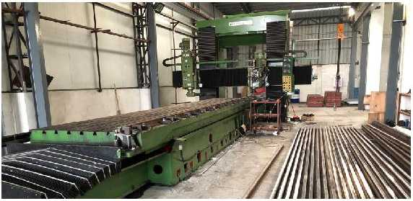
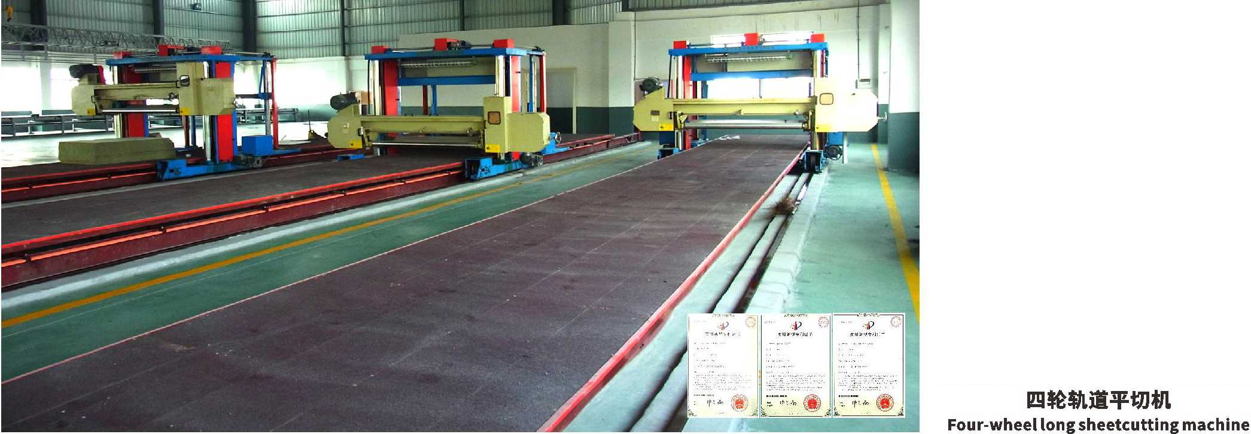
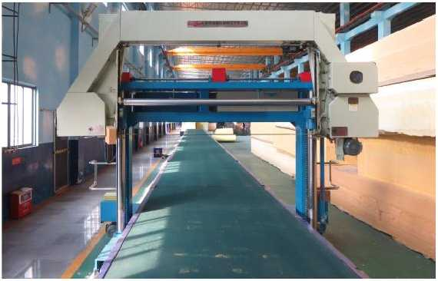
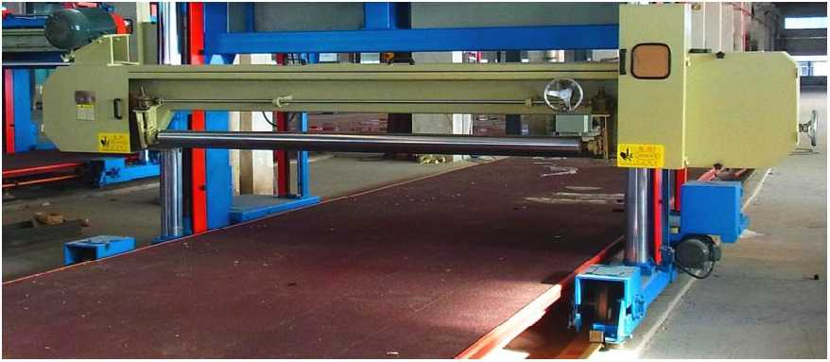
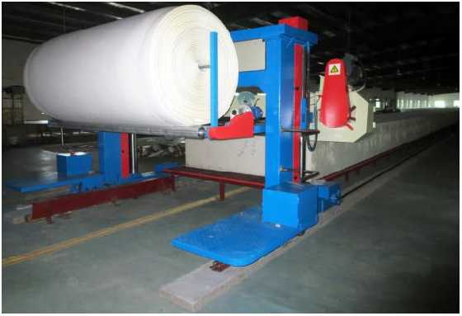
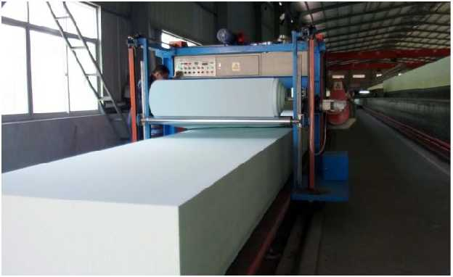
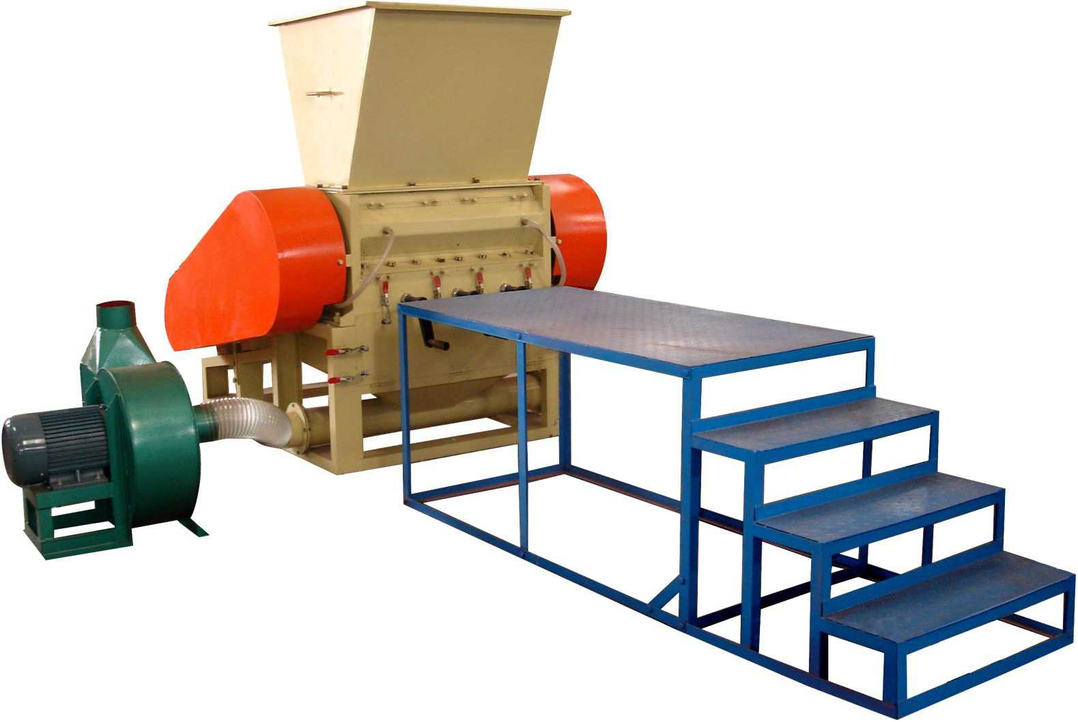
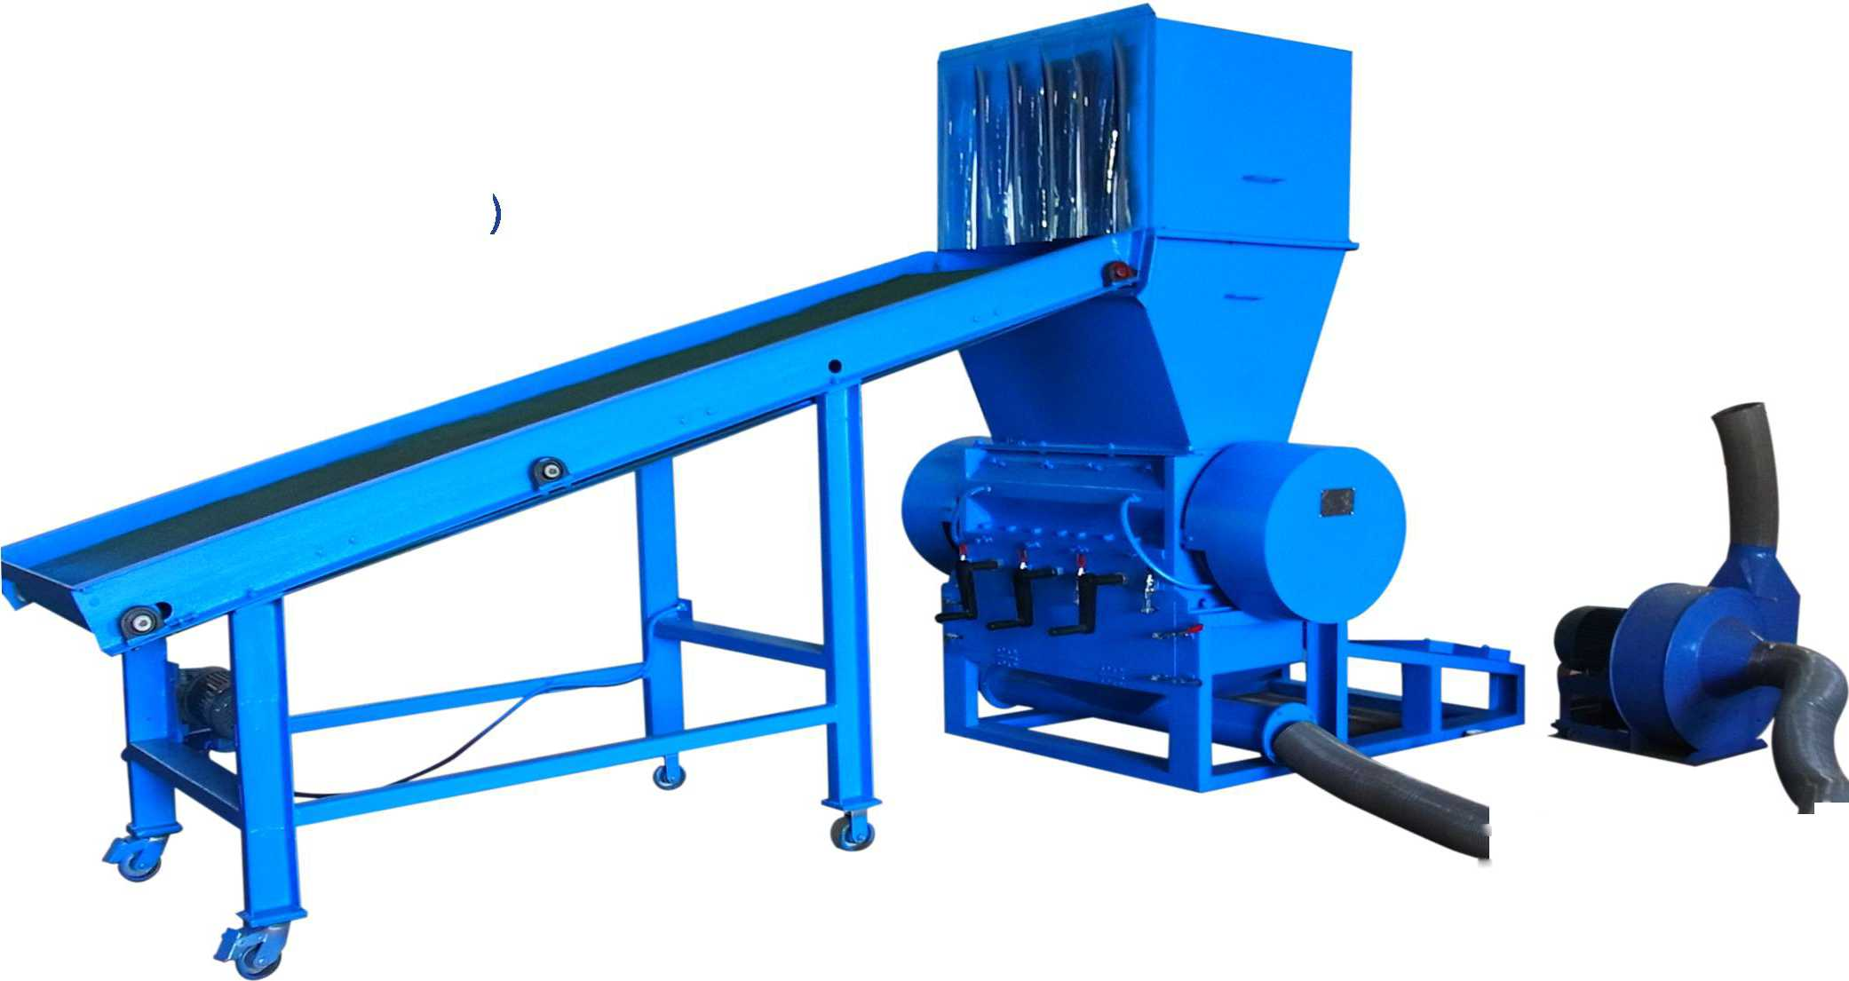

东凳市isBiiiniH制造有IE公司
DongGuan U-Long Machinery Co.,Ltd.

ULFS-11

海绵粉碎机

Foam Crushing Machine
本机主要用于将海绵边角料，废料 破碎成粒状，以作枕头、沙发、玩具充 填及再生海绵等用，该机结构紧凑，生 产率高。
This machine is mainly used to crush the corners and scraps of foams into granules for pillow, sofa, toy filling and regenerated foams, etc. The structure is compact and the productivity is high.

ULFS-22

海绵粉碎机

Foam Crushing Machine
本机主要用于海绵边角料等粉碎后 再回收利用,与再生搅拌机配套做成再生 海绵，本机功率强大，出风力强，生产效 率极高。
This machine is mainly used to crush the corners and scraps of foams for recycling, matching with regeneration mixer to make regenerated foam. The machine has strong power, strong wind output and high production efficiency.

U LLG-O-1650/2150/2350

强力海绵路轨平切机巨
NEW
High Density Foam Long Sheet Cutting Machine
慢回弹海绵输送带平台
□
Memory foam conveyor platform
可选装修边装置 Optionalside cutting device
海绵加温装置
Spongy heating device
Four-wheel driving devices
高密度欧仕莱大力绵吸风平台
Vaccum table for High density OLV Strong foam
本机是专门针对高密度特殊海绵而开发的专用切割机械，本机采用先进的电控系统再配合高精度的切割机构，专 门用于切割超高密度的鞋材海绵以及慢回弹记忆海绵，是各高级运动鞋鞋材海绵生产商的必备设备。本机同时可选配
网带输送平台，更适合慢回弹记忆海绵的输送和切割。
This machine is dedicated horizontal cutting machinery for high density special foam, and it adopt advanced PLC control system, equipped with high precision cutting structure. It is dedicated for cutting very high density shoes sponge and memory foam, its the necessary equipment for for each senior sneakers manufacturers. Meanwhile, this machine can choose to equipped with mesh-belt conveyor platform, it is more suitable fortransporting and cutting memory foam.

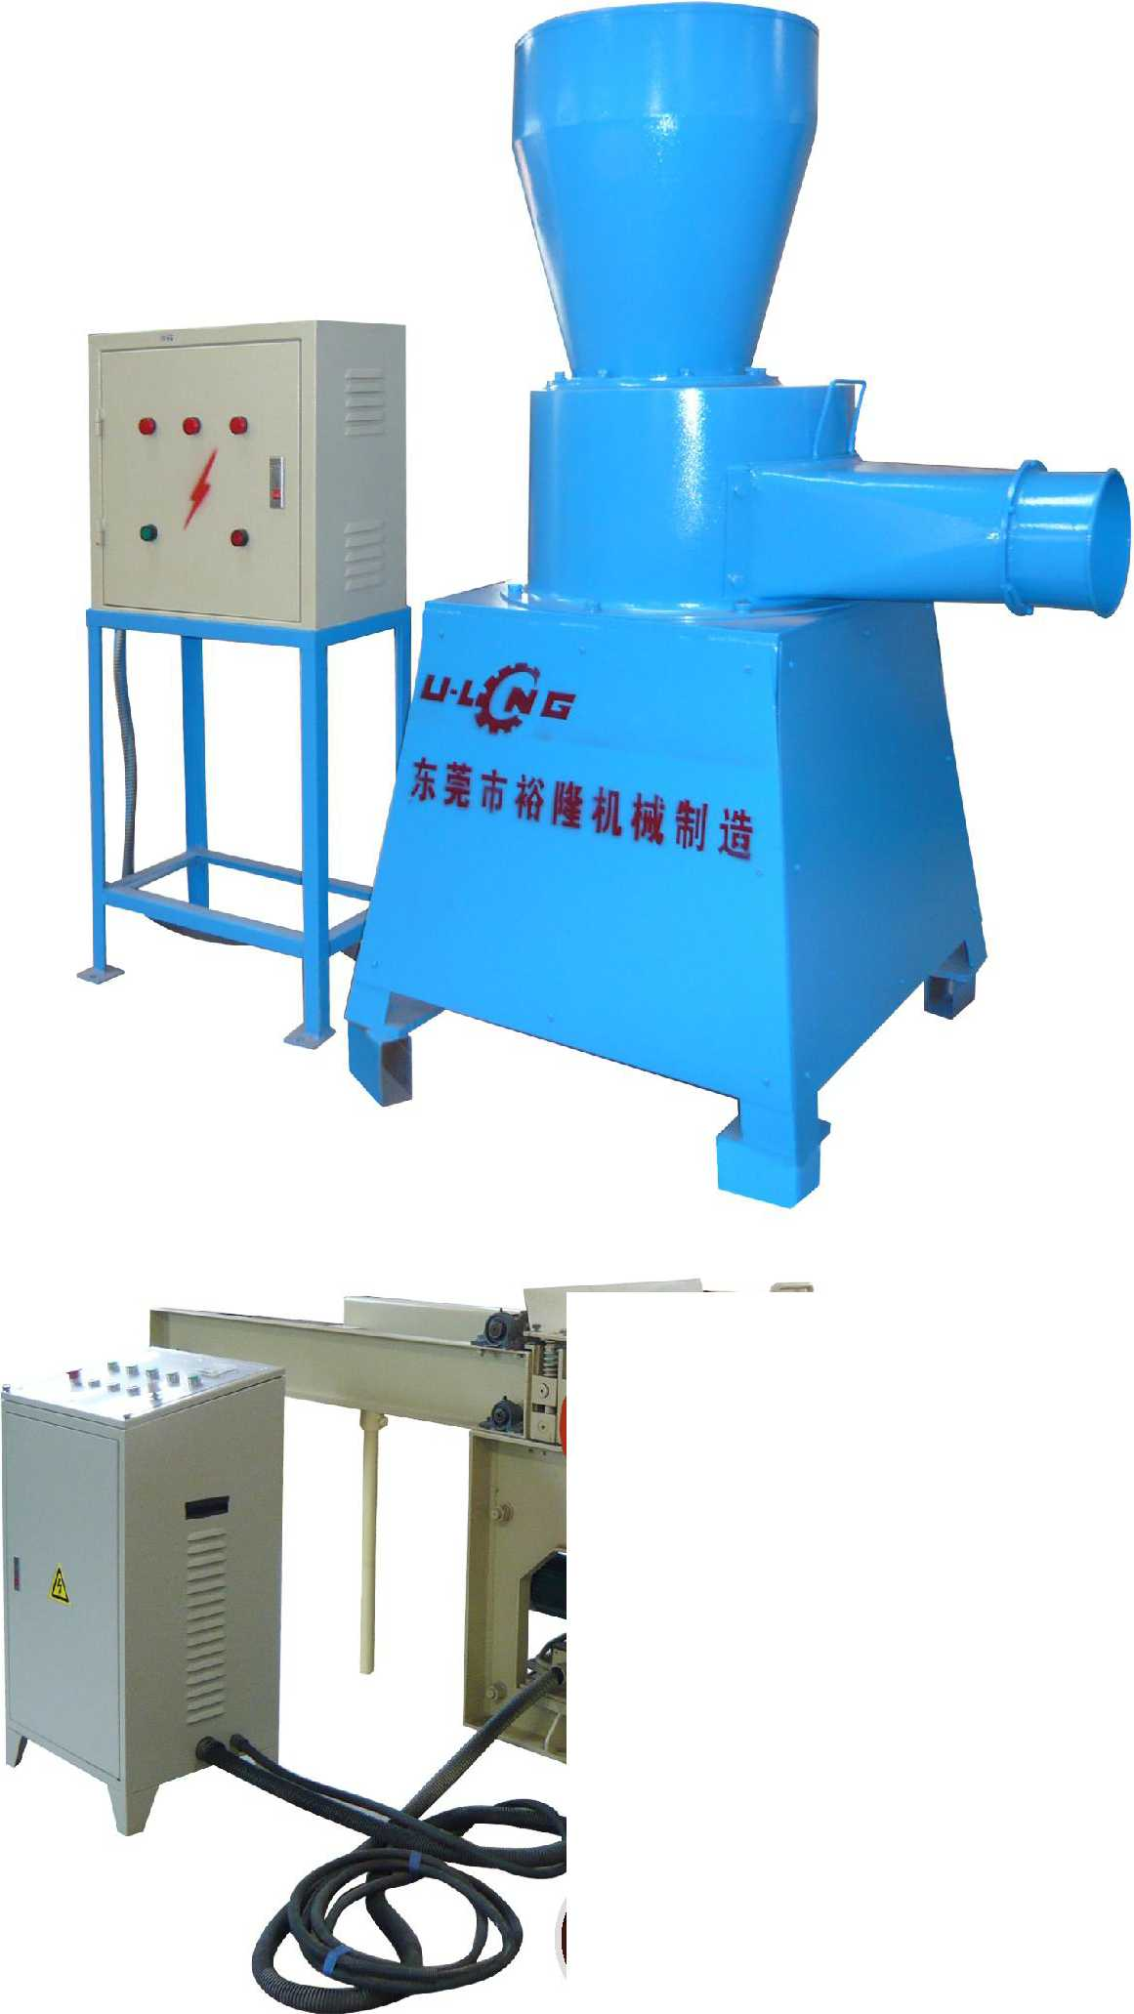
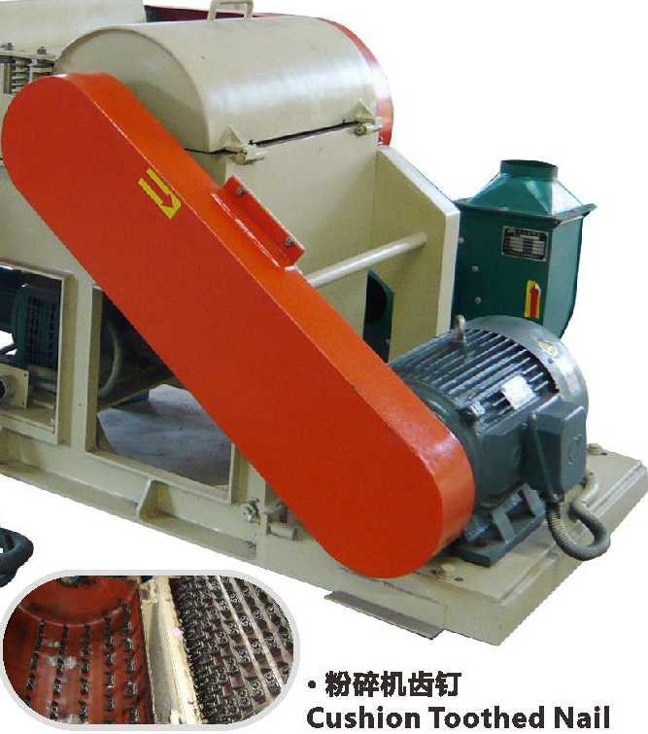
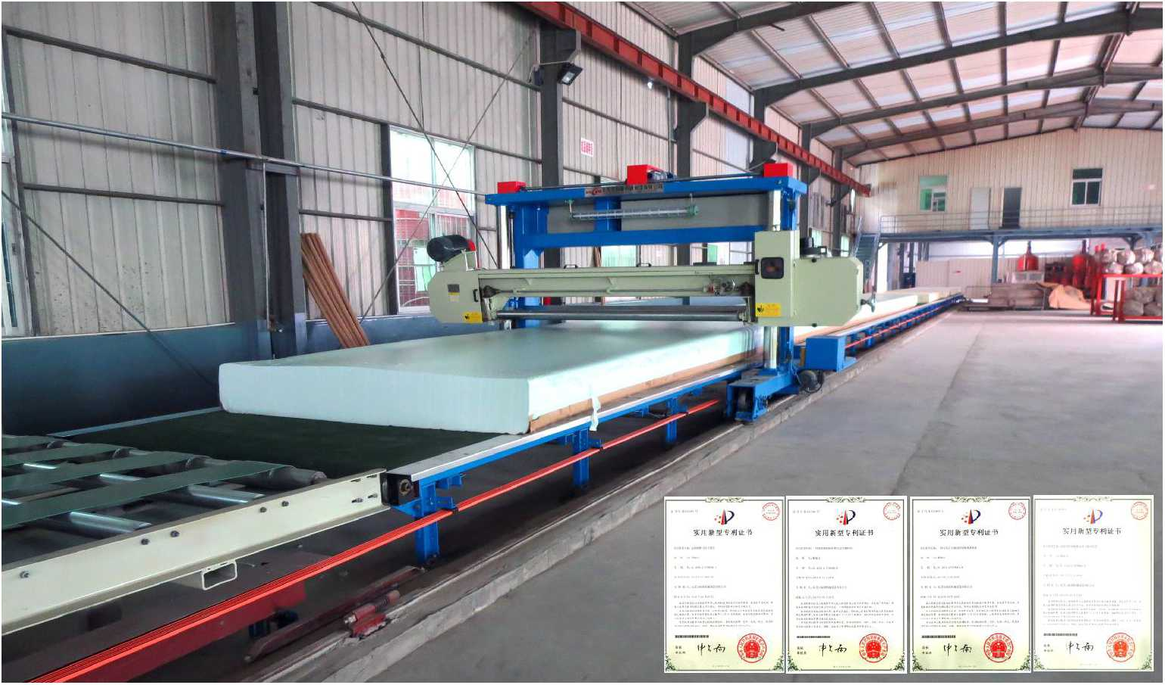
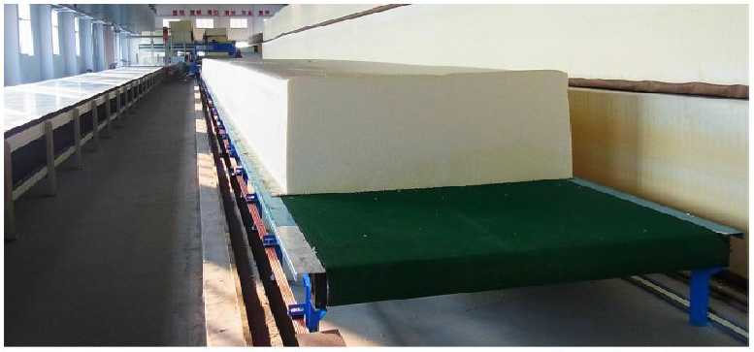
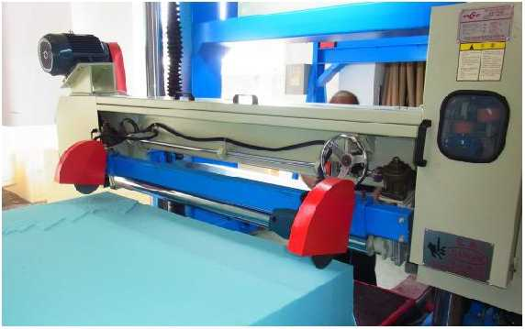
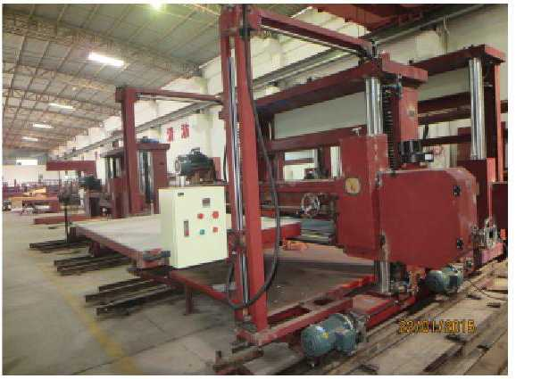
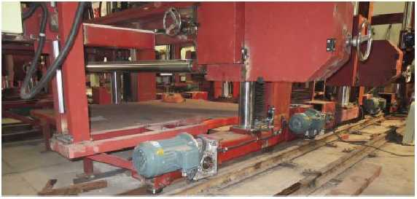
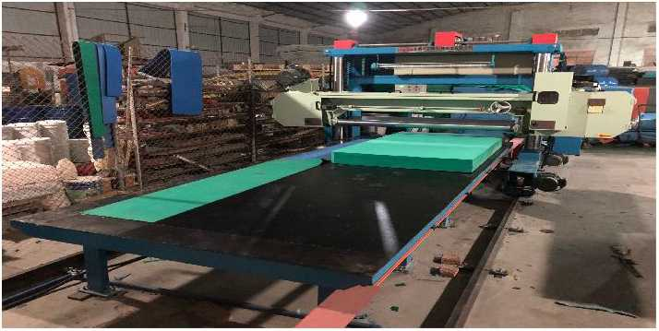

型号 | Model | ULFS-11 | ULFS-22
破碎速度 | Breaking speed | 130Kg/h | 100~300Kg/h
破碎最小粒度 | Breaking particulate min | 3mm~ mm | 3mm~25mm
总功率 | Total power | 11Kw | 27.5Kw
机器重量 | Machine weight | 500Kg | 1000Kg
筛网 | Screen(8mm, 18mm, 30mm) | 3PCS | 3PCS
风机 | Fan machine |  | 4Kw
机器外形尺寸 | Machine external size | L1250xW570xH1250mm | L2930xW1100xH1070mm
注：该设备专用于破碎海绵”严禁带铁钉和 布条。Remark: This machine only crush foam, can not crush nail and shred.
注：以上数据和参数仅供参考，实际技术数据以出厂产品为准。
Remark: The above data is only for reference, all the parameter is subjected to the sold production.

型号 | Model | ULLG-O-1650 | .ULLG-O-2150 . | ULLG-O-2350
可切海绵 | Cutting foam size | W1650mm | W2150mm | W2350mm

切割高度 | Cutting Height | 1250mm | 1250mm | H1250mm
切割速度 | Cutting Speed | 0~90m/min | 0~90m/min | 0~90M/min
切绵厚度 | Cutting Thickness | 2~30mm | 2~30mm | 2~30mm
最大切割密度 Cutting Density(max) |  | 210Kg/m³ | 210Kg/m³ | 210KG/m³
刀带长度 | Blade Length | 7400 x50x 0.56mm | 8400 x 50 x 0.56mm | 8800x50x0.56mm
总功率 | Total Power | 10.42KW | 10.42KW | 10.42KW
主机重量 | Mainframe Weight | 2000Kg | 2200Kg | 2300KG
机器外形尺寸 Machine External Size |  | L3550 x W2640 x H2350mm | L4050 x W2640 x H2400mm | L4250xW2640xH2400mm
注：以上数据和参数仅供参考，实际技术数据以出厂产品为准。
Remark: The above data is only for reference, all the parameter is subjected to the sold production.

东凳市isBiiiniH制造有IE公司
DongGuan U-Long Machinery Co.,Ltd.

ULYP-6000/7280/10500

海绵

盘平切机

ULRY-2

Carousel Splitting Foam Cutting Machine

海绵热压定型机
%詠注出
实用新型专利证书
实用新型专利书
实用新基专利血刁
可选配触摸屏

Foam Hot-pressure Machine
本机釆用全进口温度数字控制检测元件，主要用于海绵加温后压缩定型,
是各种高档电子海绵及胸围内衣海绵定型的理想设备。
Optional touch screen
This machine adopts all imported temperature digital control detection elements. It is mainly used for the compression setting of foams after heating. It is an ideal equipment forthe setting of all kinds of high-grade electronic foams and bra foams.
主要技术参
可选装电动角度装置
Optional electric motor to adjust cutting angle
外■式高压吸风机
Optional external high presssure vacuum devices
可选装强力吸风装・
Optional strong suction devices
可选装鼓风上绵装■
Optional air blast equi pment raise the foam
可选装固定式前后压辐
Optional the stationary front and back pressure roller
发热用电功率  Electricity of heating | 8.4Kw
模具发热板规格  Mould heater-board size | W450xL500mm
升降形式 | 气动
Lifting form | pneumatic
机器重量  Machine weight | 800Kg
机器外形尺寸  Machine external size | L800 xW550xH1700mm

Main Technical Specification
本机主要用于多个方形海绵的水平连续切片工作，本机采用全自动数字控制，切割精确，操作简单,生产效率极高•本机可选配

U LZY-2

再生海绵座垫蒸汽压型机

Re-bonding Foam Cushion Pressure Machine (with steam)
加装强力吸风装置，海绵固定更牢固,切割效果更好.人性化设计，提高安全保障，可选用两片夹刀盒，切割软泡效果更佳。
This machine is mainly used for horizontal continuous slicing of multiple square foam. It adopts fully automatic digital control, with high cutting precision, simple operation and high efficiency. We offer vacuum device for your option, which fixes foam firmly and brings better cutting effects. We also offer two blades for your option, which ensures the safety and better cutting for soft foam.
本机主要用途是把再生海绵加压成座垫形状，本机采用蒸汽装置，气 动操作一次同时可完成两组座垫，生产效率极高。
型号 | Model | ULYP-6000 | ULYP-7280 | ULYP-10500
可切海绵尺寸 | Cutting foam size | W1.5XL2XH1.2m(4pcs) | W1.5XL2XH1.2m(6pcs) | W1.5XL2XH1.2m(8pcs)
可切最大海绵尺寸Cutting foam size (max) |  | W1.5XL2XH1.2m(4pcs) | W2.15XL3XH1.2m(3pcs) | W2.15XL4.5XH1.2m(3pcs)
总功率 | Total power | 8.92Kw | 8.92Kw | 11.92KW
工作转盘转速 | Worktable turning speed | 0~3.5r/min | 0~3.0r/min | 0*-2.0r/min
刀带周长 | Blade length | 8980mm | 10000mm | 10240mm
加装前后压根装置刀带周长 |  | 9220mm | 10240mm | 10470mm
工作台直径 | Work table dia«|)) | 6000mm | 7280mm | 10500m
切片厚度 | Cutting thickness | 2~150mm | 2~150mm | 2~150mm
机器重量 | Machine weight | 3300Kg | 3500Kg | 4500Kg
机器外形尺寸 | Machine external size (LxWxH) | L6.9mXW6mXH2.4m | L7.9mXW7mXH2.4m | L11.5mXW10.5mXH2.4m

注：以上数据和参数仅供参考，实际技术数据以出厂产品为准。
Remark: The above data is only for reference, all the parameter is subjected to the sold production.
This machine is mainly used to press the regenerated foam into a cushion shape. The machine adopts steam device and can complete two sets of cushions at the same time by pneumatic operation. The production efficiency is very high.
模具数量  Mould quantity | 2
升降形式 | 气动
Lifting form | pneumatic
机器重量  Machine weight | 800Kg
机器外形尺寸
Machine external size | L1300 xW800xH1800mm

主要技术参数：Main Technical Specification
注：以上数据和参数仅供参考，实际技术数据以出厂产品为准。
Remark: The above data is only for reference, all the parameter is subjected to the sold production.
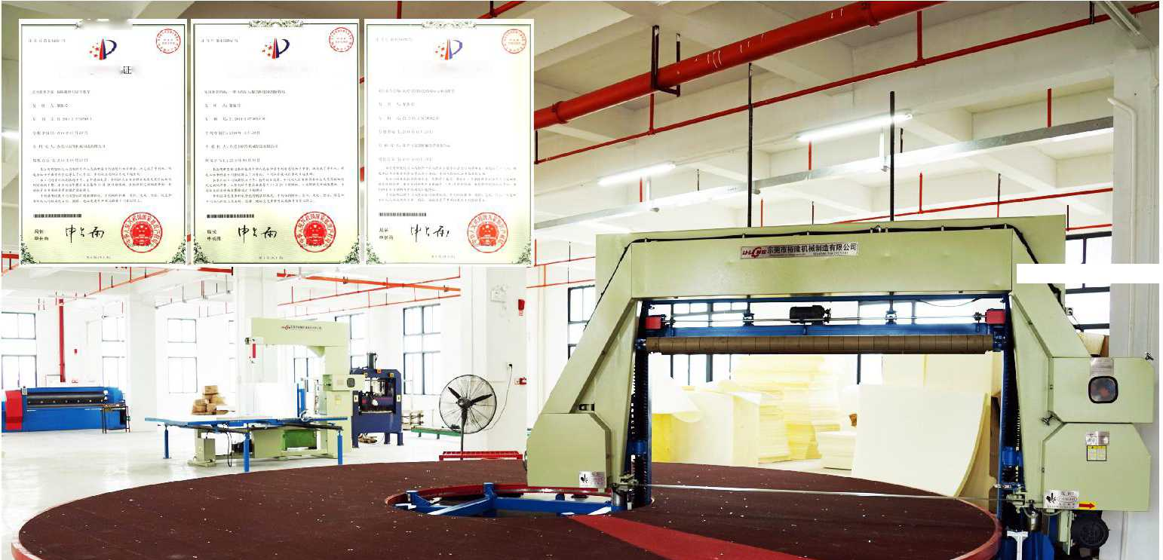
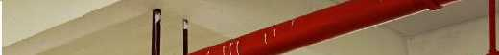
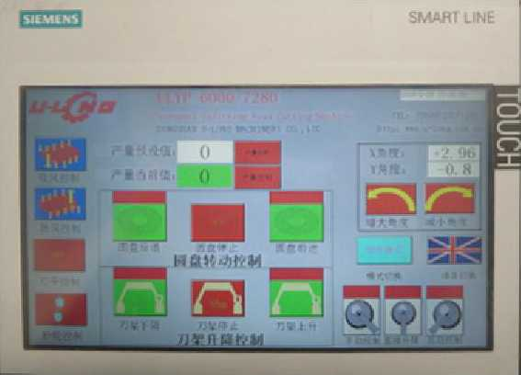
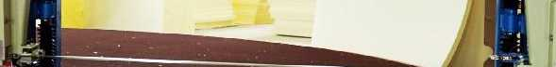
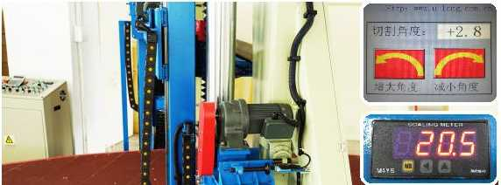
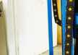

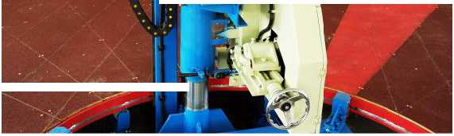
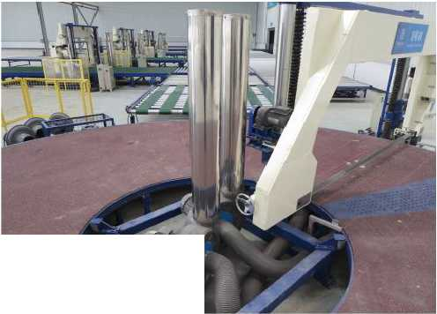
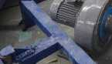
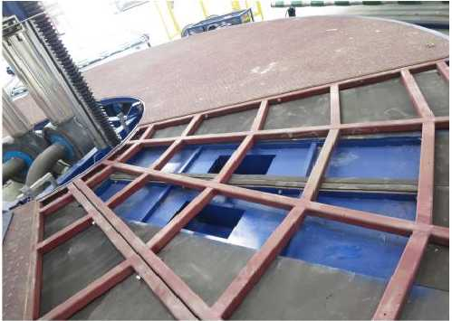
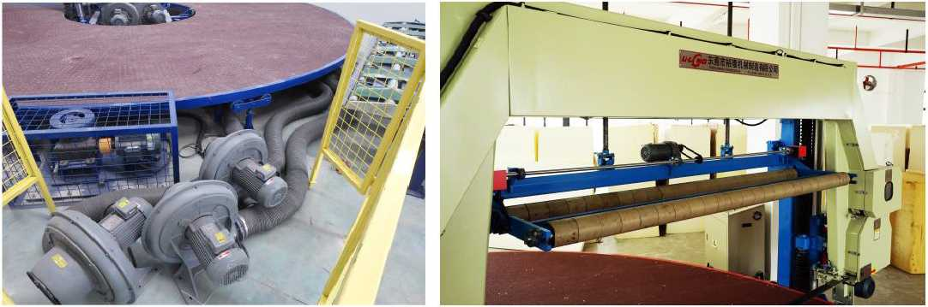
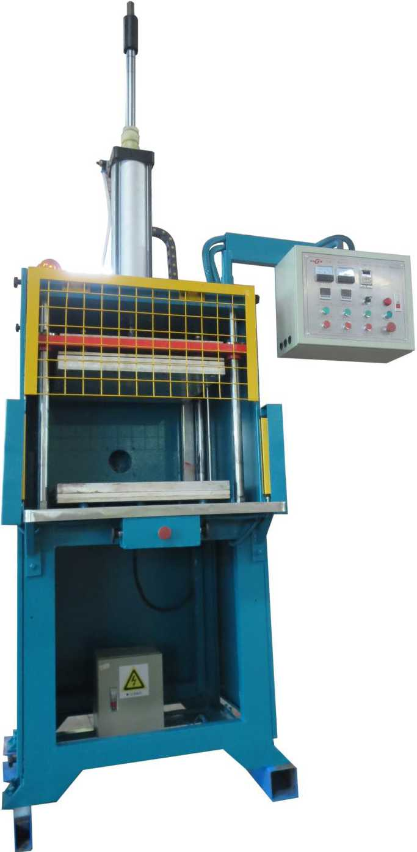
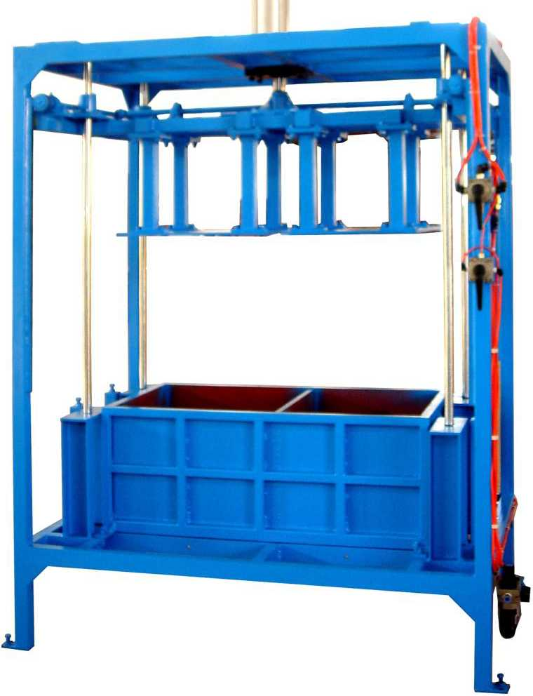

东凳市isBiiiniH制造有限公司
DongGuan U-Long Machinery Co.,Ltd.

ULJB-10C

泡再生海绵生产线
Round Foam Re-bonding Machine
材等圆泡再生海绵的生产工作。
搅拌箱容积  Stirring cubage | 10m³
搅拌转速  Stirring turning speed | 40r/min
油缸工作最大压力 Utmost work pressure of oil jar | 20000Kg
总功率  Total power | 20Kw
机器重量  Machine weight | 6000Kg
机器外形尺寸  Machine external size | L8000 x W4500 x H7500mm
发泡模具  Moulding tanks | 01200 xH3800mm

主要技术参数： Main Technical Specification
本机主要用于再生海绵地毯垫及高密度透气性鞋
This machine is mainly used for the producing of the regenerated carpet foam and high-density breathable round shoe foam.

ULPQ-1650/2150

海绵平切机 Horizontal Foam Cutting Machine
本机主要用于单个方泡海绵的水平往复切片工作，主要用 于床垫等厚海绵的切割工作。本机全自动数字控制，切割精确, 操作简便。本机可选配加装强力吸风装置，海绵固定更牢固， 切割效果更好。
This machine is mainly used for horizontal reciprocating slicing of one square foam, such as thick foam, mattress foam etc. It adopts fully automatic digital control, with high cutting precision, simple operation and high efficiency. We offer vacuum device for your option, which fixes foam firmly and brings better cutting effects. We also offer two blades for your option, which ensures the safety and better cutting for soft foam.
机KU造有限公司
f- gw.心岬.com cn

ULCL-10粉碎海绵储存称量罐Crushed Foam Storage and Scale Tank
本储存罐主要用于海绵经粉碎机粉碎后储存在罐内，再经过称量地磅称量重量后，再用送料风机把碎海绵送进再生机搅拌罐进
型号 | Model | ULPQ-1650 | ULPQ-2150
可切绵尺寸 | Cutting foam size | W1650mmXL2000mm | W2150mmXL3000mm
切绵髙度 | Cutting height | H1200mm | H1200mm
切割速度 | Cutting speed | 0~25m/min | 0~25m/min
切绵厚度 | Cutting thickness | 2.5~200mm | 2.5~200mm
最大切割密度 | Cutting density(max) | 60Kg/m³ | 60Kg/m³
刀带长度 | Blade length | 8720mm | 9720mm
总功率 | Total Power | 9.02Kw | 9.02Kw
机器重量 | Machine weight | 2000Kg | 2200Kg
机罷外形尺寸 | Machine external size | L5800mm X W3500mm X H2400m | L7800mm X W4200mm X H2400m

,可选装电动 Optionaleh adjust aitti
•可选装固霆式前后压報 Optional the stationary front and back pressure roller
行搅拌生产出再生海绵。本机是再生海绵生产线不可缺乏的辅助设备。
This storage tank is used to store the crushed foam, weigh and then delivered to stirring tank for regeneration. It is the necessary auxiliary equipment for regenerated foam producing.

ULPQ-lll-1650/2150

再生海绵平切机

Horizontal Re-bonding Foam Cutting Machine
主要技术参数：
Main Technical Specification
储棉容积  Capacity | 10m3
机械重量  Machine Weight | 800Kg
最大称量重量 Maximum weighing | 2000Kg
搅拌电机功率  Mixing Motor Power | 2.2Kw
送料风机功率  Feeding Fan Power | 4Kw
机器外形尺寸 Machine External Size | L : 2000mm  W: 1500mm  H: 5000mm

机器外形尺寸
Machine external size

ULMB-1

废绵包升降机

Scrap Foam Bundle Elevator
主要技术参数：
Main Technical Specification
最大载重  Utmost loading | 350Kg
最大行程  Treading distance(max) | 3000mm
机器重量  Machine weight | 500Kg
总功率  Total power | 2.2Kw

L1200xW850xH3680mm
il
l»l
III!
注：以上数据和参数仅供参考，实际技术数据以出厂产品为准。
Remark: The above data is only for reference, all the parameter is subjected to the sold production.
本机主要用于单个再生海绵和高密度方泡 海绵的水平往复切片工作，本机全自动数字控 制，切割精确，操作简便。
This machine is mainly used for horizontal reciprocating slicing of one square foam or high- density foam. It adopts fully automatic digital control, with high cutting precision, simple operation and high efficiency.
型号 | Model | ULPQ-lll-1650 | ULPQ-lll-2150
可切海绵尺寸 | Cutting foam size | W1650xL2000mm | W2150xL3000mm
切绵高度 | Cutting height | H1200mm | H1200mm
切绵厚度 | Cutting thickness | 2~60mm | 2~60mm
最大切割密度 | Cutting density(max) | 120Kg/m³ | 120Kg/m³
切割速度 | Cutting speed | 0~25m/min | 0~25m/min
总功率 | Total Power | 8.92KW | 8.92KW
刀带长度 | Blade length | 7200mm | 8200mm
机器重量 | Machine weight | 2000Kg | 2500Kg
机器外形尺寸 | Machine external size | L5800 x W3700 x H2400mm | L6800X W4200 xH2400mm

注：以上数据和参数仅供参考，实际技术数据以出厂产品为准。
Remark: The above data is only for reference, all the parameter is subjected to the sold production.
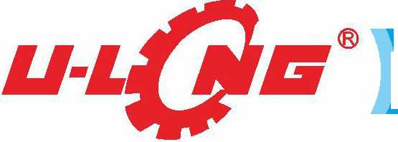
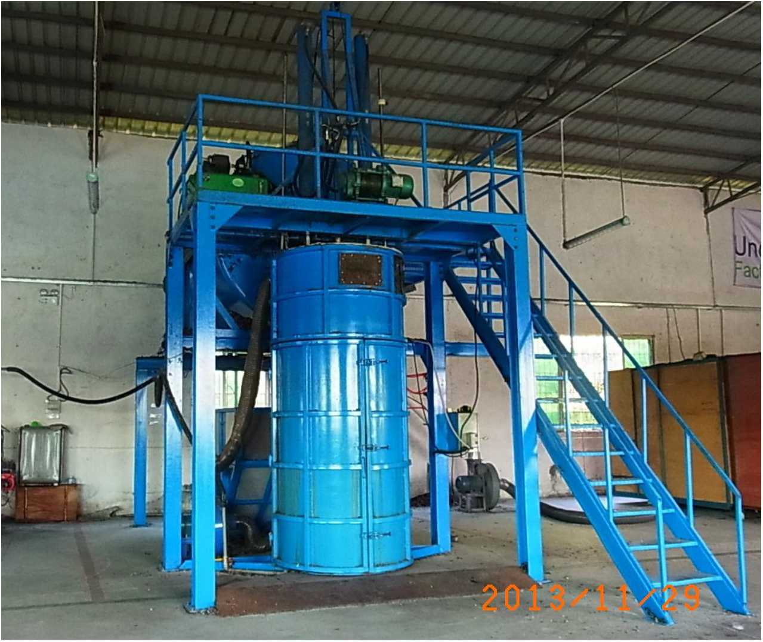
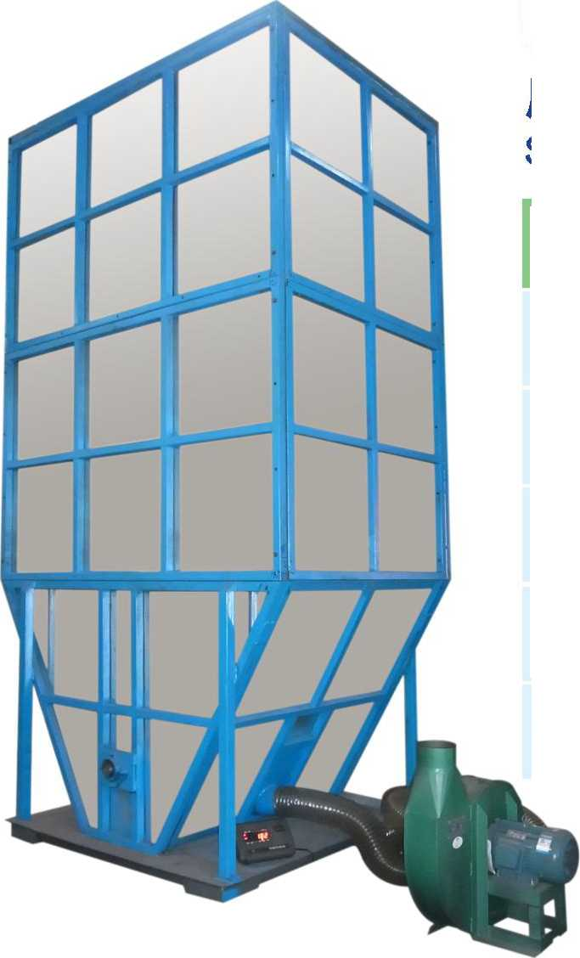
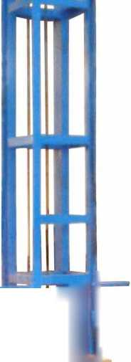
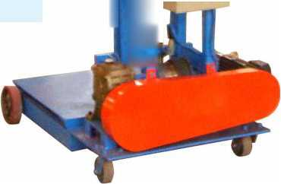
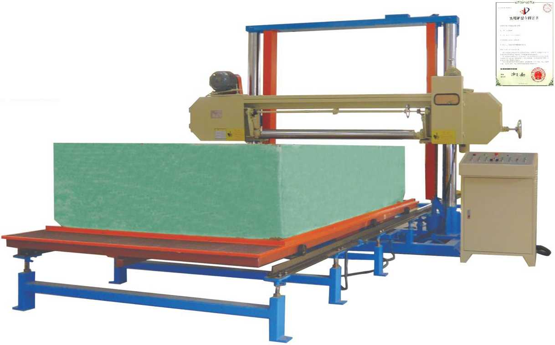
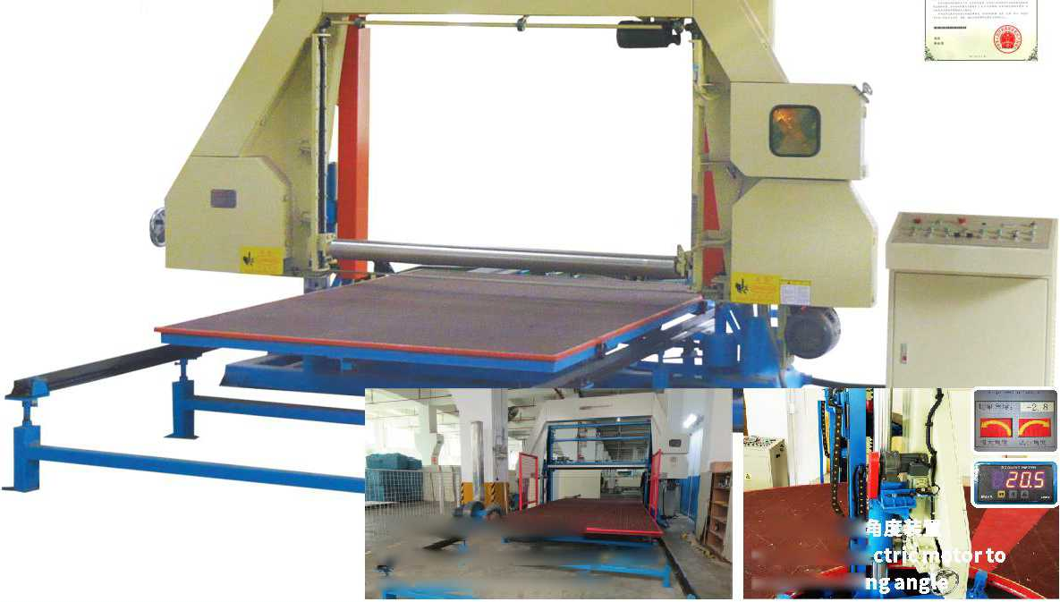

东凳市isBiiiniH制造有限公司
DongGuan U-Long Machinery Co.,Ltd.

ULPQ-WDXF-1650/2150

ULJB-12C再生海绵生产线（双模具）
NEW

海绵网带吸风平切机寻

Horizontal Foam Mesh-belt Cutting Machine (with vacuum)
KT
Foam Re-bonding Machine(Double Mouldings)
实用新型专利证书
Mt*!海蝴机眾
O7：!«r»4H.
泛山俗am 切近"以公讪
俛5
局长
中K而
*6恩M登心野书残中尊人队貝*K《林汝a — M
。仍會我贝紀.公布MU*，n
左竹认人色，徵氫6代公《矣女希'方 ML<<HM4-€ M !i 11 H 2M » WJ.♦
粉机的4管形湛二Hk/jt.
Utt港址皇*¥$用i乙双任。”分匕从上
外置式高压
砂叱丄机
Optional external high presssure vacuum devices
可选配触摸屏
Optional touch screen
可选装电动角度装置 Optional electric motor to adjust cutting angle
可配套数控异形切割机
Optional support contour cutting foam machine
型号 | Model | ULJB-12C
搅拌箱容积 | Stirring cubage | 12m³
搅拌转速 | Stirring| turning speed | 40r/min
油缸工作最大压力 Utmost work pressure of oil jar |  | 12000Kg
总功率 | Total power | 30Kw
机器重量 | Machine weight | 5500Kg
机器外形尺寸 | Machine external size | L13000 x W4275 x H6172mm
发泡模具 | Moulding tanks | L2100xW1600xH1800mm(2pcs)

本机主要用于将已粉碎的海绵与胶水搅 拌混合，再经过发泡成型模，经过油压系统 压成相应要求密度的再生泡绵。最新研制左 右双模具设计，双油压系统装置，可生产不 同规格再生泡绵，同时生产效率大幅提高。
This machine is mainly used for the stirring of the crushed foam with glue. After the foaming mould, the regenerated foam of the required density is compressed through the hydraulic system, the newly developed double- mould, double hydraulic system can produce different sizes of recycled foam and the productivity is much higher.

ULQB-2L再生海绵旋转切边机
Re-bonding Foam Rotary Side Cutting Machine
本机工作平台采用滚筒式网带传动并加装强力吸风真空装置，上料简便，特别适合于软质海绵的水平往复切片工作。
The worktable of this machine adopts roller mesh-belt transmission with vacuum equipment, easy feeding. It is mostly used for horizontal reciprocating slicing of soft foam.
本机主要用于再生海绵修边切割工作,工作台旋转移动进 行切割，加工方便，节省人手。
This machine is mainly used for the trimming of the regenerated foam. The worktable is rotating while cutting, convenient and labor saving.
型号 | Model | ULPQ-WDXF-1650 | ULPQ-WDXF-2150
可切海绵尺寸 | Cutting foam size | W1650XL2000 XH1200mm | W2150XL3000XH1200m
切割速度 | Cutting speed | 0~25m/min | 0~25m/min
切片厚度 | Cutting thickness | 2.5~150mm | 2.5~150mm
刀带长度 | Blade length | 8850mm | 9850mm
总功率 | Total power | 18kw | 18kw
机器重量 | Machine weight | 3300kg | 3500kg
机器外形尺寸 | Machine external size | L5000 X W4000 X H2500mm | L7000 X W4500 X H2500mm

注：以上数据和参数仅供参考，实际技术数据以出厂产品为准。
Remark: The above data is only for reference, all the parameter is subjected to the sold production.
工作台尺寸 | Worktable | W1500xL2000mm
有效切割高度 | Available cutting height | H1200mm
刀带长度 | Blade length | L5670mm
电机总功率 | Table power | 2.96Kw
外形尺寸 | Machine external size | L4000xW2770xH2700

主要技术参数 Main Technical Specification
注：以上数据和参数仅供参考，实际技术数据以出厂产品为准。
Remark: The above data is only for reference, all the parameter is subjected to the sold production.
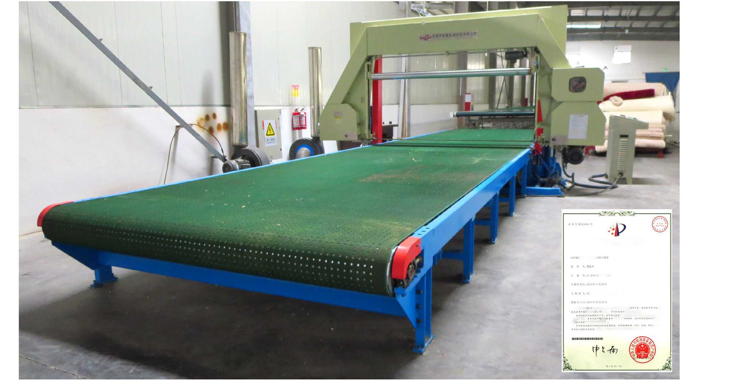
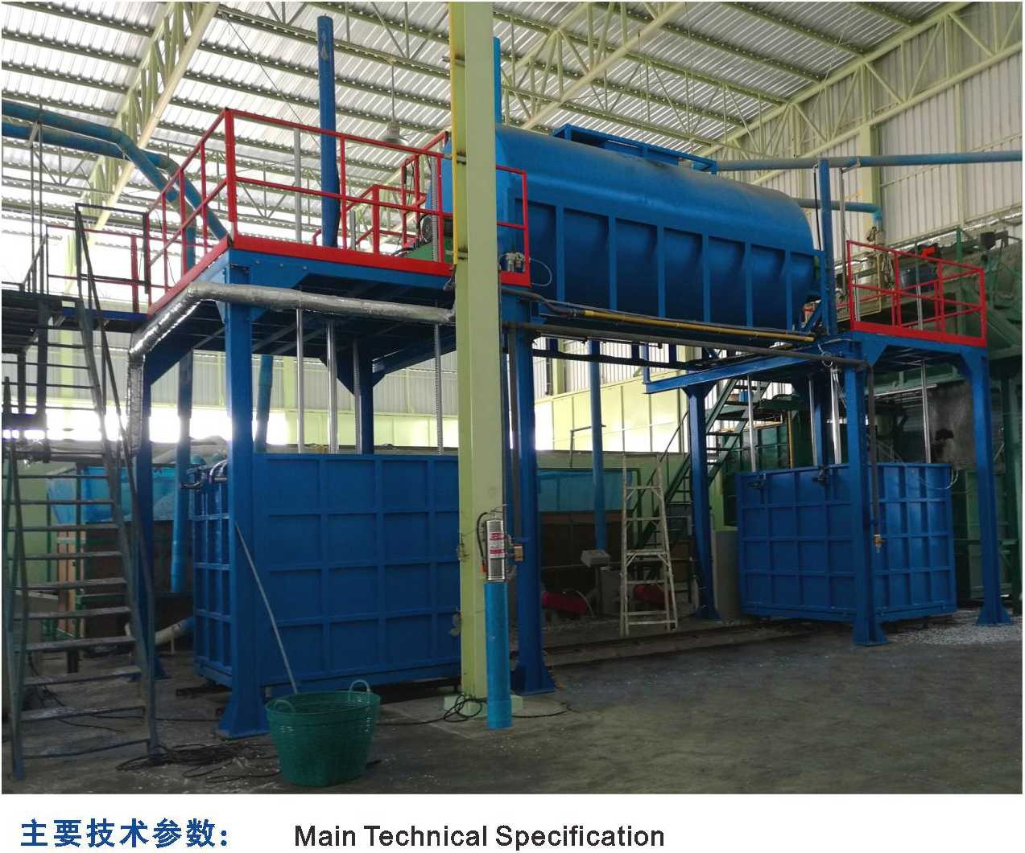
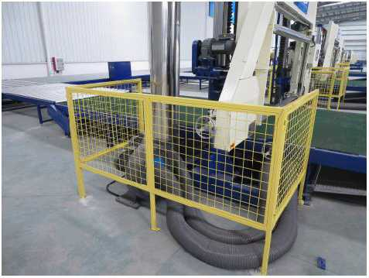
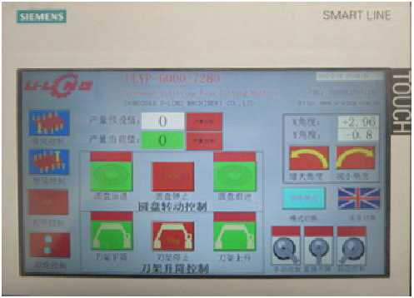
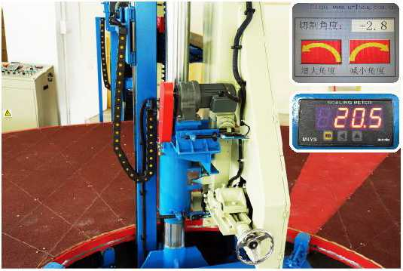
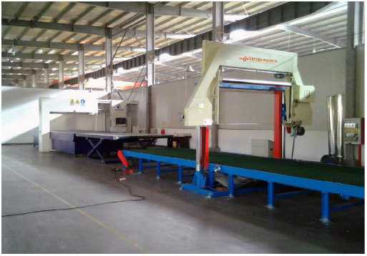
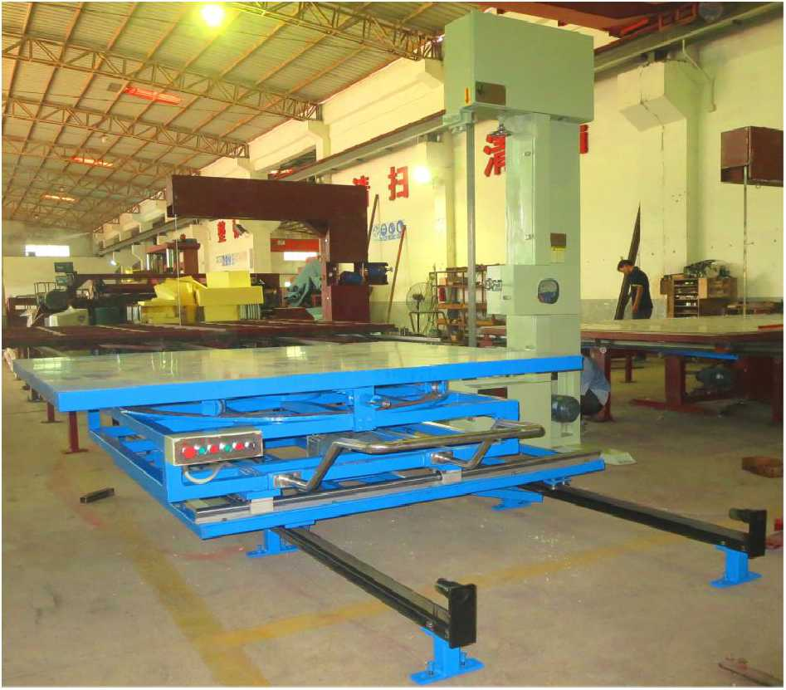

东凳市isBiiiniH制造有IE公司
DongGuan U-Long Machinery Co.,Ltd.

ULJB-10A再生海绵生产线 Foam Re-bonding Machine

ULJB-10B

再生海绵生产线(带蒸汽)

Foam Re-bonding Machine(with steam)

ULPQ-II-1250/1650/2150

海绵高精度吸风平切机
Horizontal Foam Hiah Precision Cutting Machine (\
•调整皿橫具 Mold of adjust the width
•%1・,
■ -J
Re-bondlng Foam
本机采用高精度进口滚珠丝杆传动，配备强力吸风
真空系统固定海绵，切绵工作更加平稳，切绵精密度更高
（最薄可切割厚度为1MM）。
This machine adopts high precision imported ball screw drive system, equipped with vacuum equipment to bring high-quality slicing, (minimum slicing: 1mm).
型号 | Model | ULPQ-ll-1250 | ULPQ-ll-1650 | ULPQ-ll-2150
可切海绵尺寸 | Cutting foam size | W1.25mXL2mXH1.2m | W1.65mXL2mXH1.2m | W2.15mXL3mXH1.2m
主机移动速度 | Mainframe moving speed | 0~15m/min | 0~15m/min | 0~15m/min
切片厚度 | Cutting thickness | 1~60mm | 1~60mm | 1~60mm
刀带长度 | Blade length | L5980mm | L6780mm | L7780mm
总功率 | Total power | 11.52KW | 11.52Kw | 13.32Kw
机械重量 | Machine weight | 1800Kg | 2000Kg | 2200 Kg
机器外形尺寸 | Machine external size | L5.0mXW2.5mXH2.6m | L5.0mXW2.9mXH2.6m | L6.0mXW2.9mXH2.6m

ULPQ-XD-1250/1650
ULJB-10B
ULJB-10A

聚氨脂硬质泡沫平切机
本机主要用于将已经粉碎的海绵与胶水搅拌混合，再经过发泡成型模，经油压系统压成相应要求密度的再生泡绵。本机具有搅拌、
Horizontal Hard PU Cutting Machine
混合、加压成型的一整套流水生产线，生产效率极高。最新研制的全自动带蒸汽装置模具，更可将生产效率提高5倍。
本机主要用于聚氨脂硬质泡沫（空调冷库等保温隔热
This machine is mainly used for the stirring of the crushed foam with glue. After the foaming mould, the regenerated foam of the required density is compressed through the hydraulic system. This machine has a set of production line of mixing, stirring and pressure forming, with high production efficiency. The newly developed fully automatic mould with steam device can increase production efficiency by five times.
板）的水平往复切片工作，本机可采用双面独立设定切割
1=1
厚度来回双面切割，操作简便,生产效率高。并配有吸尘装
置，确保工厂环境舒适。
主要技术参数： | Main Technical Specification
 | Model | ULJB-10A | ULJB-10B  (with steam)
搅拌箱容积 | Stirring cubage | 10m³ | 10m³
搅拌转速 | Stirringi turning speed | 40r/min | 40r/min
油缸工作最大压力 | Utmost work pressure of oil jar | 12000Kg | 12000Kg
总功率 | Total power | 13Kw | 14.5Kw
机器重量 | Machine weight | 4000Kg | 4300Kg
机器外形尺寸 | Machine external size | L6000 x W3500 x H5200mm | L6000 x W3850 x H5300mm
发泡模具 | Moulding tanks | L2050xW1550xH1000mm(2pcs) | L2050xW1550xH1800mm(1pcs) (Automatic)

注：以上数据和参数仅供参考，实际技术数据以出厂产品为准。
Remark: The above data is only for reference, all the parameter is subjected to the sold production.
This machine is mainly used for horizontal reciprocating slicing of hard PU foam. It adopt sin dependently double-sided setting and reciprocating slicing, with simple operation and high efficiency. It is also equipped with vacuum devices to ensure a comfortable environment.
型号 | Model | ULPQ-XD-1250 | ULPQ-XD-1650
可切绵尺寸 | Cutting foam size | W1250 X L2000X H1200mm | W1650 X L3000 X 1200mm
工作台移动速度 | Mainframe moving speed | 0~15m/min | 0~15m/min
切绵厚度 | Cutting thickness | 5.0~150mm | 5.0~150mm
刀带长度（带锯齿） | Blade lenght(with sawteeth) | L7700mm | L8500mm
总功率 | Total Power | 10.42KW | 10.42KW
机器重量 | Machine weight | 2000Kg | 2200Kg
机器外形尺寸 | Machine external size | L5800mm X W3500mm X H2400m | L7800mm X W4200mm X H2400m

注：以上数据和参数仅供参考，实际技术数据以出厂产品为准。
Remark: The above data is only for reference, all the parameter is subjected to the sold production.

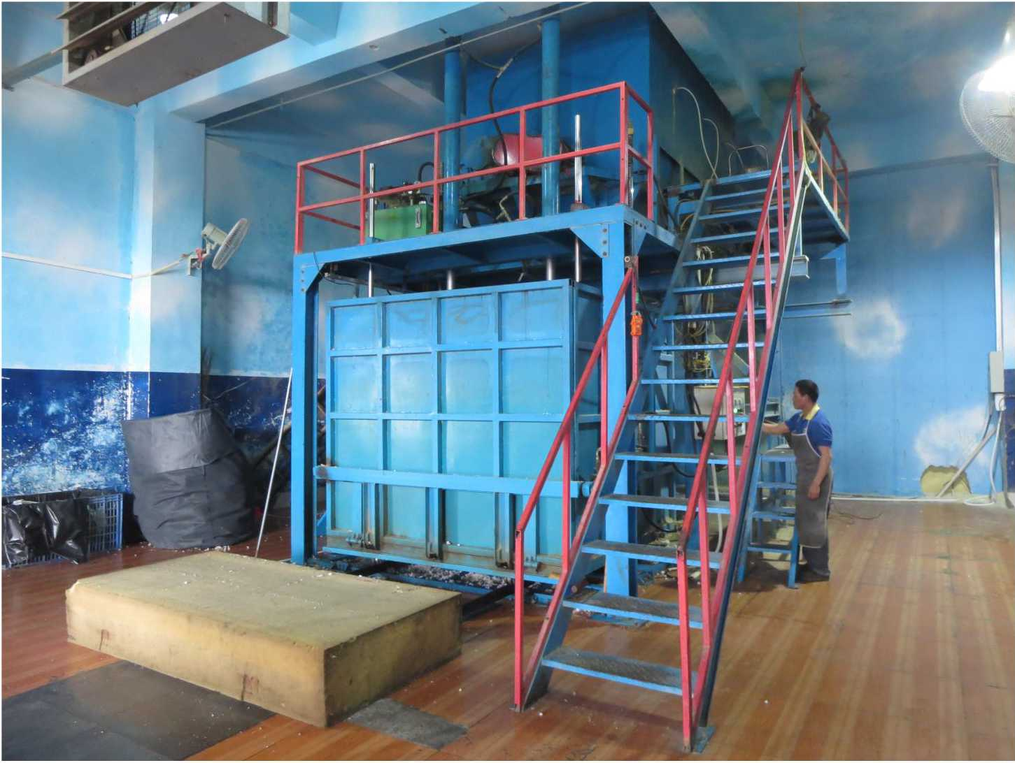
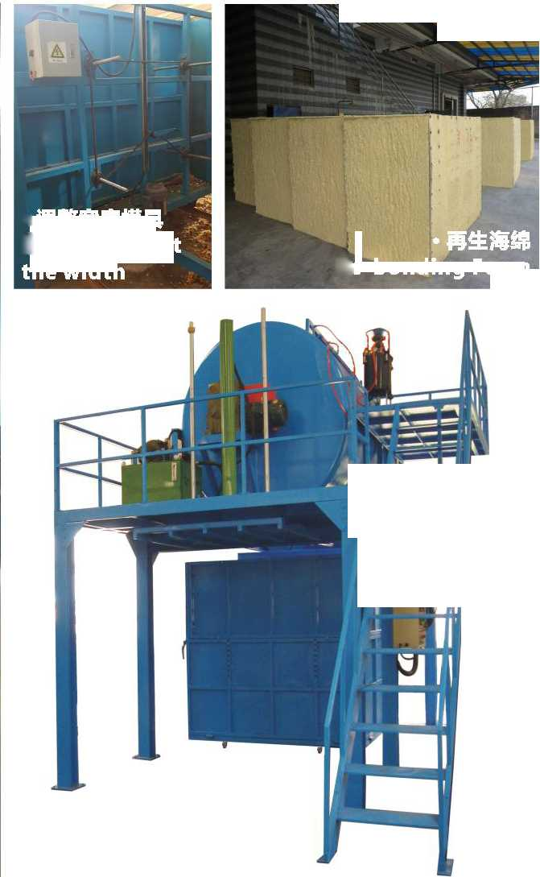
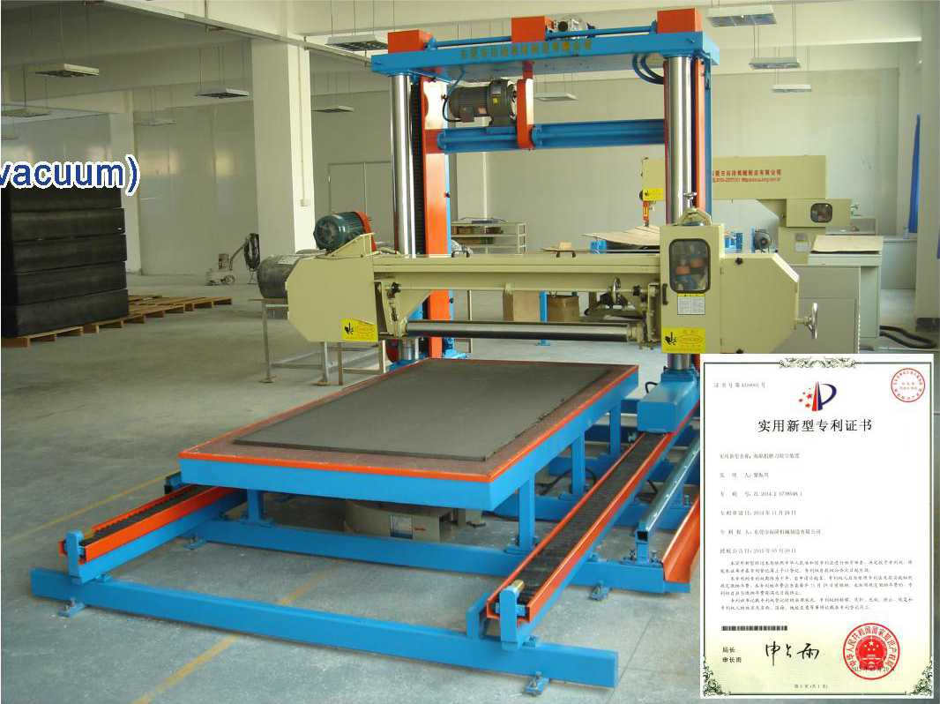
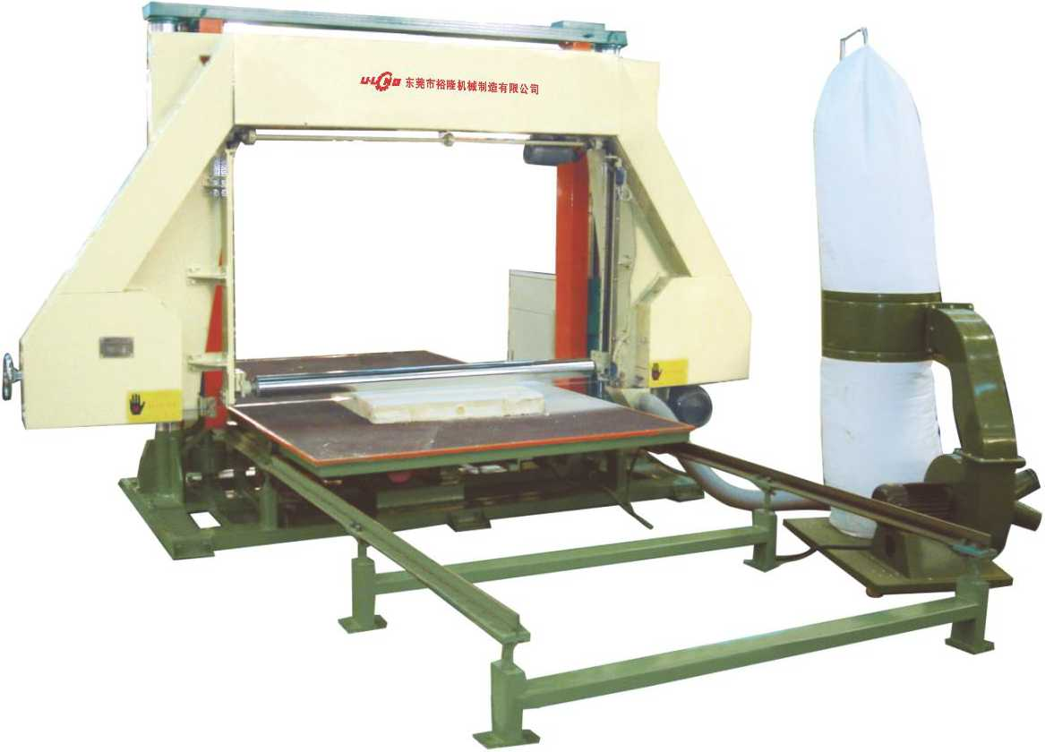

东凳市isBiiiniH制造有限公司
DongGuan U-Long Machinery Co.,Ltd.

ULYX・O・22"0 强力海绵压形机 Strong Profile Cutting Machine 三 ULYX-1650/2150海騙压形切割机 Profile Cutting Machine
三NEW

ULDB-60B

海绵压缩真空打包机
强力海绵压形机(特殊花型)
Strong foam profile cuttg machine
(special pattern)
可加装自动收料设备
Oqtional automatic receiver
•Bl瓠形直条纹波浪/ >
Cu rved straight striped waves

本机为压形切割机械切割，主要将海绵成波浪状绵。适用于电子、精密仪器、汽车座垫、保健用品以及贵重物件的包装用途。
This machine is mostly used to press the foam into wavy foam, which can be suitable for electric and precision
instruments, car cushion, health care supplies' and valuables' packing.
 | Model | ULYX-1650 | ULYX-2150 | ULYX-O-2250
最大可切割海绵厚度 | Maximum cutting thickness | 120mm | 120mm | 200mm
压辐直径 | Dia. of press roller | 0195mm | 0195mm | 0260mm
最大压形宽度 | Profiling width (maximum) | W1650mm | W2150mm | W2250mm
最大压形深度 | Profiling depth(maximum) | 30mm | 30mm | 80mm
压形轮轴转速（工作状态） | Profiling axletree turning speed (working) | 0~25r/min | 0*25r/min | 0~25i7min
总功率 | Total power | 8.92Kw | 8.92Kw | 17.1KW
切割速度 | Cutting speed | 0~25m/min | 0~25m/min | 0~25m/min
刀带长度 | Blade length | L9260mm | L10260mm | L10400mm
机器重量 | Machine weight | 2000Kg | 2500Kg | 3000Kg
机器外形尺寸（长X宽X高） | Machine external size(LxWxH) | L4.2xW1.25xH1.55m | L4.7xW1.25xH1.55m | L4.7xW1.25xH1.55m

注：以上数据和参数仅供参考，实际技术数据以出厂产品为准。
Remark: The above data is only for reference, all the parameter is subjected to the sold production.

Foam Block Seal Packing Machine
本机主要用于将整个海绵或大块泡绵进行压缩和打包，以方
便运输，节省运输成本。
This machine is mainly used for the compression and packaging of the big block foam, with view to make it convenient to transport and reduce cost.
型号 Model | ULDB-60B
油缸最大压力  Oil pressure (max) | 60T
电热片最大发热温度  Slice electricity temperature (max) | 200°C
机器重量  Machine weight | 6000Kg
最大海绵体积 Foam capacity (max) | L2200 x W2200 x H1200mm
最大行程  Treading distance (max) | 1500mm
机器外形尺寸  Machine external size | L2500 x W2300 x H3500mm

主要技术参数：Main Technical Specification

ULDB-30T/60T

废绵打包机

Scrap Foam Packing Machine
型号Model | ULDB-30T | ULDB-60T
最大海绵体积  Foam volume (max) | L900xW600xH900mm | L1000xW700xH1000mm
油缸最大压力 Oil pressure (max) | 30T | 60T
最大行程  Treading distance (max) | 1000mm | 1200mm
油箱容积 Oil box cubage | 300L | 300L
总功率  Total power | 7.5Kw | 11 Kw
机器重量 Machine weight | 2000Kg | 4000Kg
机器外形尺寸  Machine external size | L1380xW900xH3200mm | L1580xW1110xH3980mm

主要技术参数：Main Technical Specification
注：以上数据和参数仅供参考，实际技术数据以出厂产品为准。
Remark: The above data is only for reference, all the parameter is subjected to the sold production.

ULDB-30T

ULDB-60T
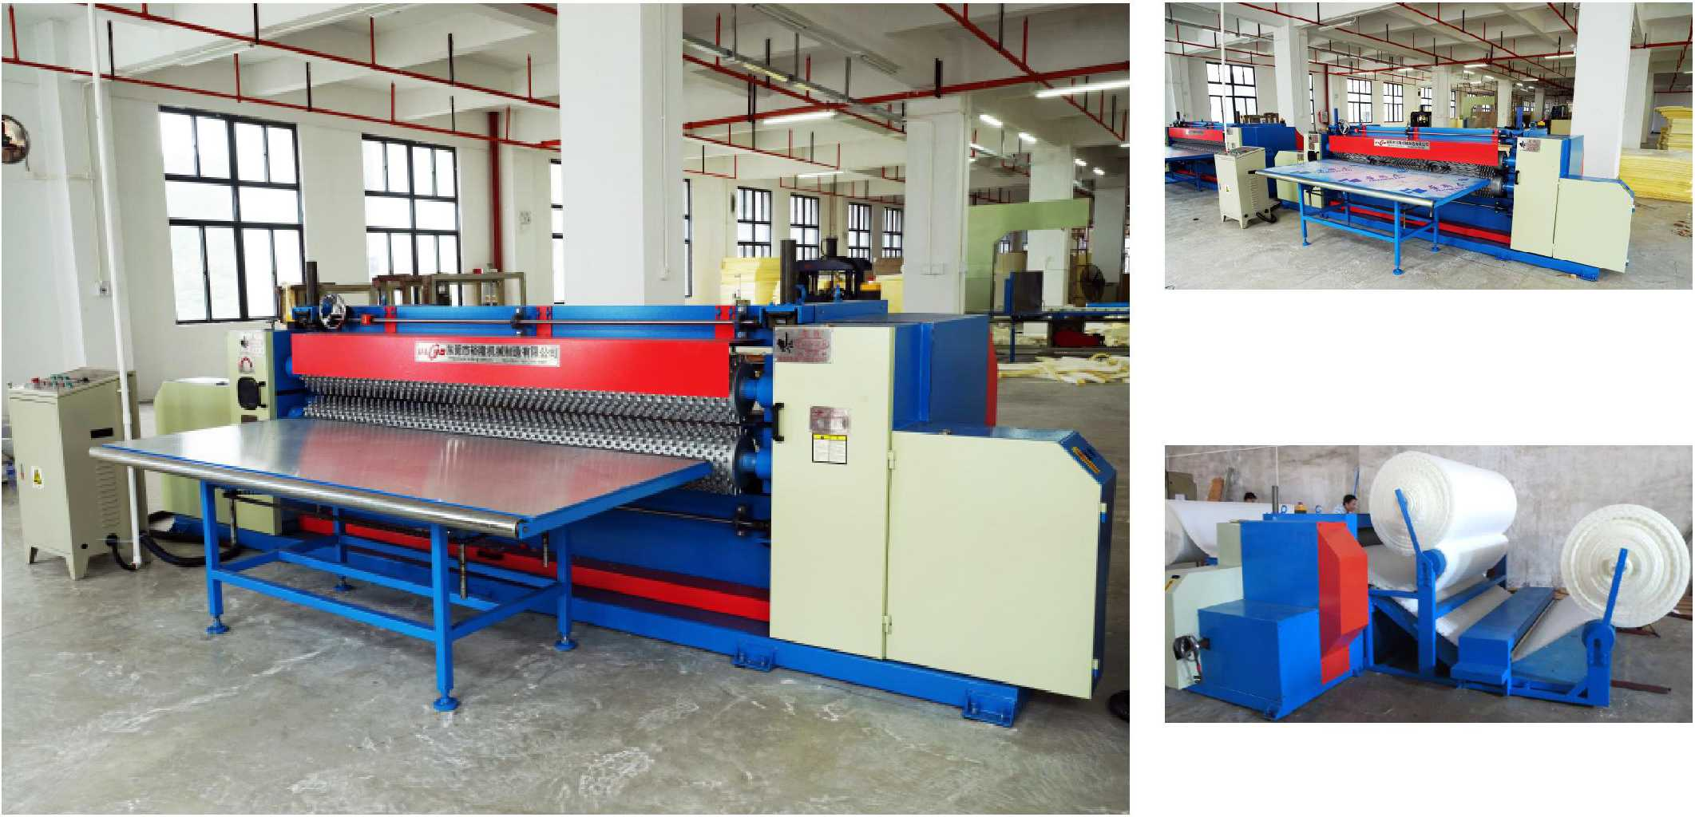
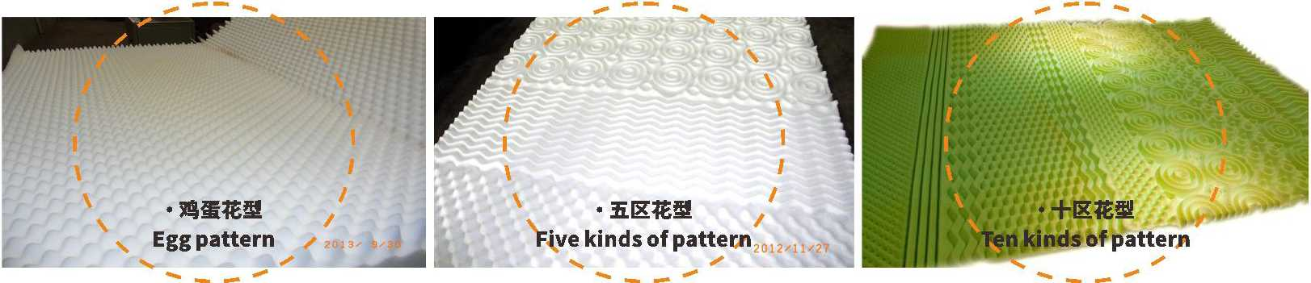
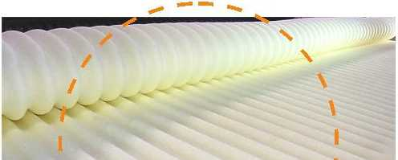
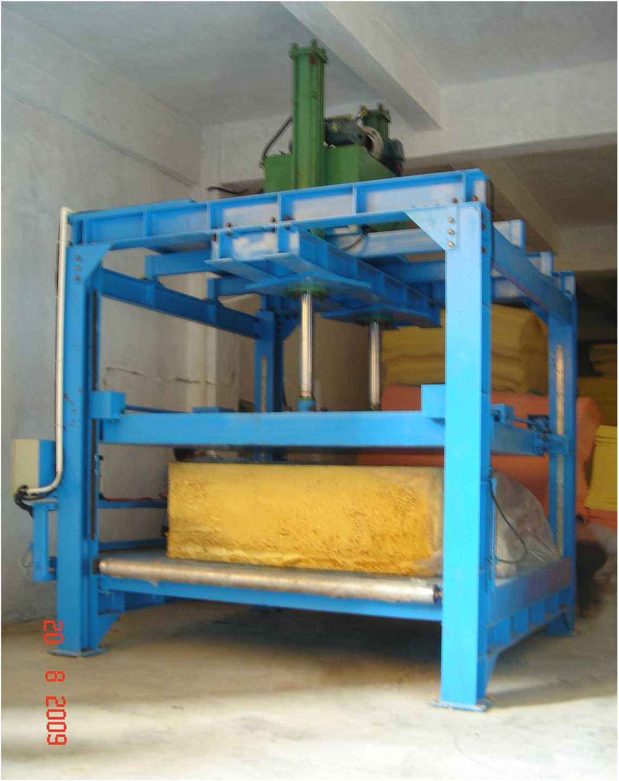
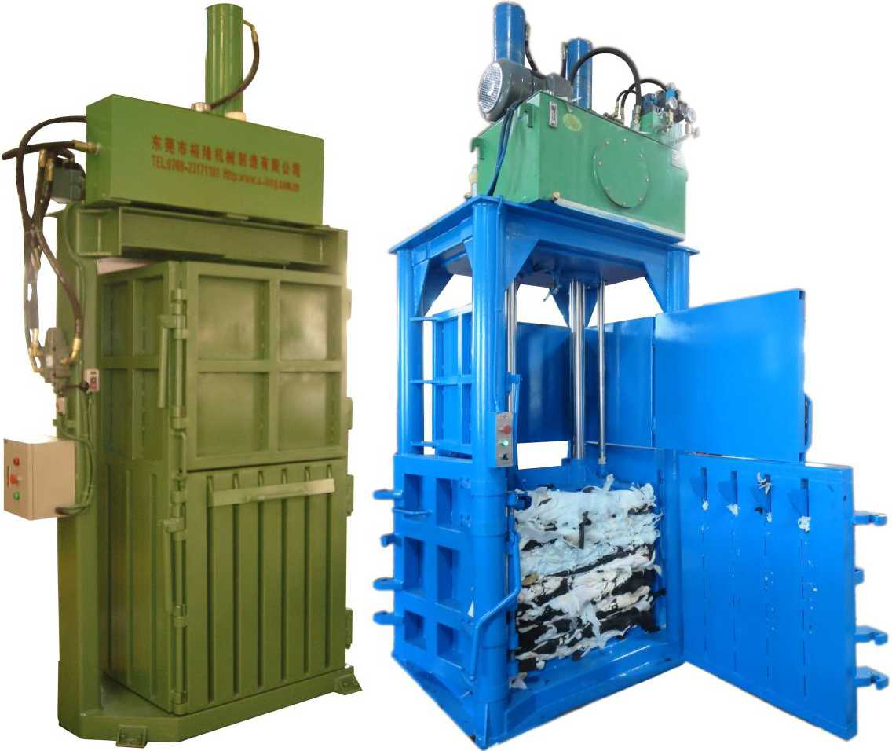

东凳市isBiiiniH制造有IE公司

DongGuan U-Long Machinery Co.,Ltd.

ULFX-6200/6900手动仿形切割机

Contour Cutting Machine(Manual Operation)

U LYX・O・2250 B 超强力海绵压形机 Heavy Duty Foam Profile Cutting Machine
本机主要用于特殊形状的海绵加工切片工作，利用预先制作的不同形状模具，可完成
柱、
弧、枕头等特殊形状产品的加
Io并配有风机，以固定海绵使切割效果更佳，确保产品质量，减少浪费。
This machine is mainly used for the cutting of special manufactured foam. The special shapes can be processed according to different shapes of moulds, such as cylindrical, arc, and pillow shapes. It is equipped with vacuum to
ensure better cutting effects, higher quality and less waste.
主要技术参数：Main Technical Specification
型号 Model | ULFX-6200 | ULFX-6900
最大切割宽度 Cutting width (max) | W1200xL1200mm | W1500xL1200mm
最大切割高度 Cutting height (max) | 600mm | 600mm
电机总功率  Total power of motor | 3.8Kw | 3.8Kw
刀带圆周长度 Cutter band total length | 6200mm | 6900mm
机器重量 Machine weight | 600Kg | 800Kg
机器外形尺寸(长X宽x高) Machine external size(LxWxH) | ULFX-6200: L2270xW2550xH1500mm  ULFX-6900: L3000xW2850xH1500mm

ULDB-30A/60A

床垫封口打包机

Matress Seal Packing Machine
本机主要用途是将大块海绵或床垫压实使其体积缩小，然后将其真空包装。
This machine is mainly used for compression of the big block foam and then vacuum packaging.
主要技术参数：Main Technical Specification
型号 Model | ULDB-30A  单面手动 Single side (manual) | ULDB-60A  双面自动 Double side (automatic)
油缸最大压力  Oil pressure (max) | 30T | 60T
电热片最大发热温度 Slice electricity temperature (max) | 200°C | 200°C
机器重量  Machine weight | 4500Kg | 6000Kg
最大海绵体积  Foam capacity (max) | L2100xW2000xH500mm | L2100xW2000xH500mm
最大行程  Treading distance (max) | 600mm | 600mm
机器外形尺寸  Machine external size | L2500 x W2300 x H3000mm | L10000xW3000xH3500mm

本机为压形切割机械切割，主要将海绵成波浪状绵。适用于电子、精密仪器、汽车座垫、保健用品以及贵重物件的包
装用途。
This machine is mostly used to press the foam into wavy foam, which can be suitable for electric and precision instruments, car cushion, health care supplies' and valuables' packing.

ULDB-60A 双面自动 Double side (automatic)
型号 | Model | ULYX-O-2250B
最大可切割海绵厚度 | Maximum cutting thickness | 300mm
压辐直径 | Dia. of press roller | 0400mm
最大压形宽度 | Profiling width (maximum) | W2250mm
最大压形深度 | Profiling depth(maximum) | 80mm
压形轮轴转速（工作状态） | Profiling axletree turning speed(working) | 0~25r/min
总功率 | Total power | 24.19KW
切割速度 | Cutting speed | 0~25m/min
刀带长度 | Blade length | L10600mm
机器重量 | Machine weight | 5000KG
机器外形尺寸（长x宽X高） | Machine external size(LxWxH) | L5.3xW3.35xH1.9M

注：以上数据和参数仅供参考，实际技术数据以出厂产品为准。
Remark: The above data is only for reference, all the parameter is subjected to the sold production.
注：以上数据和参数仅供参考，实际技术数据以出厂产品为准。
Remark: The above data is only for reference, all the parameter is subjected to the sold production.

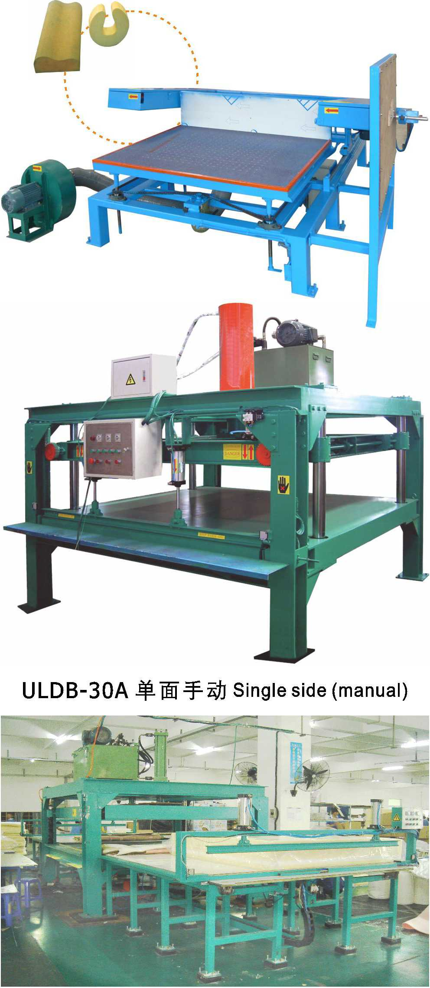
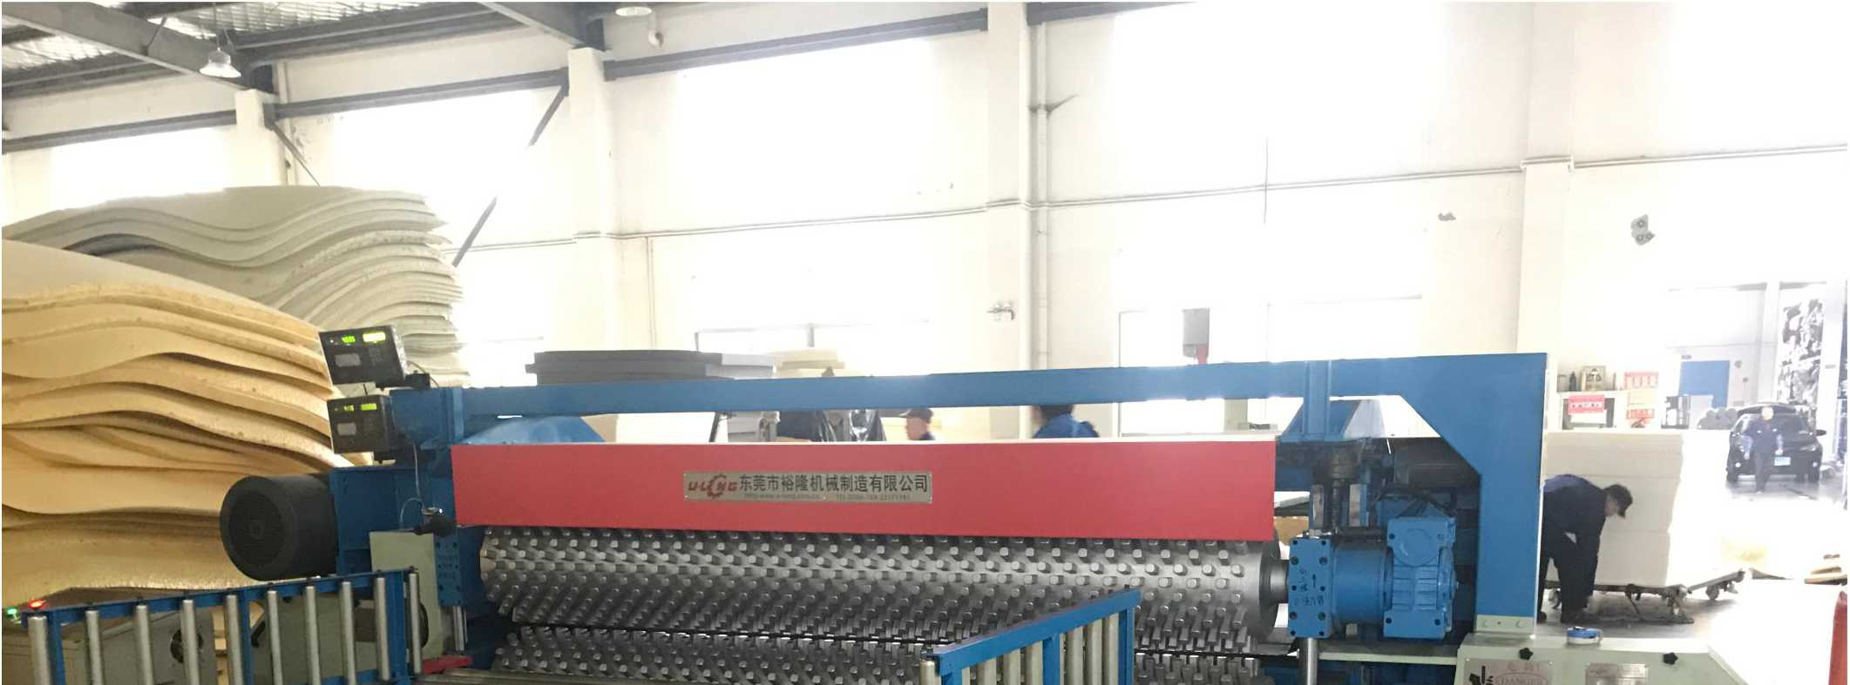
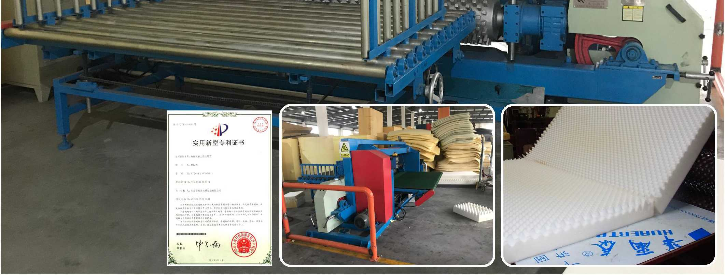

东凳市isBiiiniH制造有限公司

DongGuan U-Long Machinery Co.,Ltd.

ULKP-1650/2150
NEW
-P
实用新型专利证书

ULFJJ-2150

海绵开片机 Foam Slice Machine

海绵放绵复卷机
该机主要用于对厚度不标准的 海绵、海绵顶皮及底皮等进行分片 切割，大幅提高海绵成品率，为海 绵厂家创造更大经济效益。
This machine is mostly used to cut the foam of non-standard thickness, and the top or bottom part of the foam. It will significantly improve the foam yield and create more economic benefits for the

Foam Rewinding Machine
本机主要用于经过数控异形切割机(CNC)螺旋切割后的无限
长方形泡绵的复卷工作，采用电动调节，气动助力。操作简单，减
少工作空间，大量节省人力，提高生产效率。
型号 | Model | ULKP-1650 | ULKP-2150
切片尺寸 | Foam slice size | W1650mm | W2150mm
切片厚度 | Slice thickness | 2~200mm | 2-200mm
切片速度 | Slice speed | 0-30m/min | 0~30m/min
刀带长度 | Blade Length | 8700mm | 9700mm
总功率 | Total power | 8.52Kw | 8.52Kw
机器重量 | Machine weight | 1500Kg | 2000Kg
机器外形尺寸 | Machine external size | L3800xW1200xH 1400mm | L4300xW1200xH1400mm

manufacturers.
This machine is mainly used for the continuous rolling of square foam spiral cut by CNC special-shaped cutting machine. It adopts electrical adjustment, pneumatic booster, with simple operation, less labor force, high efficiency.
主要技术参数： Main Technical Specification
型号 | Model | ULFJJ-2150
有效卷绵宽度 | Available width | W2150mm
方泡最大尺寸 | Maximum block size | L2500xW2150xH1200mm
皮带驱动电机 | Belt driving motor power | 1.5kw
固定挡板宜径 | Diameter of fixed baffle | 0 1550mm

ULSPQ-800

海绵三维立体切割机
Foam Three Dimensional Cutting Machine (Manual Operation)
此设备主要用于特殊海绵的成型切割工作, 能根据客户的要求生产不同形状的产品如胸围 海绵，婴儿用品，电子包装等。
This machine is mainly used for the cutting of special shaped foam. According to customers⁵ demands, different shapes of foam can be customized, such as bra sponge, baby products, and electronic packing etc.
实用新型专利证书
IK
A At A* W 心”■
主要技术参数:
Main Technical Specification
切割宽度
Cutting Width
760mm

LlLrWYM-2^^{l}>n海绵暖暖排气圧绵机

3 ^{w} uuu Foam Odor and Exhaust Pressing Machine
主要技术参数： Main Technical Specification
主要用于将海绵卷材内部形成的气泡经挤压排气去除闭孔
现象、排除海绵内部残留的气体异味，再吸收新鲜的空气，再
经计码后自动卷为成品。极大的提高了海绵的质量，操作简便, 生产效率高。
This machine is mainly used for the squeezing and exhausting the bubbles, eliminating remaining odor and absorbing fresh air and then, rolling automatically after coding. The quality of the foam has been greatly improved, with simple operation and high efficiency.

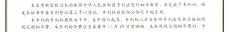
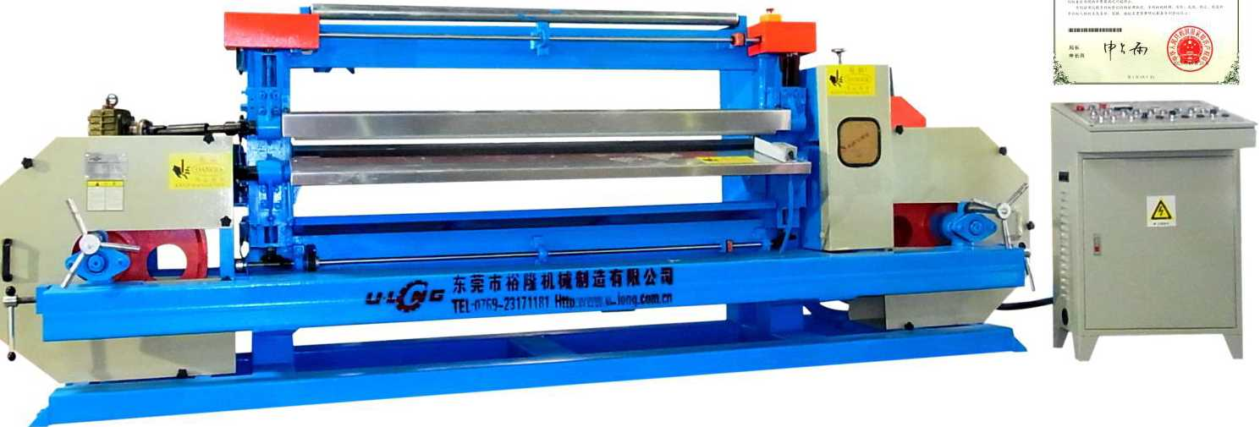
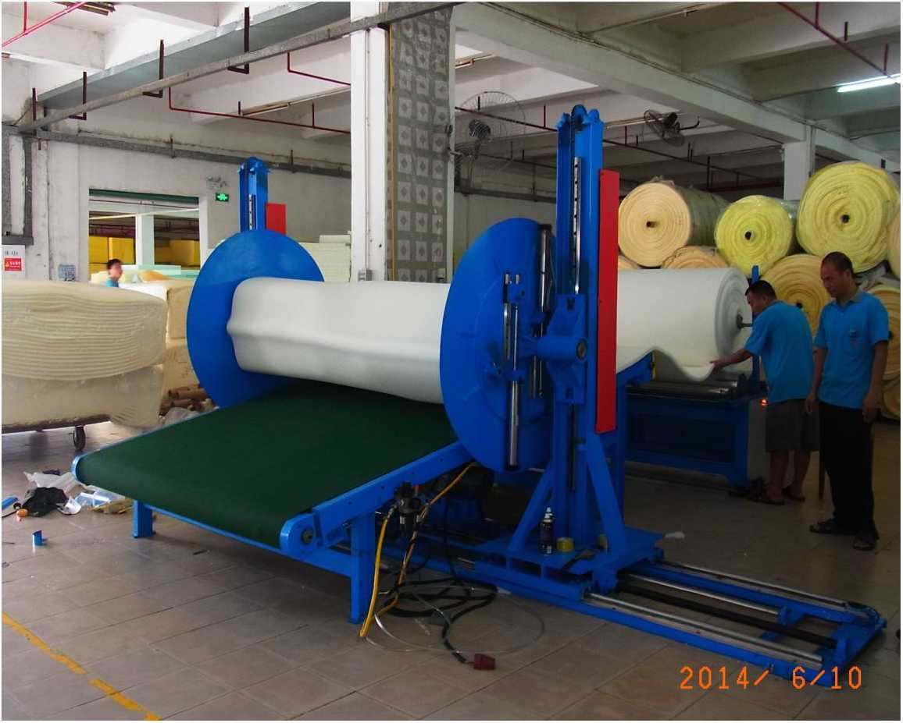
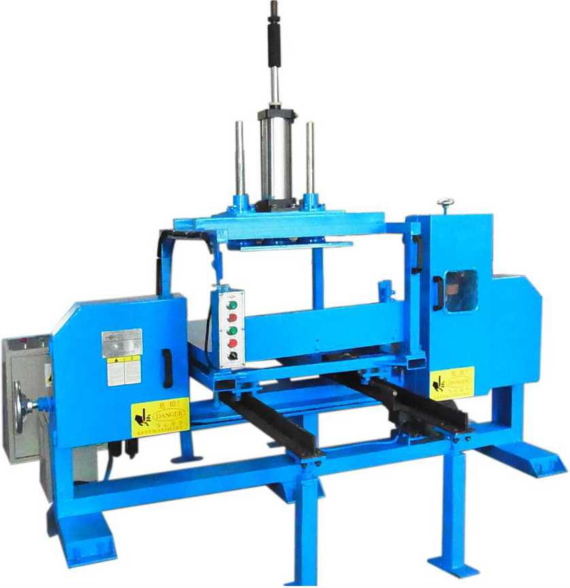
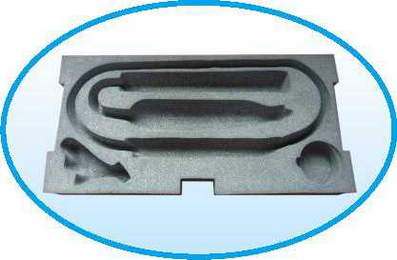


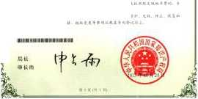
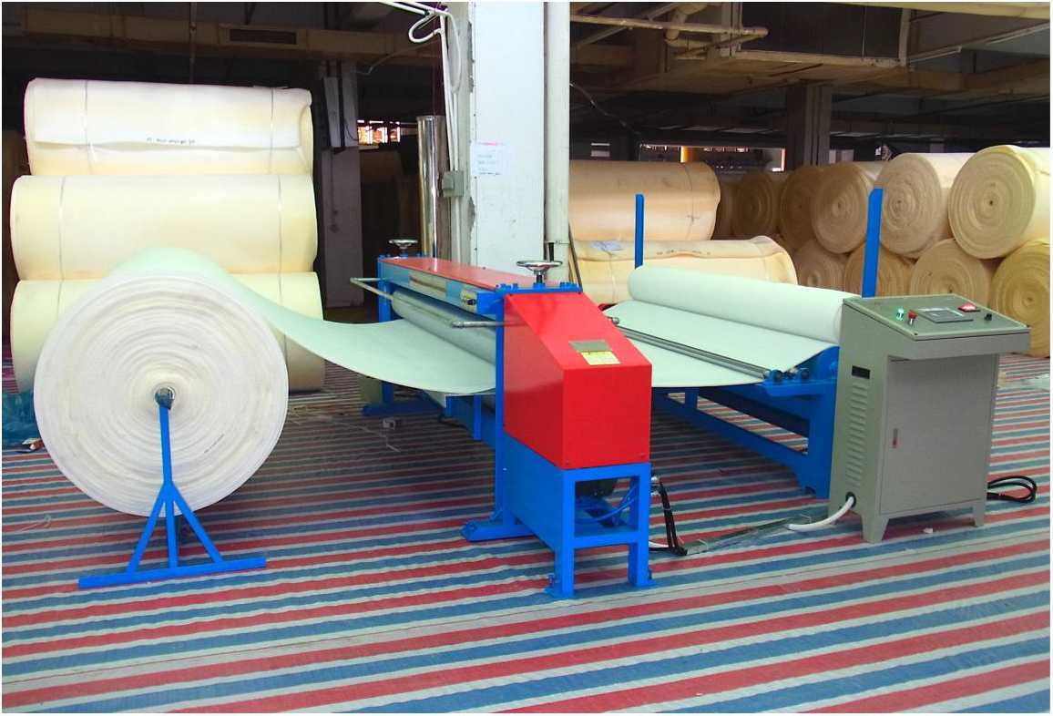

工作台尺寸 | Worktable Size | L800XW760mm
电机总功率 | Motor Power | 3Kw-4Pole
刀带长度 | Blade Length | 5000mm
总重量 | Total Weight | 1000Kg
外形尺寸 | External Size | L2800XW1600XH1200mm
压绵平台最大可调高度 Adjustment Height of Pressing Board(max)
100mm
注：以上数据和参数仅供参考，实际技术数据以出厂产品为准。

Remark: The above data is only for reference, all the parameter is subjected to the sold production.
型号 | Model | ULCWYM-2350
有效压绵宽度 | Available cutting width | W2350mm
压绵速度 | Pressing speed | 0~60m/min
压绵最大厚度 | Maximum pressing thickness | 0~200mm
电机功率 | Motor power | 5.15Kw
压绵辗直径 | Pressing rollers diameter | 0215mm

注：以上数据和参数仅供参考，实际技术数据以出厂产品为准。
Remark: The above data is only for reference, all the parameter is subjected to the sold production.

东凳市isBiiiniH制造有限公司

DongGuan U-Long Machinery Co.,Ltd.

ULCNC-1650A

线刀数控异形切割机

CNC Contour Cutting Foam Machine
This machine is mainly used for the special-shaped cutting of insulatin board and ventilation pipelines._{Q} It adopts CNC cutting system, high speed blade.
本机为两维电脑控制异形切割机，本机采 用高速线刀切割，主要用于保温隔热板及空调 通风管道的异形切割工作。
保温管切割产品 Insulated pipe Cutting Products
主要技术参数：Main Technical Specification
重量(Kg) Weight
2500Kg
刀架升降速度m/min
Cutter frame lifting speed
可编程轴 Editable program axis
X、Y
外形尺寸(mm) External machine size
L4800xW2580xH2540mm
断线保护
Break off protection
已设置
Already set
编程语言
Edit language
C+ +
最大加工尺寸(mm) Max processing size
W1600xL2000xH1200mm
CNC类型
CNC type
PC电脑/工控机
PC/Control machine
输入格式
Input format
Gcode(*.ISO)
线刀参数(mm)
Line blade parameter
4)1.2 x L7160mm
显示器
Display
15〃
加工精度(mm)
Precision of processing
±0. 5
工作台位移速度m/min Speed of worktable moving
L 5m/min
操作系统
Operation system
Windows2000

ULQB-1900

再生海绵粘合切边机

Re-bonding Foam Edge Cutting Machine
本机主要用于再生海绵的粘合切边及修边工作。
This machine is mostly used for the adhesive trimming and edge cutting of recycled foam.
主要技术参数：Main Technical Specification
切割宽度
切绵高度
Jointing width
Cutting height
总功率 Total power

ULCNC-2150B

数控异形海绵切割机（单/双刀）
KI

Vibration Blade CNC Contour Cutting Machine (Single/Double Blade)
本机采用先进的伺服电机及控制系统控制，高速窄型锯齿震动刀切割，排版速度快，无粉尘，切割精确，生产效率高，外型美
观，是目前海绵异形加工的最理想设备。
This machine adopts servo system, CNC system, high-speed vibration blade system, featured with high accuracy, no dust, fast feeding, and high efficiency. It is the ideal equipment for special-shaped foam processing.
最大加工宽度 Max processing width | 2,150 mm | 断刀保护 Blade break protect | 已设 lalreadyset
最大加工高度 Max processing height | 1,200 mm | 振刀长度  Vibration blade length | 跖 L2500mm  Srticai L1500mm
最大加工长度 Max processing length | 3,000 mm | 电压要求  Voltage | 220Vor380V 3P
刀行走速度 Blade Moving speed | 0.5-5M/min | 总功率  Total power | 9Kw
振刀线速度  Vibration blade speed | 4.8m/s | 总重量  Total weigh | 3000Kg
加工精度  Processing precision | 中60mm ± 0.5mm | 机器外形尺寸  Machine external size(LxWxH) | L7280xW3220xH2550mm

主要技术参数：Main Technical Specification
注：以上数据和参数仅供参考，实际技术数据以出厂产品为准。
Remark: The above data is only for reference, all the parameter is subjected to the sold production.
W1200-1900mm
H200mm
0
lEEP hands off
2.56Kw
机器外形尺寸 Machine external size L3500 x W600 x H2000mm

ULQB-2300

海绵导向切边机
Foam Guidance Edge Cutting Machine
调定位滚筒导向，通过输送带连续输送产品进行切边
作业。左右切边机采用电动同步调节宽度，操作简单, 节省人力’生产效率高。
This machine is mostly used for the side cutting of the whole block foam. The foam to be cut is conveyed through the continuous conveyor belt under the guidance of electronic adjustable roller. The left & right-side cutting machine adopts electric synchronous regulation of width, with simple operation, reduced manpower costs and high efficiency.
本机主要用于整泡海绵的切边工作，采用电动可
主要技术参数： | Main Technical Specification
前后平台输送带尺寸 | Conveyor size | W2300xL2000mm
有效切割高度 | Available cutting height | H1200mm
有效切割宽度 | Available cutting width | W2300mm
刀带电机 | Blade motor | 1.5kw-6极
切割误差 | Cutting deviation | ±L5mm
切割速度 | Cutting speed | 0~12m/min

注：以上数据和参数仅供参考，实际技术数据以出厂产品为准。
Remark: The above data is only for reference, all the parameter is subjected to the sold production.
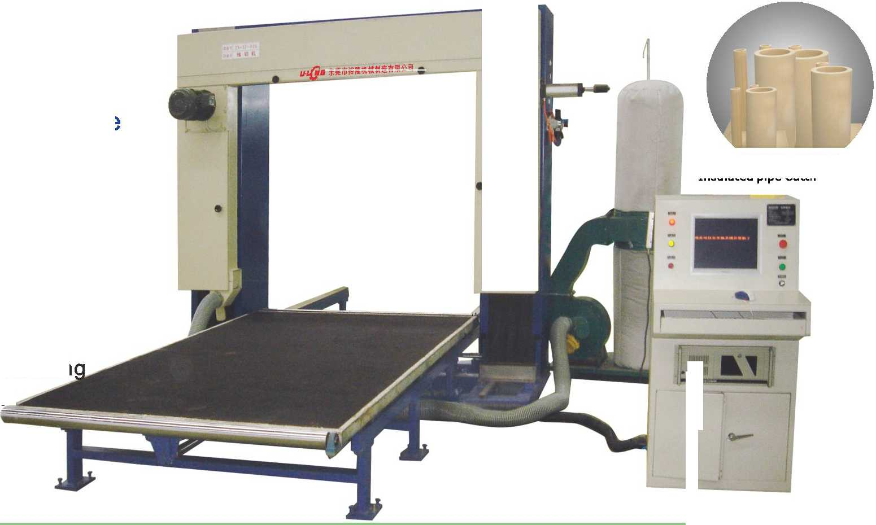
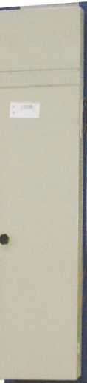
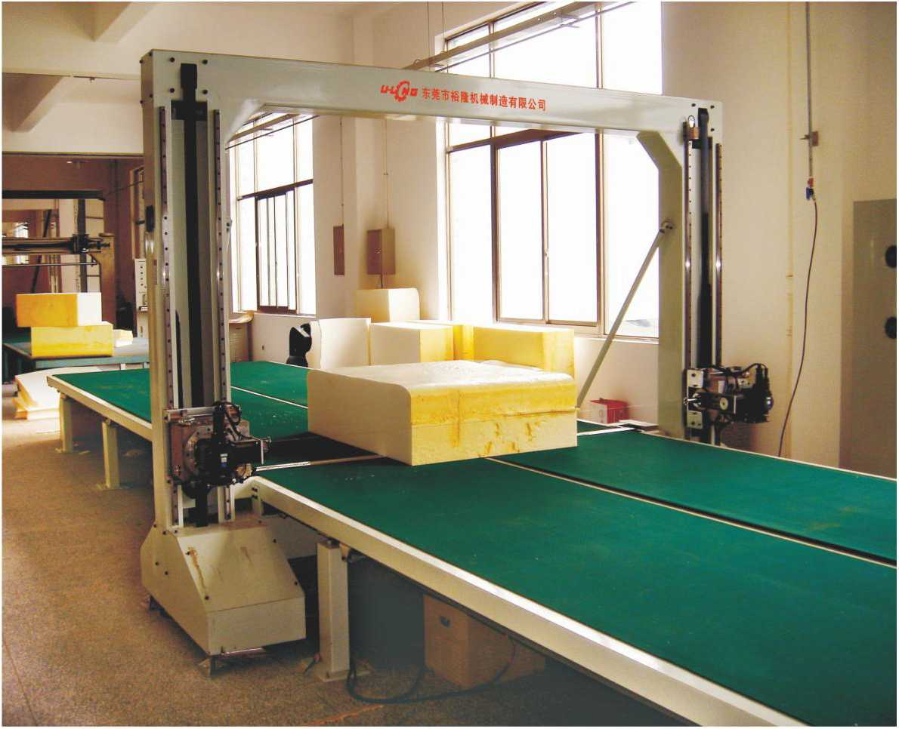
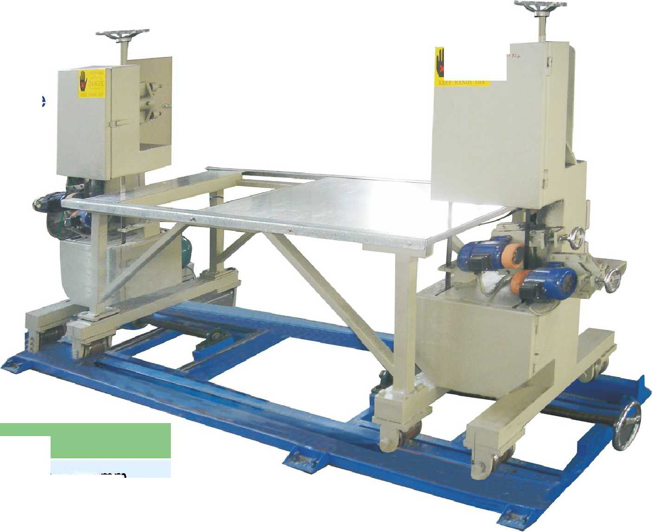
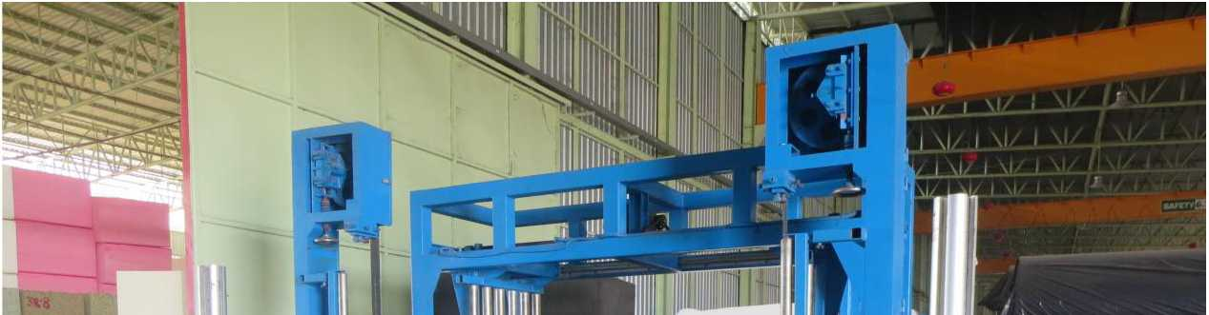
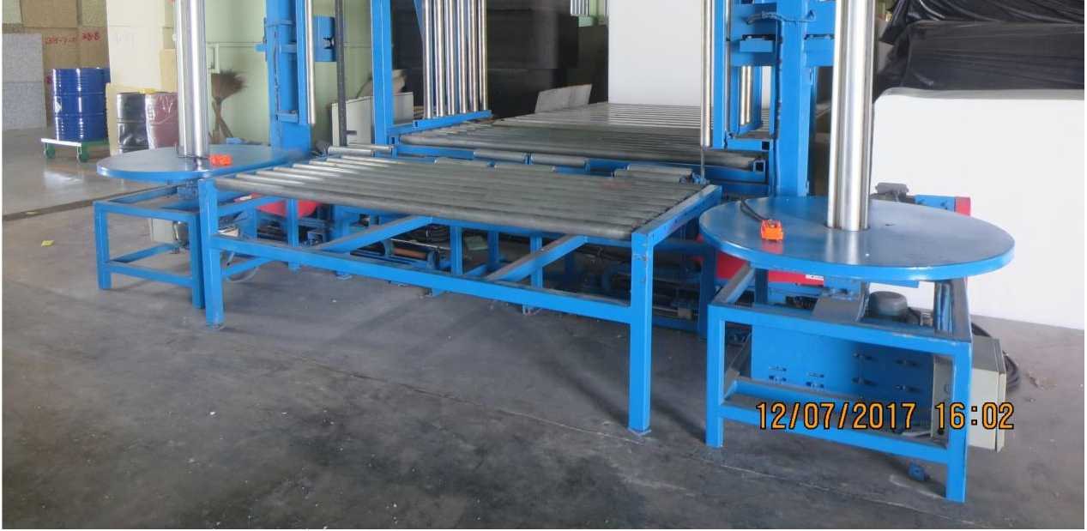

东凳市isBiiiniH制造有限公司

DongGuan U-Long Machinery Co.,Ltd.

U LLQ・2L海綿直切机(小型)

= = Vertical Foam Cutting Machine(Small)
本机主要用于小型海绵的垂直切片及海绵成型的精密切片工作，同时 可加工各类珍珠绵包装材料及EVA等材料。
This machine is mainly used for the vertical slicing of small foam, the precision cutting for foam^{J}s forming. In addition, it can also process all kinds of EVA and EPE.
内工作合尺寸
Inside worktable size
W480mm x L1000mm
外工作台尺寸
Outside worktable size
W1000mm x L1000mm
挡板高度
Baffle height
H400mm
切割高度
Cutting height
H600mm
刀带长度 Blade length
L4620mm
总功率
Total power
1.28Kw
机器重量
Machine weight
800Kg
夕卜形尺寸（长x宽x髙） Machine external size
L1650 x W1600 x H2150mm

」」 "丄 Vertical Foam Cutting Machine ( 3 Sheel)
本机主要用于小型海绵及切割高度小于600MM的EVA及蜂窝纸之 类的产品的切割工作。
This machine is mainly used for the cutting of small foam, all kinds of EVA under 600mm, and honeycomb paper.
内工作台尺寸
Inside worktable size
W1320mm x L2440mm
外工作台尺寸
Outside worktable size
W1200mm x L2440mm
Baffle height
H200/300mm
切割高度
Cutting height
H400/600mm
刀带长度
Blade length
L5810/L6040mm
总功率
Total power
1.34Kw
机器重量
Machine weight
1000Kg
夕卜形尺寸（长x宽x高）Machine external size
L4500 x W4000 x H2100mm

ULLQ-4LW

湿帘纸切割机

Wet Screens Cutting Machine
本机主要用于湿帘纸垂直 切割及湿帘纸成型的切割工作。
This machine is mainly used for the vertical cutting and forming cutting of wet curtain.
Model
内工作台尺寸 Inside worktable size W1320mm x L2290mm W1720mm x L2290mm
外工作台尺寸 Outside worktable size W1200mm x L2290mm W2000mm x L2290mm
切割厚度
Cutting thickness
H800/1200mm | H800/1200mm
L7320mm/L8100mm | L8100mm/L8900mm
2.41 Kw | 2.41 Kw
1300Kg | 1500Kg
L4500xW4000xH2550mm | L4500xW4800xH2550mm

切割高度 Cutting height
刀带长度 Blade length
总功率 Total power
机器重量 Machine weight
夕卜形尺寸(长x宽X高)Machine external size

ULQK-1500

岩棉保温管分中切割机

RockWool Insulated Pipe Cutting Machine
此机主要用于把保温管和圆柱形岩棉从中间对半
切开，主要用于空调及液体输送管道等需要保温隔热 管道的产品生产，该机操作简便，生产效率高。
This machine is mainly used for the half cutting of the insulated pipes and cylindrical rock wool, with simple operation and high efficiency. It is mainly used for the producing of air condition and liquid delivery pipelines that need insulated pipes.
主要技术参数：Main Technical Specification
操作平台尺寸：  Worktable size: | L1600xW1500xH400mm
保温管最大尺寸： Insulated pipe size(max) | H1200xei200mm
总功率  Total power | 3.7Kw

ULQK-1500B
注:
以上数据和参数仅供参考，实际技术数据以出厂产品为准。
Remark: The above data is only for reference, all the parameter is subjected to the sold production.

岩棉保温管组合切割机

RockWool Insulated Pipe Cutting Machine
本机主要用于岩棉保温管先切割两端端面后再 进行中分切割的全自动一次成型切割工作，本机是 空调以及液体输送等保温管道材料生产的必须设备
This machine is mainly used for the one- time forming cutting of the rock wool insulating pipes. It is the necessary equipment for the producing of air condition and liquid delivery pipelines.
主要技术参数：Main Technical Specification
保温管切割宽度 Cutting Width For Insulated Pipe | 900^1200mm
最大切割直径  Cutting Diameter | (maximum)900mm
刀带长度  Blade length | 9400 X25X 0.45mm /5800X25X 0.45mm

注：以上数据和参数仅供参考，实际技术数据以出厂产品为准。
Remark: The above data is only for reference, all the parameter is subjected to the sold production.
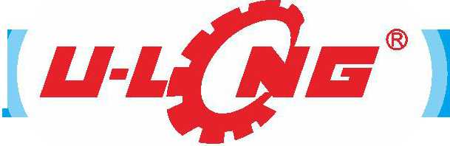
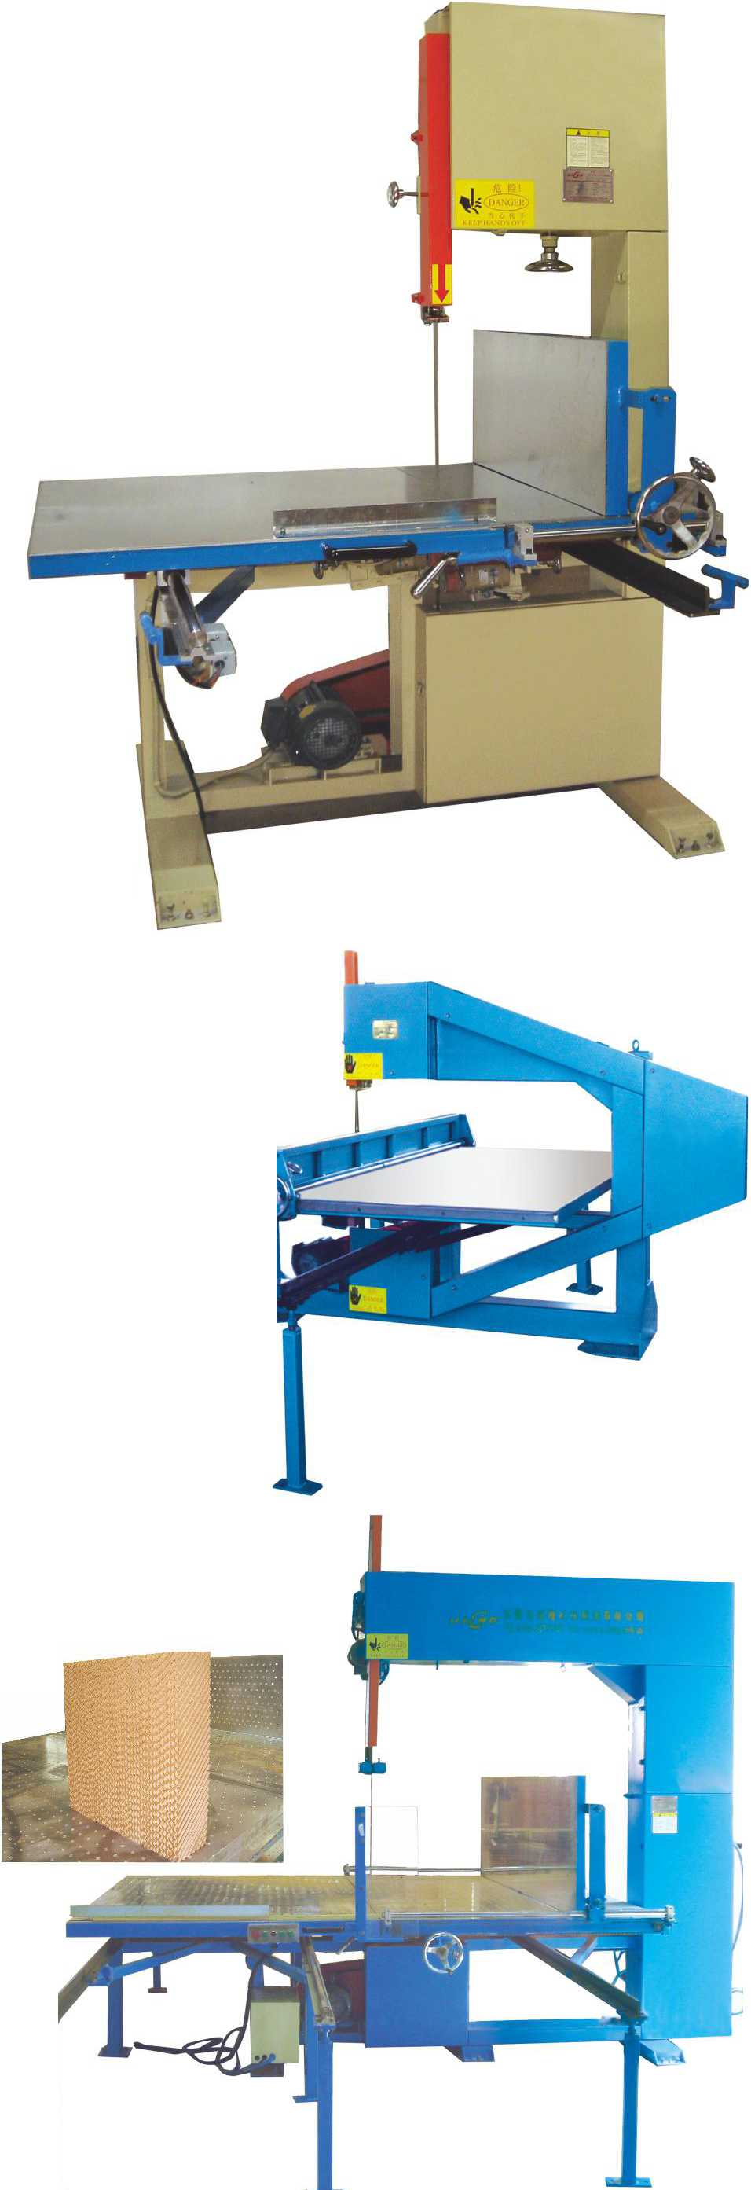
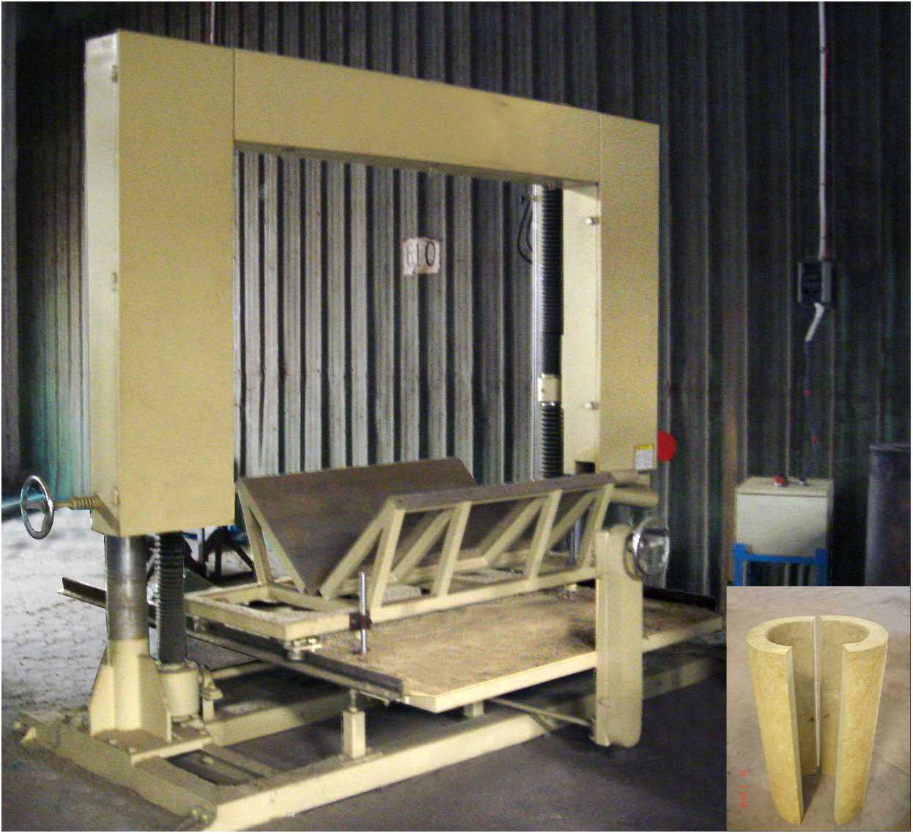
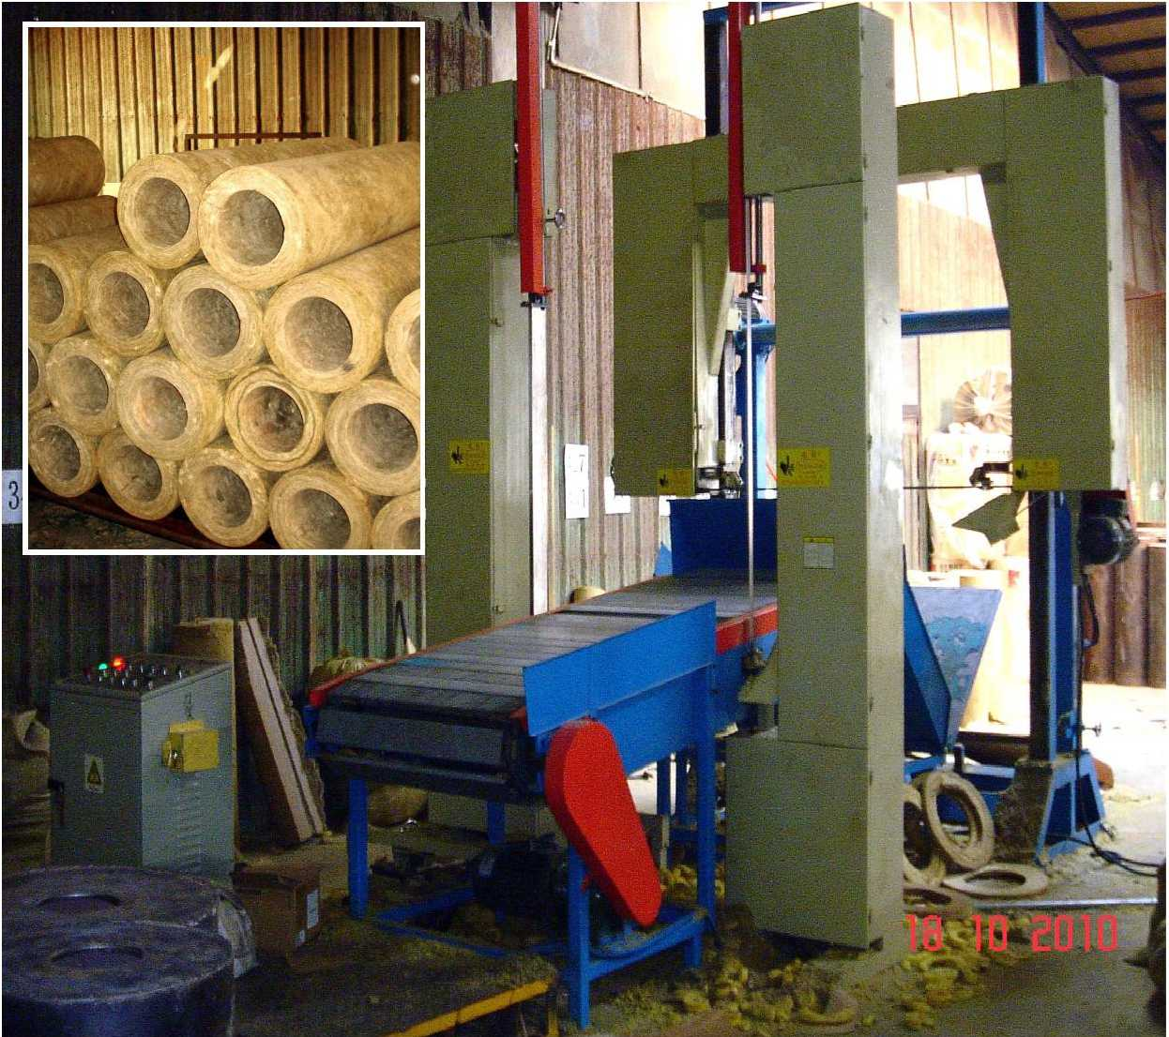

东凳市isBiiiniH制造有限公司

DongGuan U-Long Machinery Co.,Ltd.

U LYQ・1 650 强力旋切机 Strong Peeling Machine

ULLQ-4LE
切割产品
(cutting products)
―网r—

海绵直切机(高精度型)

Vertical Foam Cutting Machine(Precision)
本机主要用于海绵垂直切片及海绵成型的切片工作，采用先进的直线导轨制作，切割精度相对较高。本机同时可加工各种纸类EVA及珍珠绵工作。
「少
实用新型专利证H
r .*5•好
5. 1九*云1
实用新型专利证书
型号Model | ULYQ-1650C | ULYQ-1650D
最大切割尺寸（直径X长度）  Cutting size（dia.Length） | 1500x1650mm | (|) 1500x1650mm
切割厚度范围 Cutting thickness | 2-20mm | 2-20mm
总功率  Total power | 17.44KW | 32.74KW
刀带长度  Blade length | L9300xW100xT0.8mm L10400xW1 OOxTImm
最大切割密度  Cutting density(max) | 800Kg/m³ | 1200Kg/m³
旋转速度  Turning speed | 0~30m/min | 0~10m/min
机器重量 Machine weight | 3000KG | 5500KG
机器外形尺寸(长x宽x高) Machine external size(LxWxH) | L5200xW2300xH2200mm L5855xW4950xH 1400mm

本机主要用于运动场弹性橡胶地板，橡胶卷材和防滑橡胶浴室地垫等，以及超高密度再生海绵和透气鞋垫卷材（如：海波丽）等产
品的无限长薄片切割工作。本机采用伺服系统，全自动数字控制切割厚度，切割精确，操作简单，生产效率极高。
This machine is mostly used to cut round product into continuously long slices, include: Rubber floor of playground, Rubber sheet and Skidproof rubber floor, etc. and High density rebonding foam and Ventilate insole sheet (ex.:HI-POLY) and so on. This machine adopt servo system and digital system to control the cutting thickness auto matically, the cutting is exact, the operation is simple and the effidiency is high.

ULYQ-1650D鲸力旋切机 Heavy Duty Peeling Machine
次用芹型苗利亦竹
实州創型&河止
切割产品
(cutting products)
注：以上数据和参数仅供参考，实际技术数据以出厂产品为准。
Remark: The above data is only for reference, all the parameter is subjected to the sold production.
This machine is mainly used for the vertical slicing and forming slicing of the foam. It adopts advanced beeline track
with relatively high accuracy. All kinds of EVA materials can be processed.
主要技术参数：Main Technical Specification
型号Model | ULLQ-4LE 中型Middle | ULLQ-4LE 大型Big
内工作台尺寸  Inside worktable size | W1320mmxL2440mm | W1720mm xL2440mm
外工作台尺寸  Outside worktable size | W1200mmxL2440mm | W2000mm x L2440mm
切割厚度 Cutting thickness | 3~ mm | 3“ mm
切割高度 Cutting height | H800/1200mm | H800/1200mm
刀带长度  Blade length | L7320mm/L8100mm | L8100mm/L8900mm
总功率 Total power | 1.34KW | 1.34Kw
机器重量 Machine weight | 1300Kg | 1500Kg
外形尺寸(长x宽x高) Machine external size | L4500xW4000xH2550mm | L4500xW4800xH2550mm

ULLQ-4L

海绵直切机（中型和加大型）

Vertical Foam Cutting Machine(Middle and Big)
本机主要用于海绵垂直切片及海绵成型的切片工作。本机同时可加工各
种纸类EVA及珍珠绵工作。最先釆用直线导轨进行挡板移动导向，定位更准, 切绵效果更佳。
This machine is mainly used for the vertical slicing and forming slicing of the foam. It adopts advanced beeline track with relatively high accurate positioning and cutting. All kinds of EVA materials can be processed.
型号Model | ULLQ-4L 中型Middle | ULLQ-4L 大型Big
内工作台尺寸  Inside worktable size | W1320mmxL2440mm | W1720mm xL2440mm
外工作台尺寸 Outside worktable size | W1200mmxL2440mm | W2000mmxL2440mm
切割厚度 Cutting thickness | 3~ mm | 3~ mm
切割高度  Cutting height | H800/1200mm | H800/1200mm
刀带长度  Blade length | L7320mm/L8100mm | L8100mm/L8900mm
总功率  Total power | 1.34Kw | L34Kw
机器重量 Machine weight | 1300Kg | 1500Kg
外形尺寸(长x宽x高)  Machine external size | L4500xW4000xH2550mm | L4500xW4800xH2550mm

主要技术参数：Main Technical Specification

加大型 ULLQ-4L(Big)
注：以上数据和参数仅供参考，实际技术数据以出厂产品为准。
Remark: The above data is only for reference, all the parameter is subjected to the sold production.


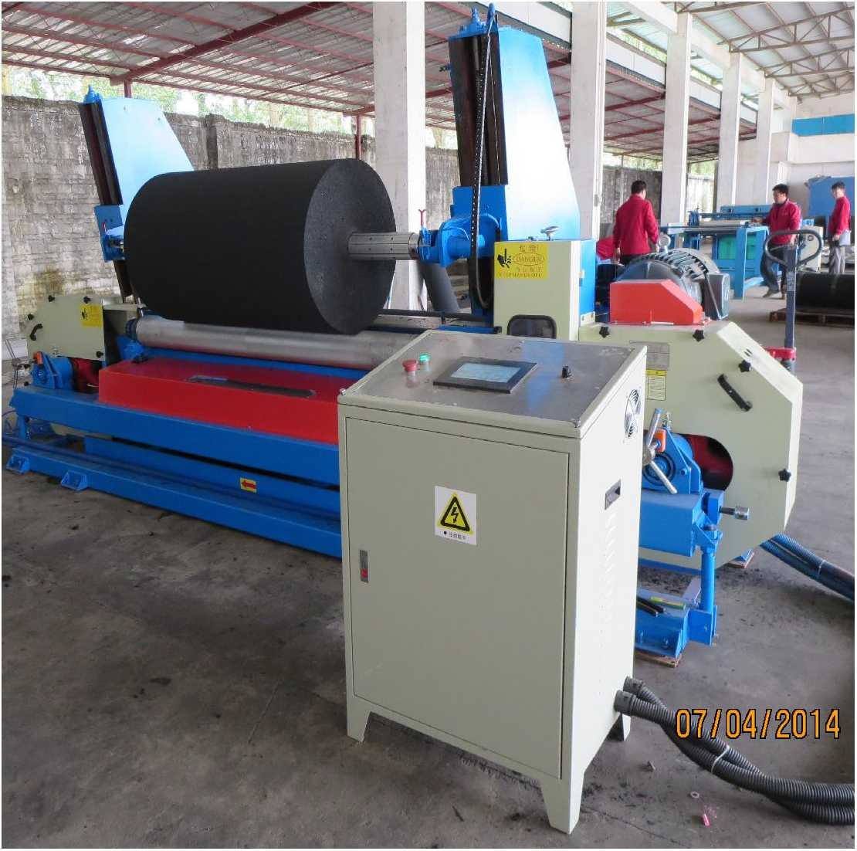
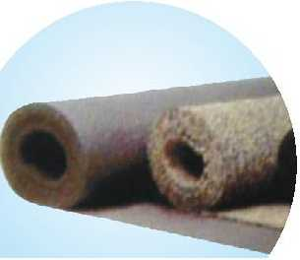


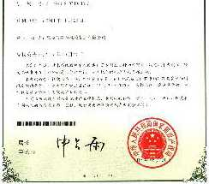
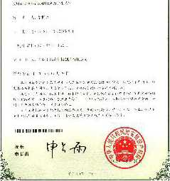
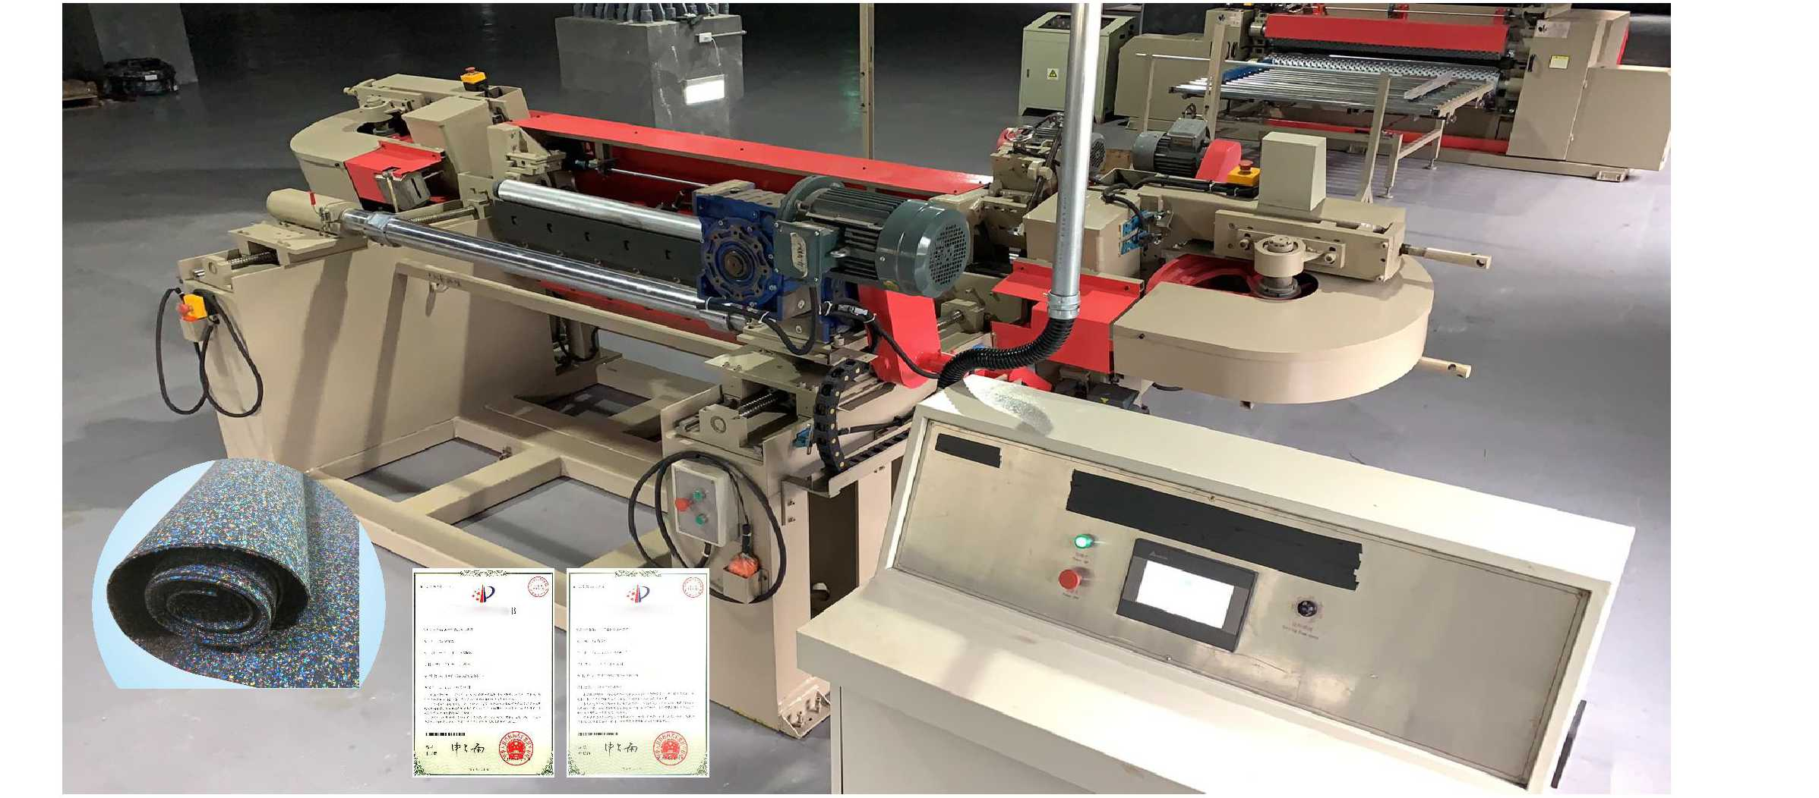
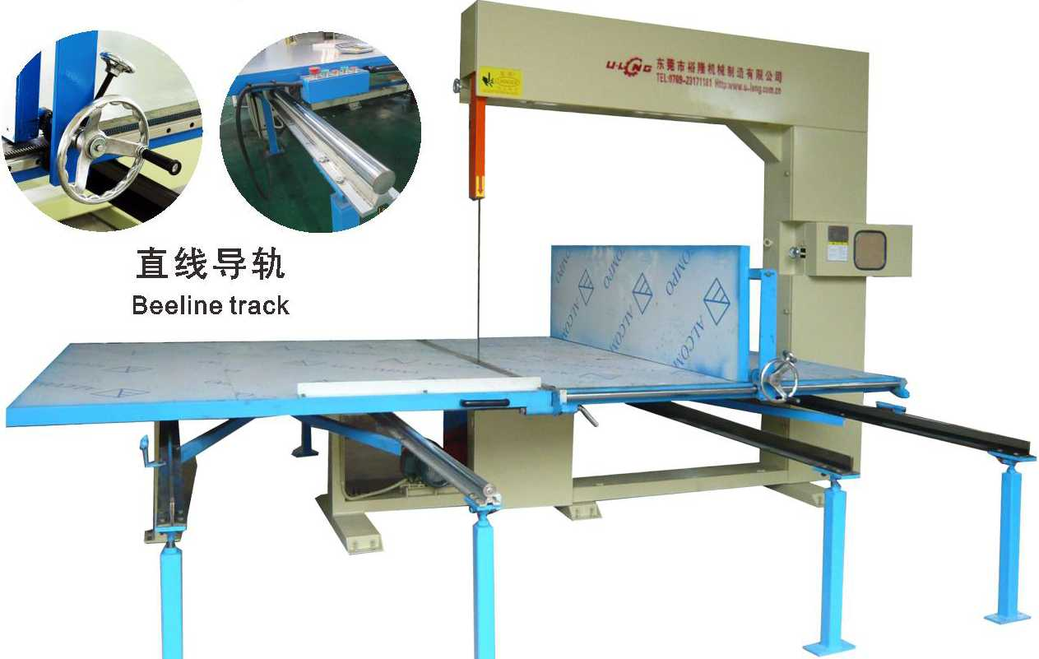
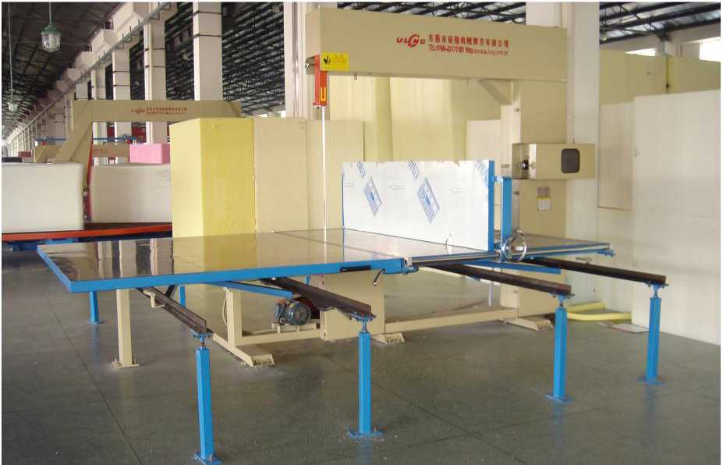
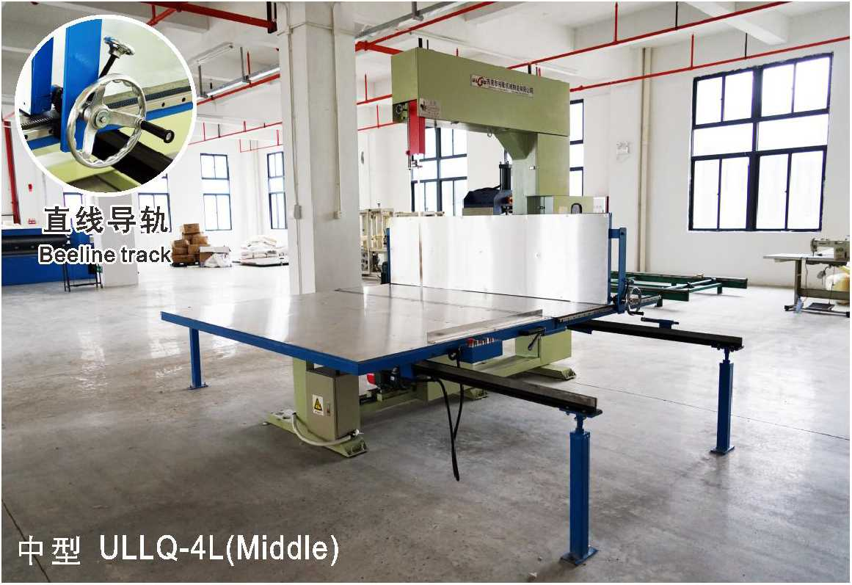

东凳市isBiiiniH制造有IE公司

DongGuan U-Long Machinery Co.,Ltd.

ULLQ-4LA

海绵半自动直切机

Semi-automatic Vertical Foam Cutting Machine
主要用途：Main Usage
本机采用刹车电机驱动切绵挡板，采用数字控制 切绵厚度，切绵更准确，效率更高，大力降低操作员
的劳动强度，同时采用电动控制夹刀杆自动升降，提
供更周全的劳动保护。
This machine adopts brake motor driving baffle, digital control of cutting thickness, with higher accuracy and efficiency ‘vigorously reducing labor force. Clamping rod is automatically controlled to make it safer.
主要技术参数：Main Technical Specification
型号Model | ULLQ-4LA 中型Middle | ULLQ-4LA 大型Big
内工作台尺寸  Inside worktable size | W1320mm xL2440mm | W1720mmxL2440mm
外工作台尺寸 Outside worktable size | W1200mmxL2440mm | W2000mmxL2440mm
切割厚度  Cutting thickness | 3~ mm | 3~ mm
切割高度  Cutting height | H800/1200mm | H800/1200mm
刀带长度  Blade length | L7320mm/L8100mm | L8100mm/L8900mm
总功率 Total power | 1.92Kw | 1.92Kw
机器重量 Machine weight | 1300Kg | 1500Kg
外形尺寸(长X宽X高)  Machine external size | L4500xW4000xH2550mm | L4500xW4800xH2550mm

ULYQ-2150

海绵圆切机

Foam Peeling Machine
本机主要用于各类圆柱形海绵的无 限长薄片切割工作.本机最新研制开发, 可选配电数字控制设定切割厚度，去除 繁琐的变换齿轮改变切割厚度的工作，操 作更快捷,精密度更高！
This machine is mainly used for the continuous cutting of the cylindrical foam. This machine is the latest developed, and computer control system of cutting thickness is optional, with simpleroperation and higher cutting accuracy.
K 1
□

ULLQ-4LB

海绵全自动直切机

Automatic Vertical Foam

Cutting Machine
主要用途：Main Usage
主要技术参数：Main Technical Specification
本机采用刀架移动切割工作，工作台及工件
定启动控制切绵厚度，刀带来回移动进行切割。
本机全自动控制，切割精确，节省人手，生产效率
大为提咼。
This machine conducts reciprocating cutting by adopting moving carrier, fixed worktable, with automatically control of the cutting thickness.
Fully automatic control of this machine ensures higher accuracy and efficiency, less labor force.
刀带长度  Cutter length | L9480mm | 有效切割行程 Available cutting stroke | 2200mm
挡板行程  Baffle distance | 2050mm | 切绵厚度范围 Cutting thickness scope | 3~ mm
总功率  Total power | 7.09Kw | 切绵有效高度 Available cutting height | 1100mm
挡板行走速度 Baffle treading speed | 0~10m/min | 刀架行走速度  Blade Frame moving speed | 0~20m/min

内工作台尺寸(长X宽)  Inner worktable size:(WxL) | W2150mmXL2440mm
外工作台尺寸(长X宽)  Outer worktable size(WxL) | W2150mmXL2440mm
最大外形尺寸(长X宽X高)  Machine external size max(L xWxH) | L3700 X W5700 X H2900mm

注：以上数据和参数仅供参考，实际技术数据以出厂产品为准。
Remark: The above data is only for reference, all the parameter is subjected to the sold production.
最大切割尺寸(直径X长度) Cutting size(dia.Length) | 4)2000x2150mm
切割厚度范围 Cutting thickness | 2~25mm
总功率  Total power | 6.94Kw
刀带长度 Blade length | 9260mm

主要技术参数：Main Technical Specification
最大切割密度 Cutting density(max) | 60Kg/m³
旋转速度  Turning speed | 25m~30m/min
机器重量  Machine weight | 1800Kg
机器外形尺寸(长X宽X高)  Machine external size(LxWxH) | L4430xW1650xH1950mm

可选配电脑数字控制系统 Additional computer control system

ULYQ-1900B

再生海绵圆切机

Re-bonding Foam Peeling Machine
本机主要用于各类再生圆海绵的无限长薄片切割工作， 主要用于再生海绵地毯及高密度透气鞋材等产品的切割生产 工作。可选配电脑数字控制设定切割厚度，去除繁琐的变换 齿轮改变切割厚度的工作，操作更快捷，精密度更高！
This machine is mainly used for the continuous cutting of recycled round foam, such as recycled foam carpet, high- density breathable shoe materials. Computer control of cutting thickness is for your option, w代h simpler operation and higher cutting accuracy.
主要技术参数：Main Technical Specification
最大切割尺寸(直径x长度)
Cutting size(dia.Length)
切割厚度范
Cutting thickness
总功率
Total power
刀带长度 Blade length
4)2000x1900mm
2~25mm
9.44Kw
L9600XW60XT0.65mm
最大切割密度 Cutting density(max) | 150Kg/m³
旋转速度  Turning speed | 25m~30m/min
机器重量 Machine weight | 2000Kg
机器外形尺寸(长X宽x高) Machine external size(LxWxH) | L4730xW1800xH2200mm

注：以上数据和参数仅供参考，实际技术数据以出厂产品为准。
Remark: The above data is only for reference, all the parameter is subjected to the sold production.
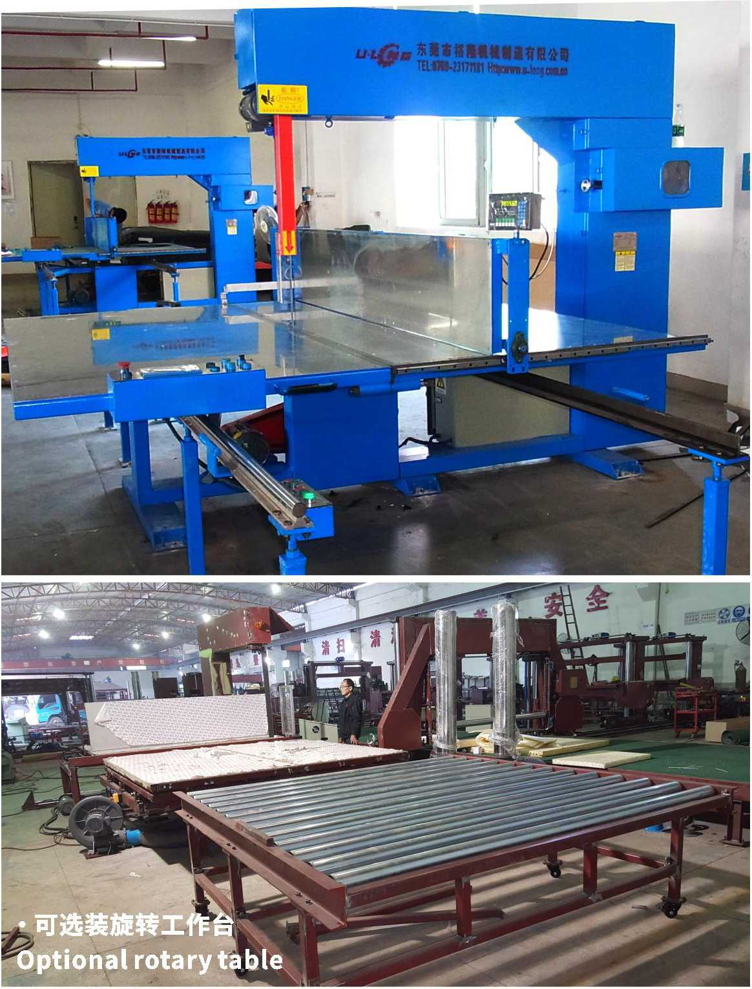
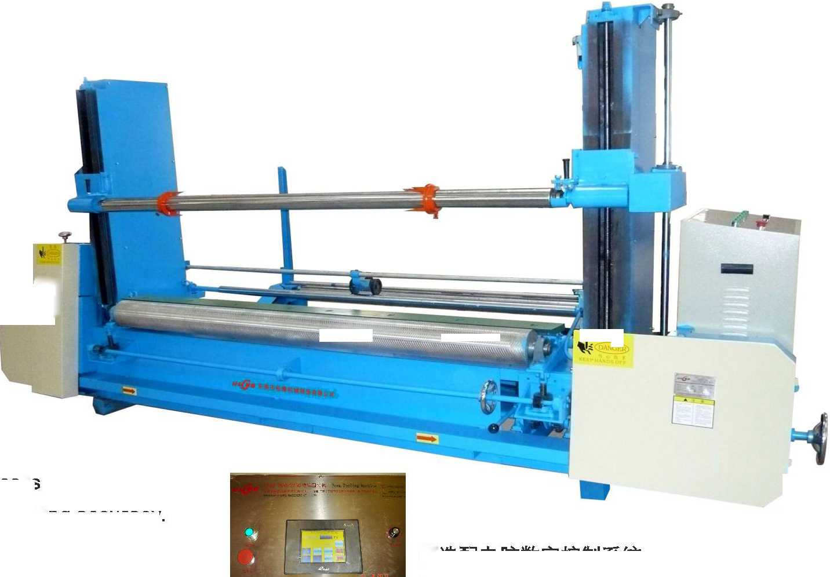
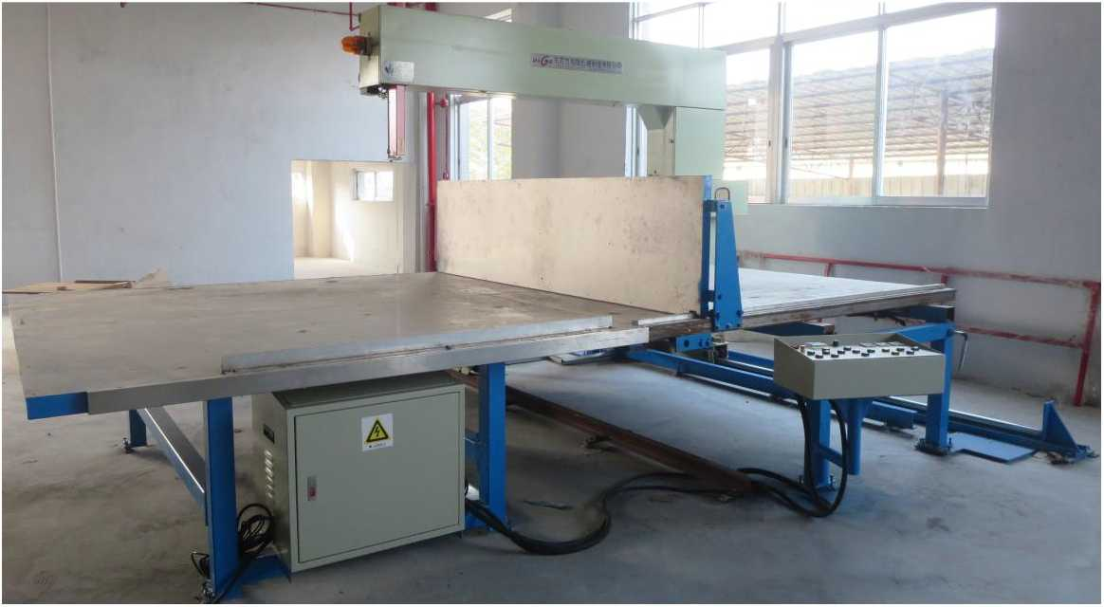
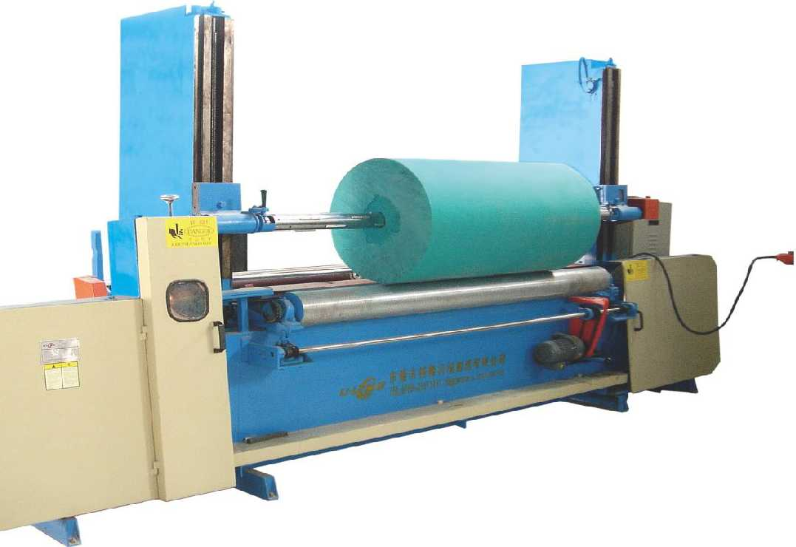

东凳市isBiiiniH制造有限公司

DongGuan U-Long Machinery Co.,Ltd.
ULZK-45A
海绵卧式钻孔机

Foam Seated Boring Machine
本机主要用于圆形海绵的中间钻
孔工作，为
切机的必备配套设备。
This machine is mainly used for center drillingof thefoam,whichisthenecessary equipmentfor the circular cutter.
型号Model | ULZK-45A
钻孔直径  Punching diameter | 63mm
主轴转速  Principal axis turning speed | 230r/min
机器重量 Machine weight | 800Kg
加工件尺寸(直径X长度) Processed parts size (diaxlength) | 0 2000x2200mm
总功率 Total power | 0.2Kw
机番尺寸  Machine external size | L5.7xW1.35xH1.8m

)j 海绵全自动直切机(单面/双面切割)

U '縛』 Automatic Vertical Foam Cutting Machine (Single Side/Double Side Cutting)
本机采用平台移动切割工作，刀架固定，海绵块被左右挡板夹持自动控制切绵厚度，工作台来回移动进行切割。本机釆用计数
器及编码器控制，切割精确，节省人手，生产效率大为提高。
This machine adopts moving worktable, fixed carrier. The worktable conducts reciprocating cutting ofthe foam fixed by baffles, with automatic thickness control. This machine adopts counter and coder control, with high cutting accuracy and efficiency, less labor force.
ULZK-45B
海绵立式钻孔机

Foam Vertical Boring Machine
本机主要用于圆形海绵的中间钻
孔工作，为圆切机的必备配套设备。
This machine is mainly used for center drilling ofthe foam, which is the necessary equipment for the circular cutter
型号Model | ULZK-45B
钻孔直径  Punching diameter | 63mm
主轴转速  Principal axis turning speed | 230r/min
机器重量  Machine weight | 1200Kg
加工件尺寸(直径X长度) Processed parts size (diaxlength) | 0 2000x2200mm
总功率 Total power | 1.15Kw
机器尺寸  Machine external size | L1.4xW2.3xH5.5m

型号Model | ULLQ-4LC 中型Middle | ULLQ-4LC 大型Big
内工作台尺寸(长x宽)  Inner worktable size:(WxL) | W1320xL2440mm | W1720xL2440mm
外工作台尺寸(长X宽)  Outer worktable size(WxL) | W1200xL2440mm | W2000 x L2440mm
有效切割高度  Available cutting height | 800/1200mm | 800/1200mm
刀带长度  Blade length | 7320mm/8100mm | 8100mm/8900mm
挡板高度 Baffle height | 400/600mm | 400/600mm
切绵厚度范围  Cutting thickness scope | 3~ mm | 3~ mm
挡板行走速度 Baffle treading speed | 0-10m/min | 0-10m/min
平台移动速度  Worktable moving speed | 0-20m/min | 0~20m/min
总功率 Total power | 3.62Kw | 3.62Kw
最大外形尺寸(长X宽X高)  Machine external size max(LxWxH) | L4000xW4800xH2550mm | L4500xW4800xH2550mm

注：以上数据和参数仅供参考，实际技术数据以出厂产品为准。
Remark: The above data is only for reference, all the parameter is subjected to the sold production.

ULLQ-ZH-2150

全自动海绵组合切割机：
Fully Automatic Foam Cutting Machine
NEW
本机主要用于将块状海绵进行横向和纵向的自动切割，实现将较大尺寸的块状海绵一次性加工成为较小块状海绵。该机具有切 割精确，加工灵便，占地小，节约材料，效率高等优点。
This machine is mainly used for the vertical and horizontal cutting of the foam block, with a view to cut the big block into smaller blocks with a single process. This machine is feathered with high cutting accuracy, flexible processing, small footprint, material saving, and high efficiency.
主要技术参数：
Main Technical Specification
切割宽度  Cutting Width | 2150mm
切边长度  Side Cutting Length | 3000~6000mm
切割高度  Cutting Height | 1000mm
最小切割宽度 Cutting Width (min) | N100mm
刀带规格  Blade Specification | 9500X20*0.45mm/ 9600X20X0.45mm/ 4880X20X0.45mm
机器重量  Machine Weight | 4000Kg

注：以上数据和参数仅供参考，实际技术数据以出厂产品为准。
Remark: The above data is only for reference, all the parameter is subjected to the sold production.
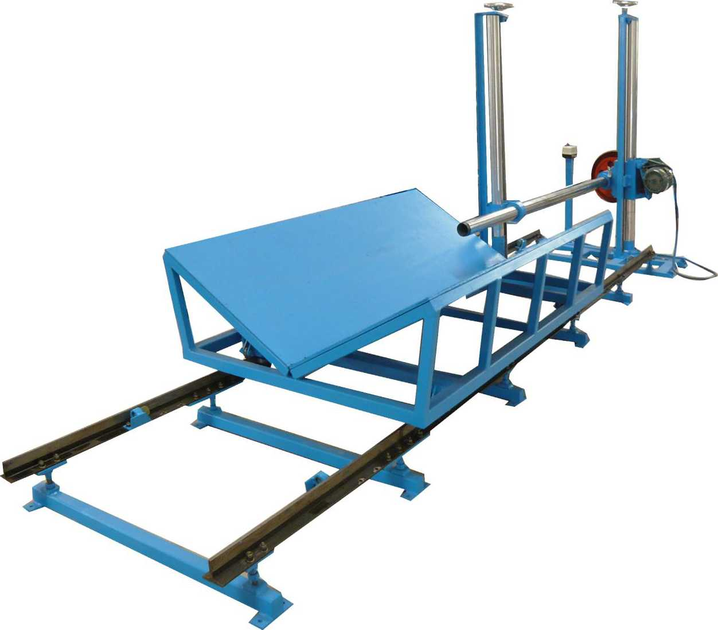
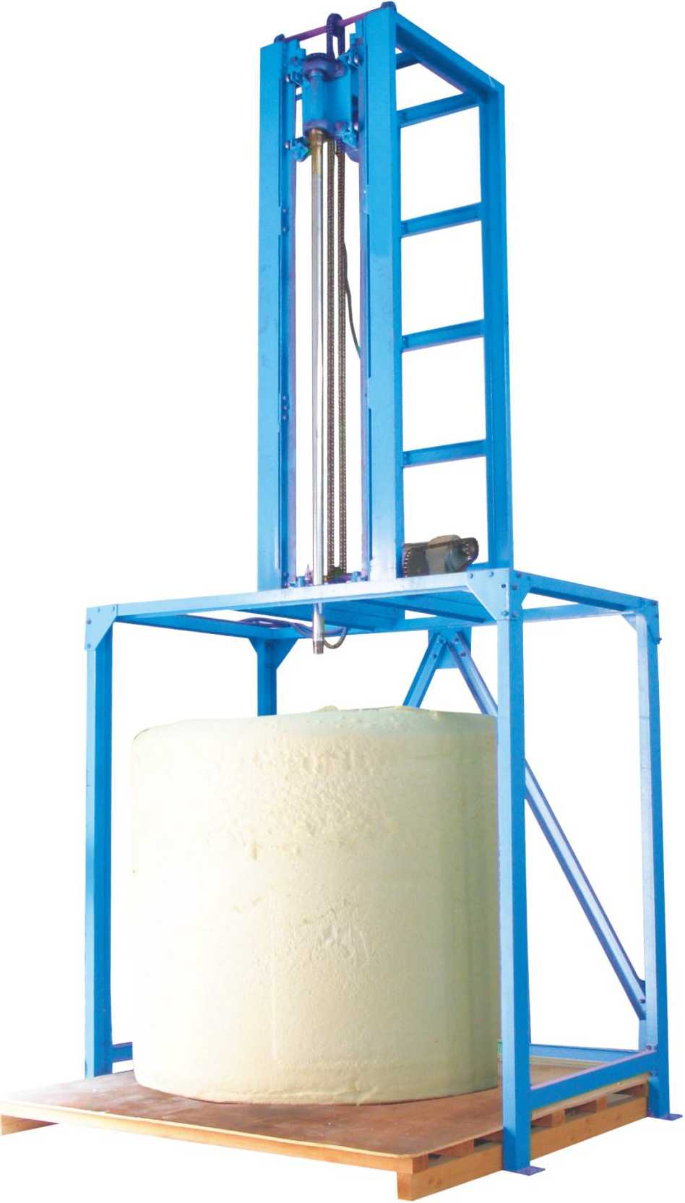
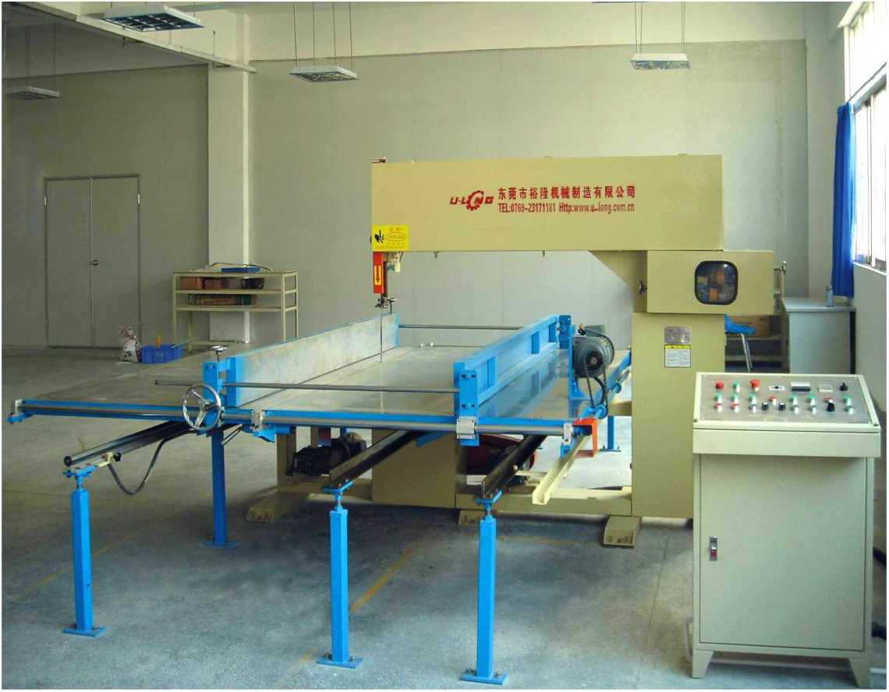
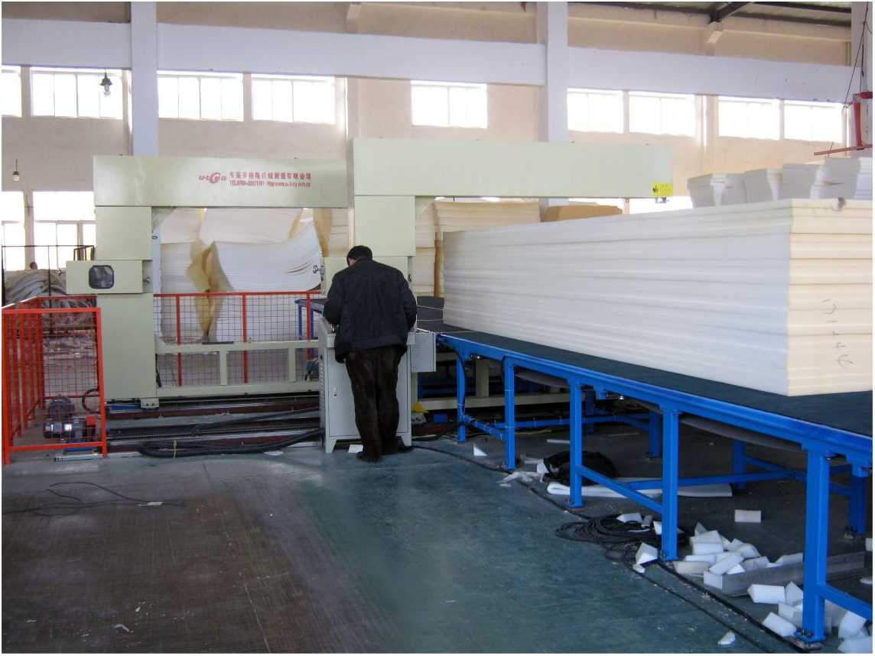

东凳市isBiiiniH制造有限公司

DongGuan U-Long Machinery Co.,Ltd.

ULJQ-2L-A

海绵角度切割机（圆弧型）

Angle Foam Cutting Machine(Circle)
型号Model | ULJQ-2L-A
工作台的尺寸 Worktable size | W1000 xL1500mm
可切海绵尺寸 Cutting foam size | W1000xL1500xH800mm
加工角度  Processing angle | 45-90°
刀带长度  Blade length | L4460mm
总功率  Total power | 1.68Kw
机器重量 Machine weight | 800Kg
机器外形尺寸 Machine external size | L1800><W2500xH2400mm

主要技术参数：Main Technical Specification
2012/ 9/23

ULJQ-3L

海绵三轮角度切割机

Angle Foam Cutting Machine (3 wheels)
本机主要用于小型泡棉的斜角切割工作，同时
可加工各种EAV及珍珠棉等软性材料。
This machine is mainly used for bevel cutting of the small foam, which can also process all kinds of EVA material.

ULJQ-2L-B

海绵角度切割机（直线型）

Angle Foam Cutting Machine(Beeline)
本系列机主要用于海绵的斜角切片工作。
This machine is mostly used for foam rubber beveled angle slicing.
—
示器
Angle indicat 齐^
M4YS
SCALING METER
主要技术参数： | Main Technical Specification
型号 | Model | ULJQ-3L
工作台的尺寸 | Worktable size | W1000xL2000mm
有效切割角度 | Available cutting angle | 15-90°
切割高度 | Cutting height | H600mm
刀带长度 | Blade length | L5300mm
总功率 | Total power | 3.93Kw
机器重量 | Machine weight | 1500Kg
机器外形尺寸 | Machine external size | L3120mm x W2000mm x H1954mm

ULJQ-2L-C

海绵角度切割机(直线型)

Angle Foam Cutting Machine(Beeline)
型号Model | ULJQ-2L-B | ULJQ-2L-C

主要技术参数：Main Technical Specification
工作台的尺寸 | 内工作台W300xL1500mm | 内工作台W480xL1200mm
Worktable size | 外工作台 W1000 xL1500mm | 外工作 ^W1000xL1200mm
挡板高度  Baffle height | 300mm | 300mm
加工角度 Processing angle | 45-90° | 0-90°
刀带长度  Blade length | L4460mm | L4620mm
总功率  Total power | 1.68Kw | 1.28Kw
机器重量 Machine weight | 800Kg | 800Kg
机器外形尺寸 Machine external size | L3000 x W2000 x H2200mm | L3000 x W2000 x H2200mm

ULJQ-4L

海绵四轮自动角度切割机

AutomaticAngle Foam Cutting Machine
主要技术参数：Main Technical Specification
型号Model | ULJQ-4L
工作台的尺寸  Worktable size | W1000xL4000mm
可切海绵尺寸 Cutting foam size | W1000X L2000 x H1000mm
加工角度  Processing angle | 0-90°
刀带长度  Blade length | L6700mm
总功率  Total power | 4.59Kw
机器重量 Machine weight | 1800Kg
机器外形尺寸  Machine external size | L251 Omm x W4000mm x H400mm

注：以上数据和参数仅供参考，实际技术数据以出厂产品为准。
Remark: The above data is only for reference, all the parameter is subjected to the sold production.
注：以上数据和参数仅供参考，实际技术数据以出厂产品为准。
Remark: The above data is only for reference, all the parameter is subjected to the sold production.
